­­Referred {

@@@<https://www.youtube.com/watch?v=tWVWeAqZ0WU>

}

Graph Algorithms:



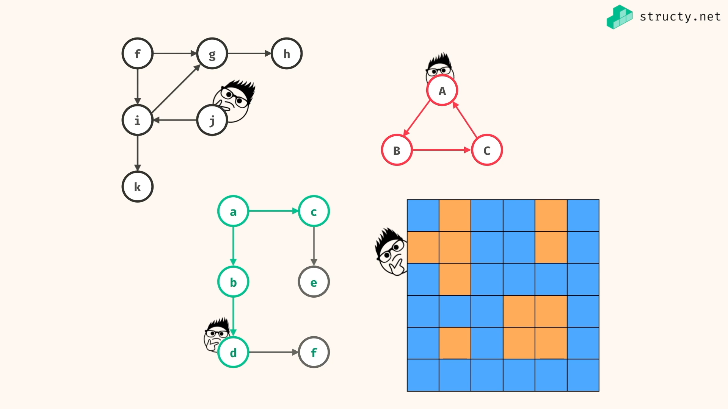

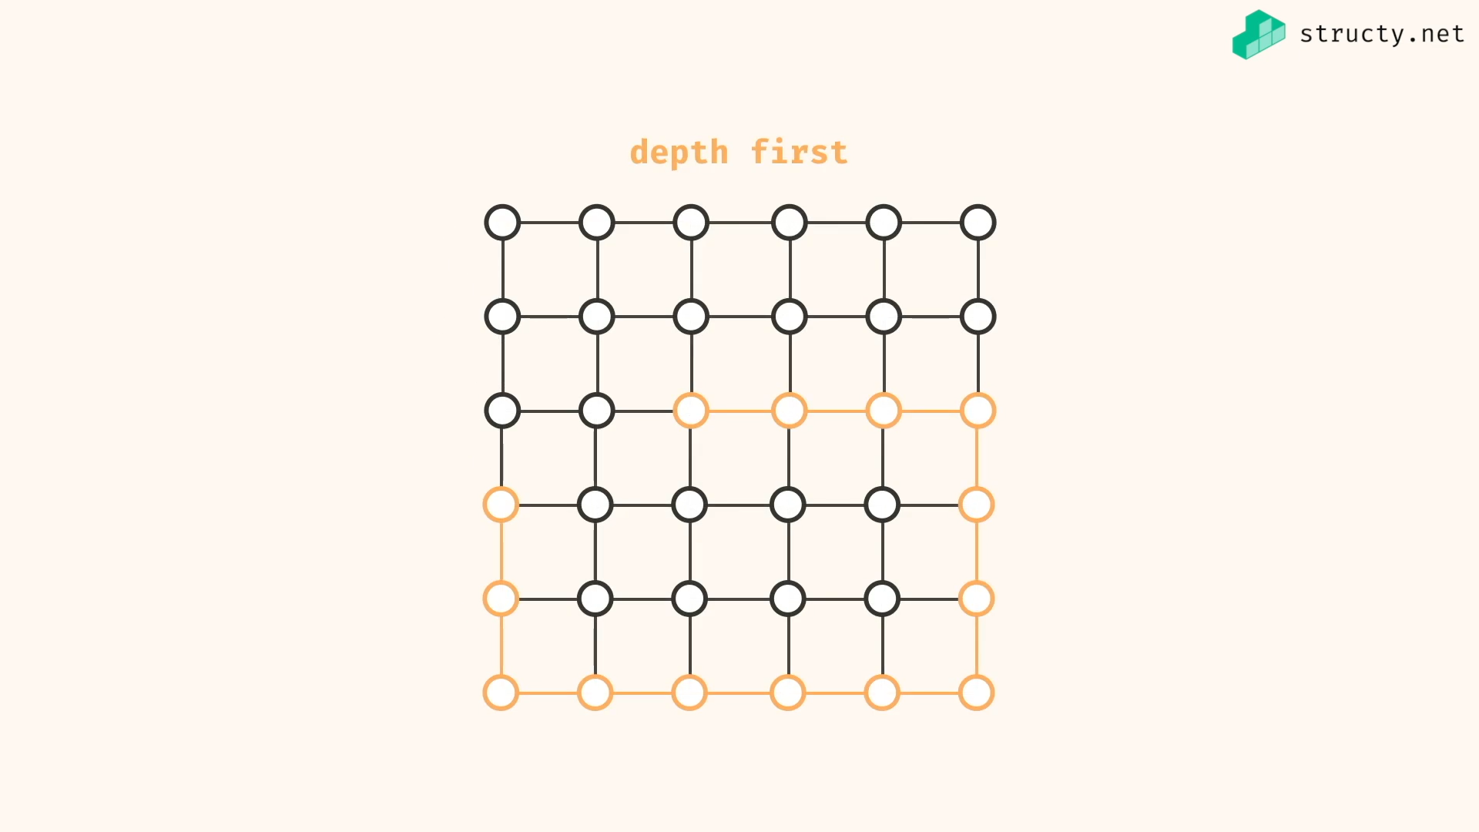

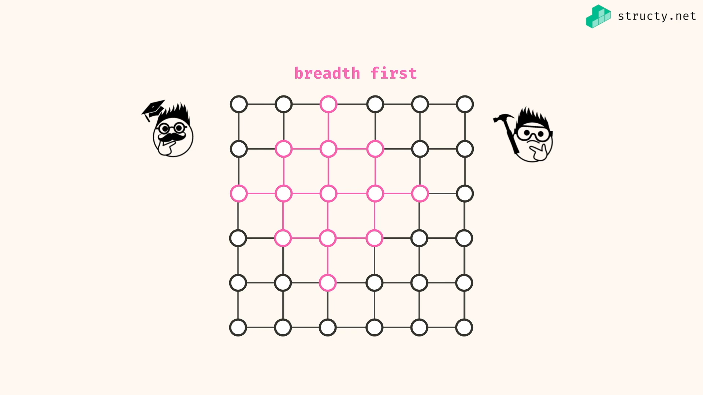

Nodes – any point on graph having values or no need

Edges – connection between nodes

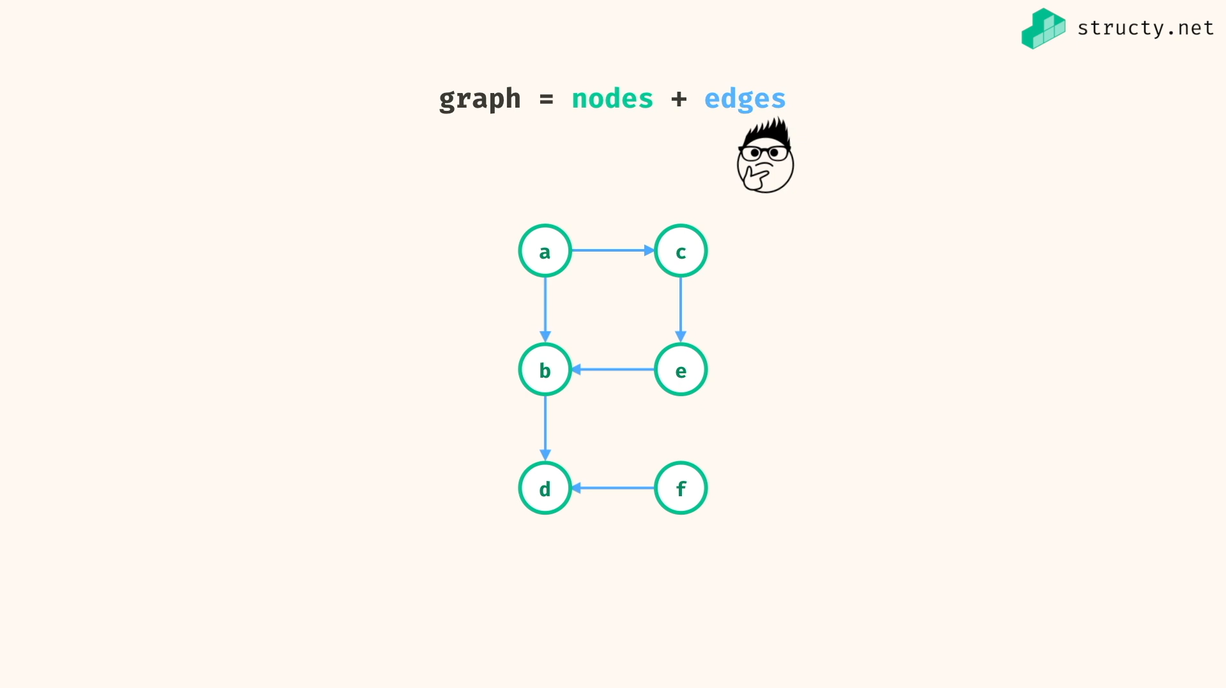

In real world,

Nodes are just things, edges are relationship between things…

Like cities are nodes and the road connecting cities are edges…

Directed and undirected graph : single direction vs any direction…

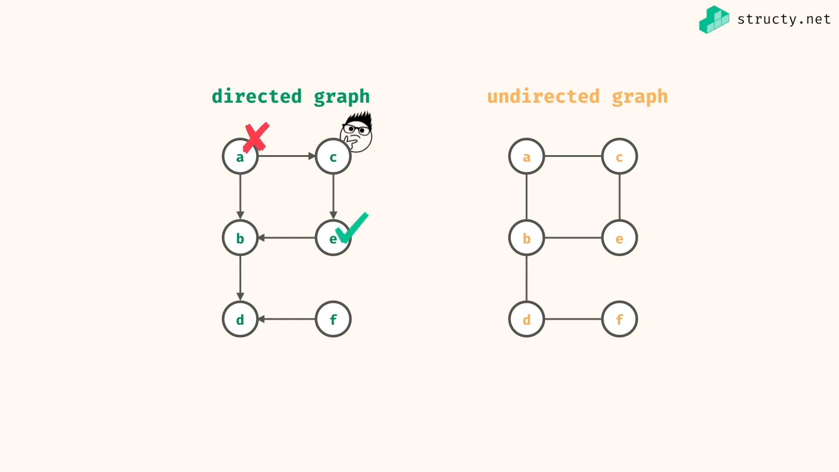

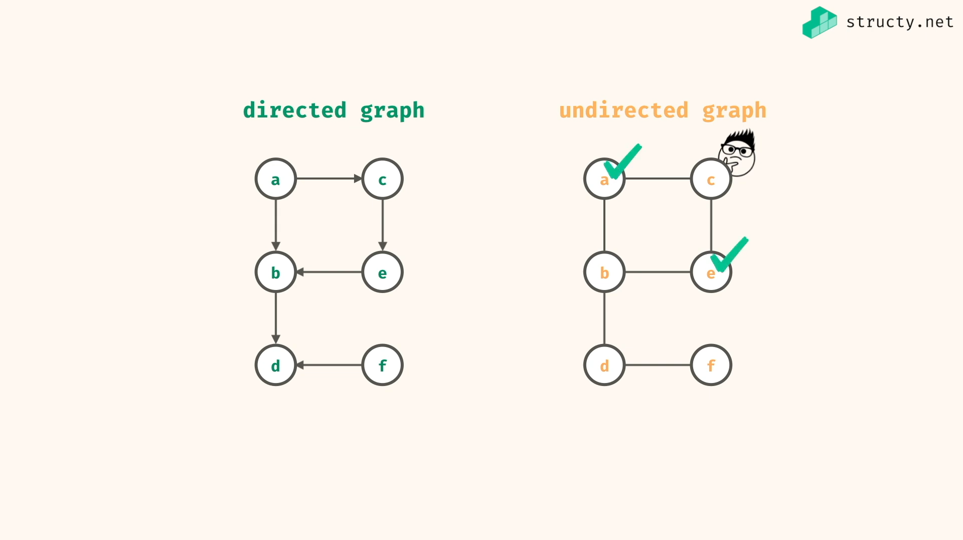

Terminologies:

Neighbour nodes : nodes that are possible to get in next move [ not all nodes near it, only those nodes which have directed way to get near them… ]

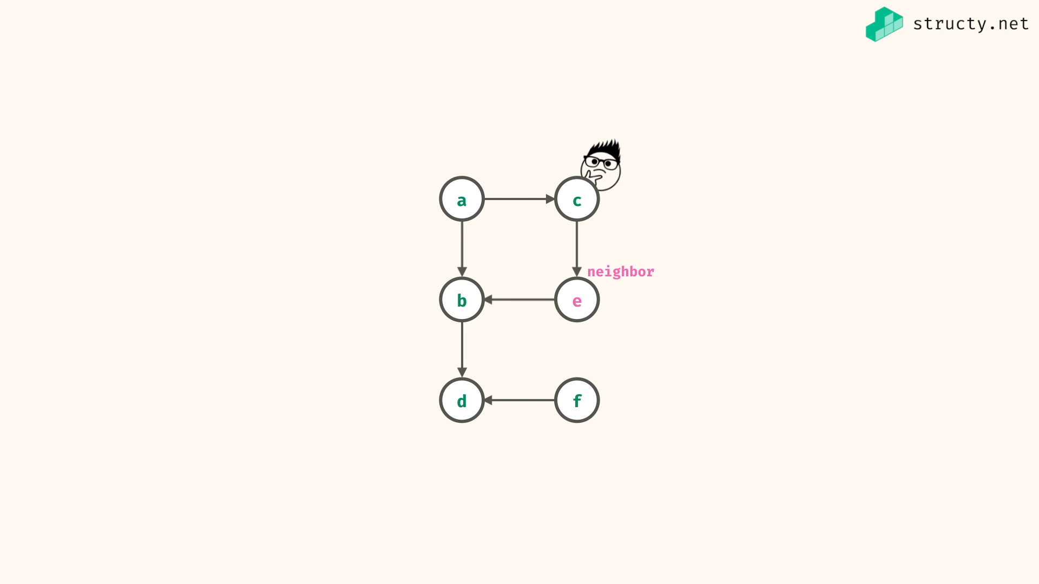

Preferred way to represent graph information in programmatic way is Adjacency list..

Adjacency list have to be constant time look up data structure… i.e key value pair mapping

i.e

Object in js,

Dictionary in py,

Unordered Map in java/c….

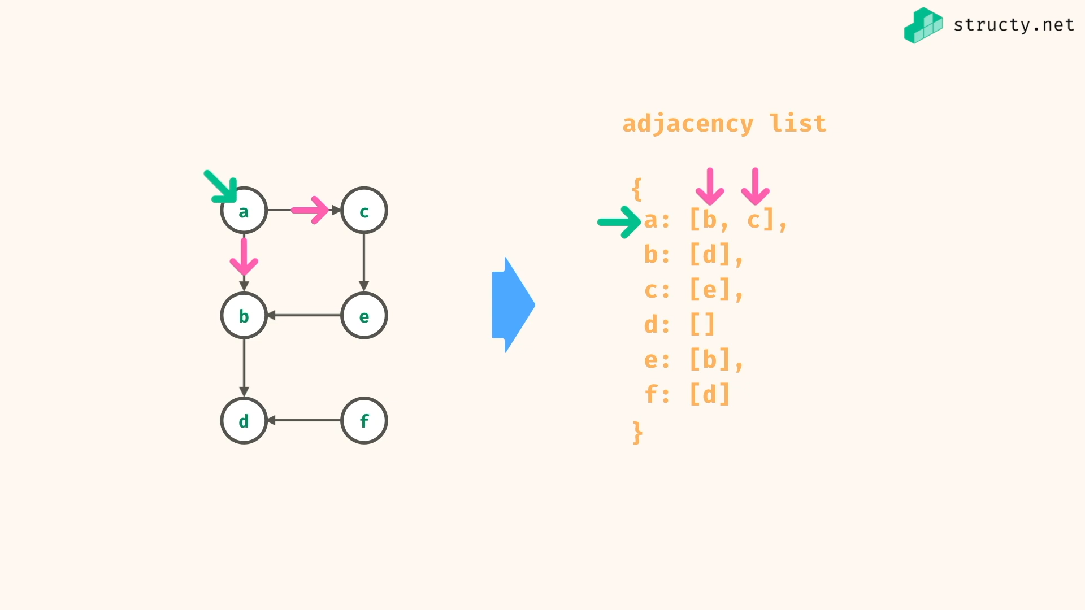

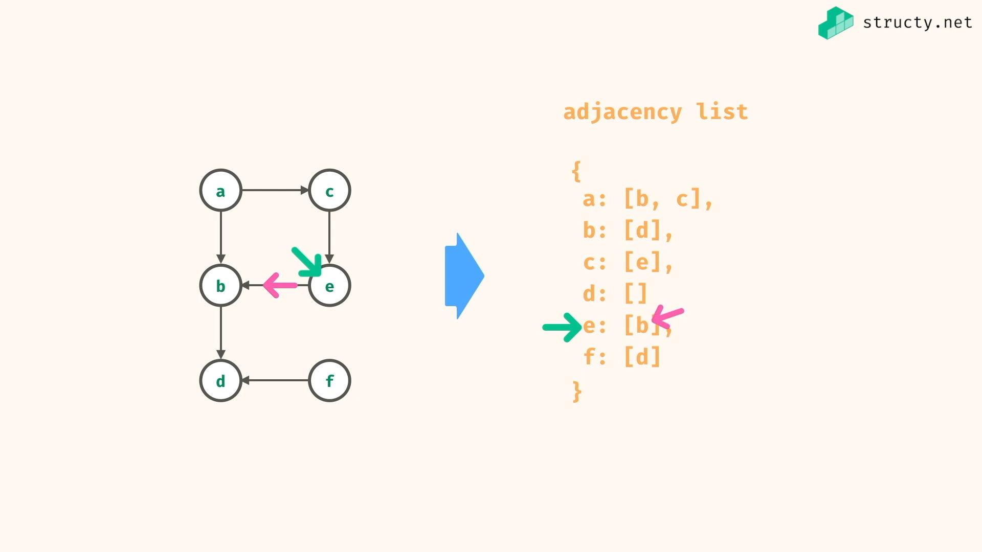

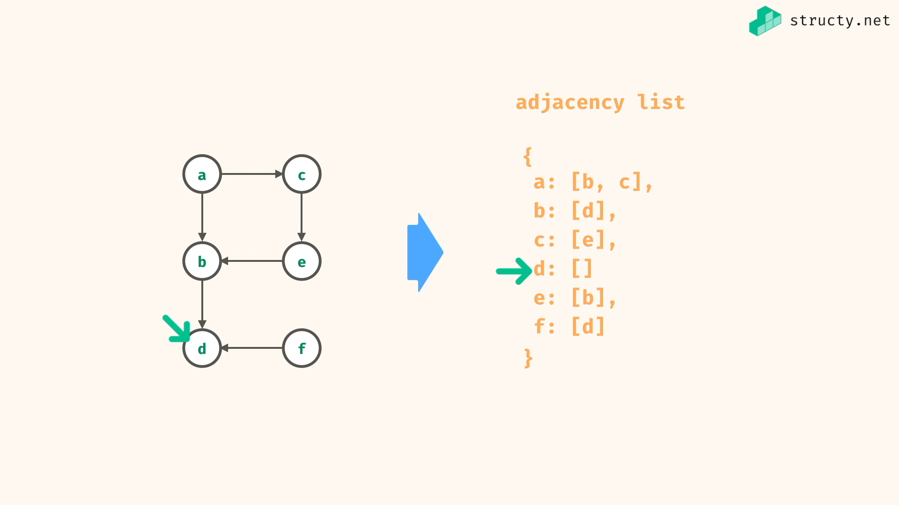

Depth first Traversal:

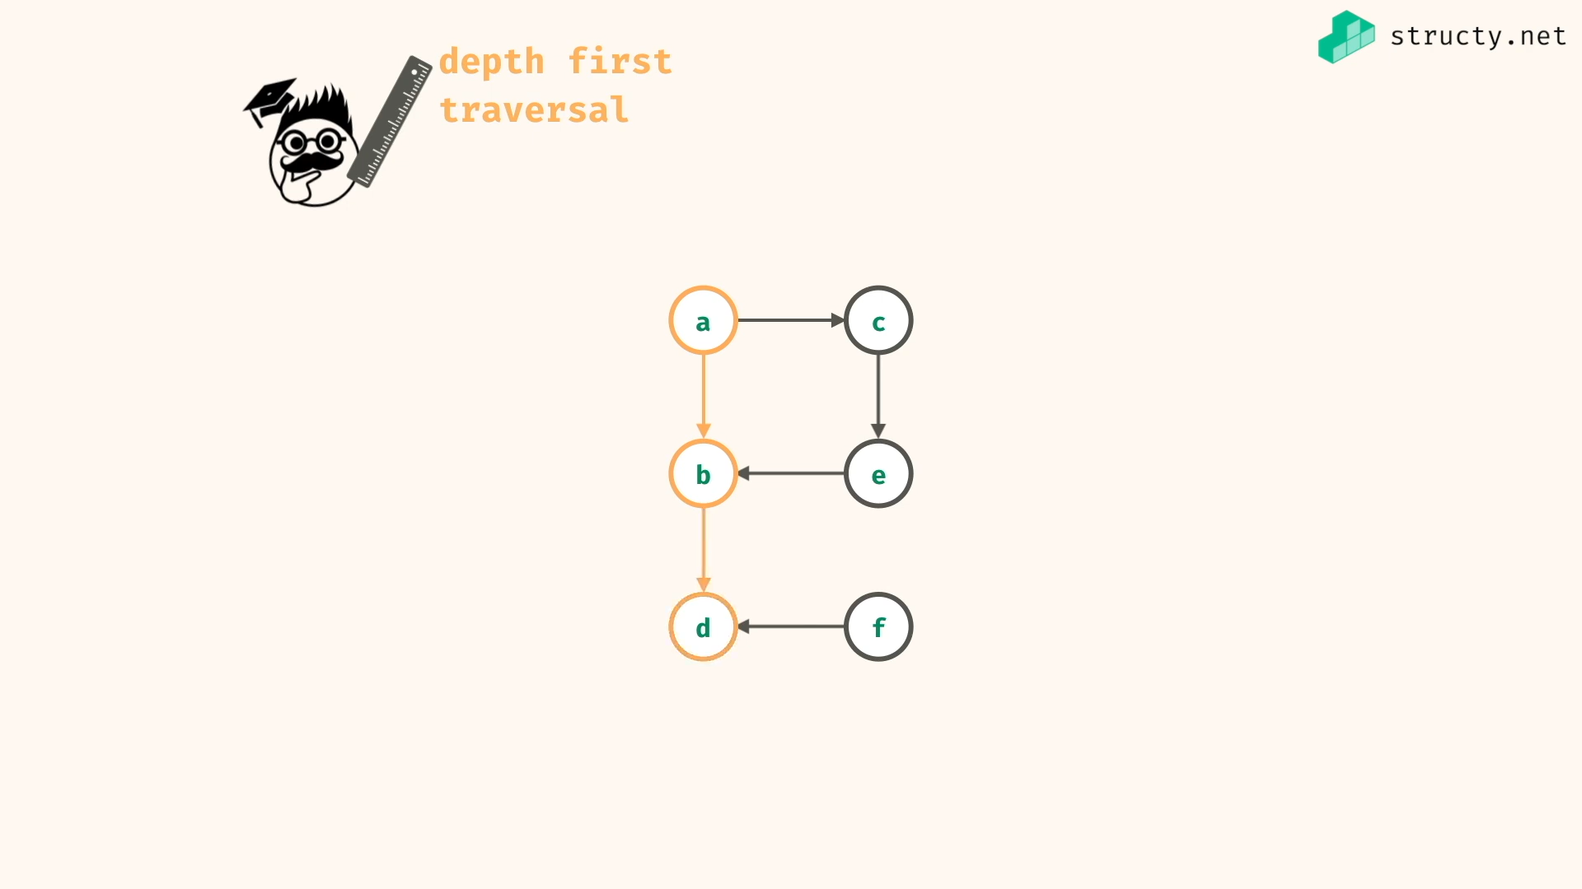

In DFS, one neighbours whole things has to be visited before going to other neighbour

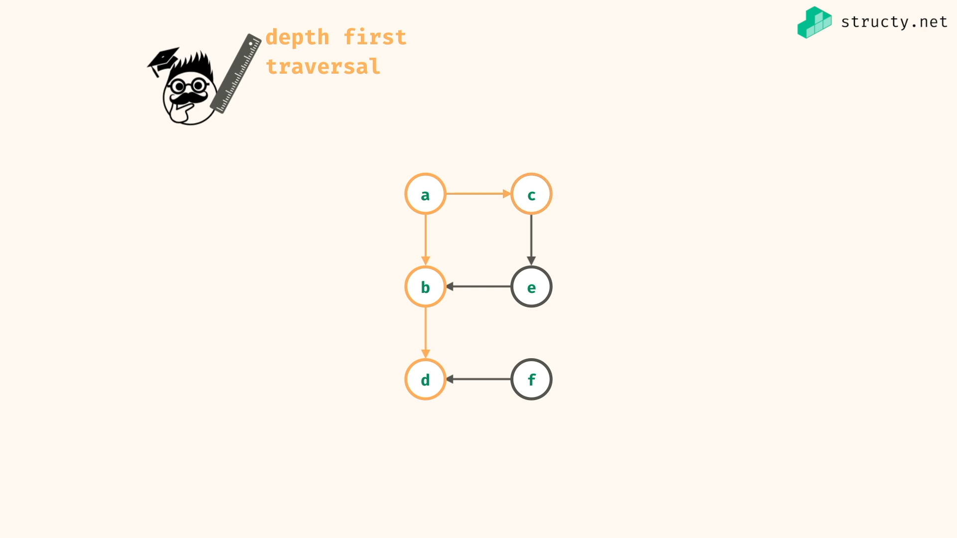

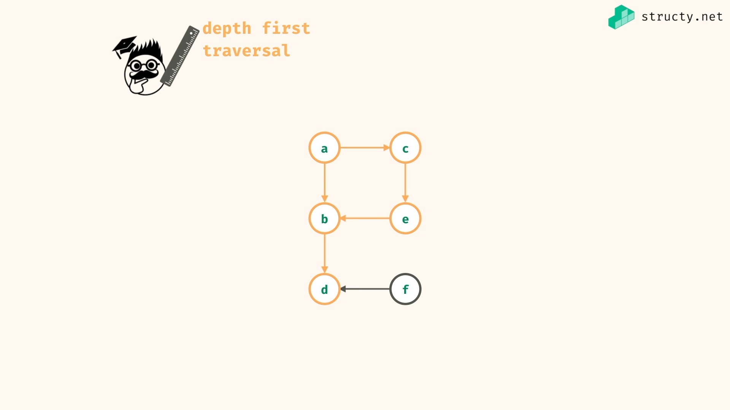

In above example, when you start from A.. you can’t reach F..

DFS vs BFS

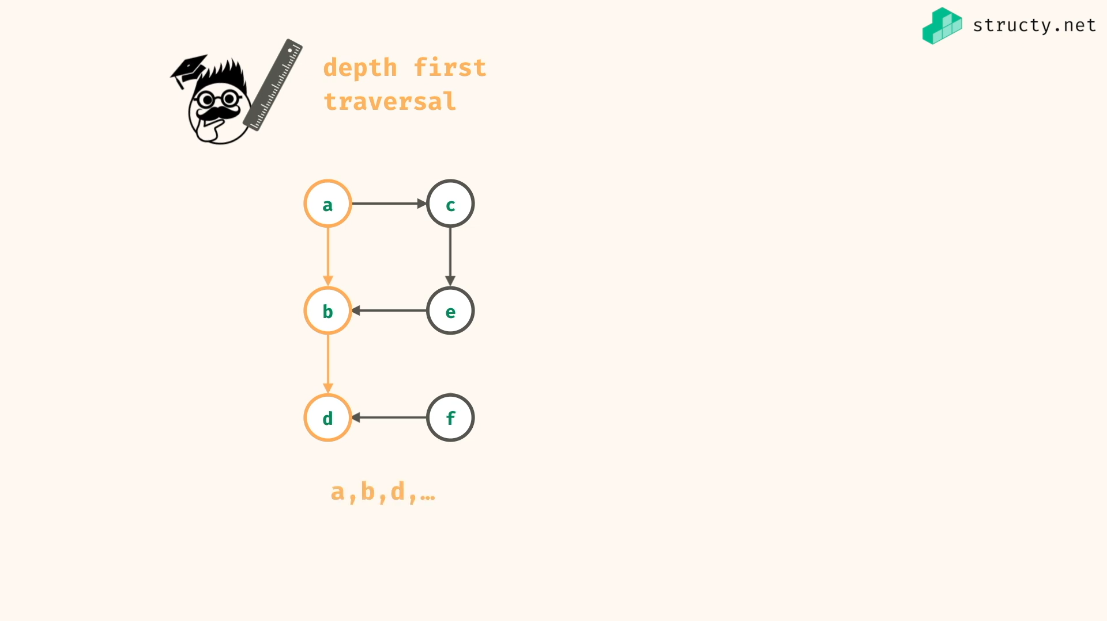

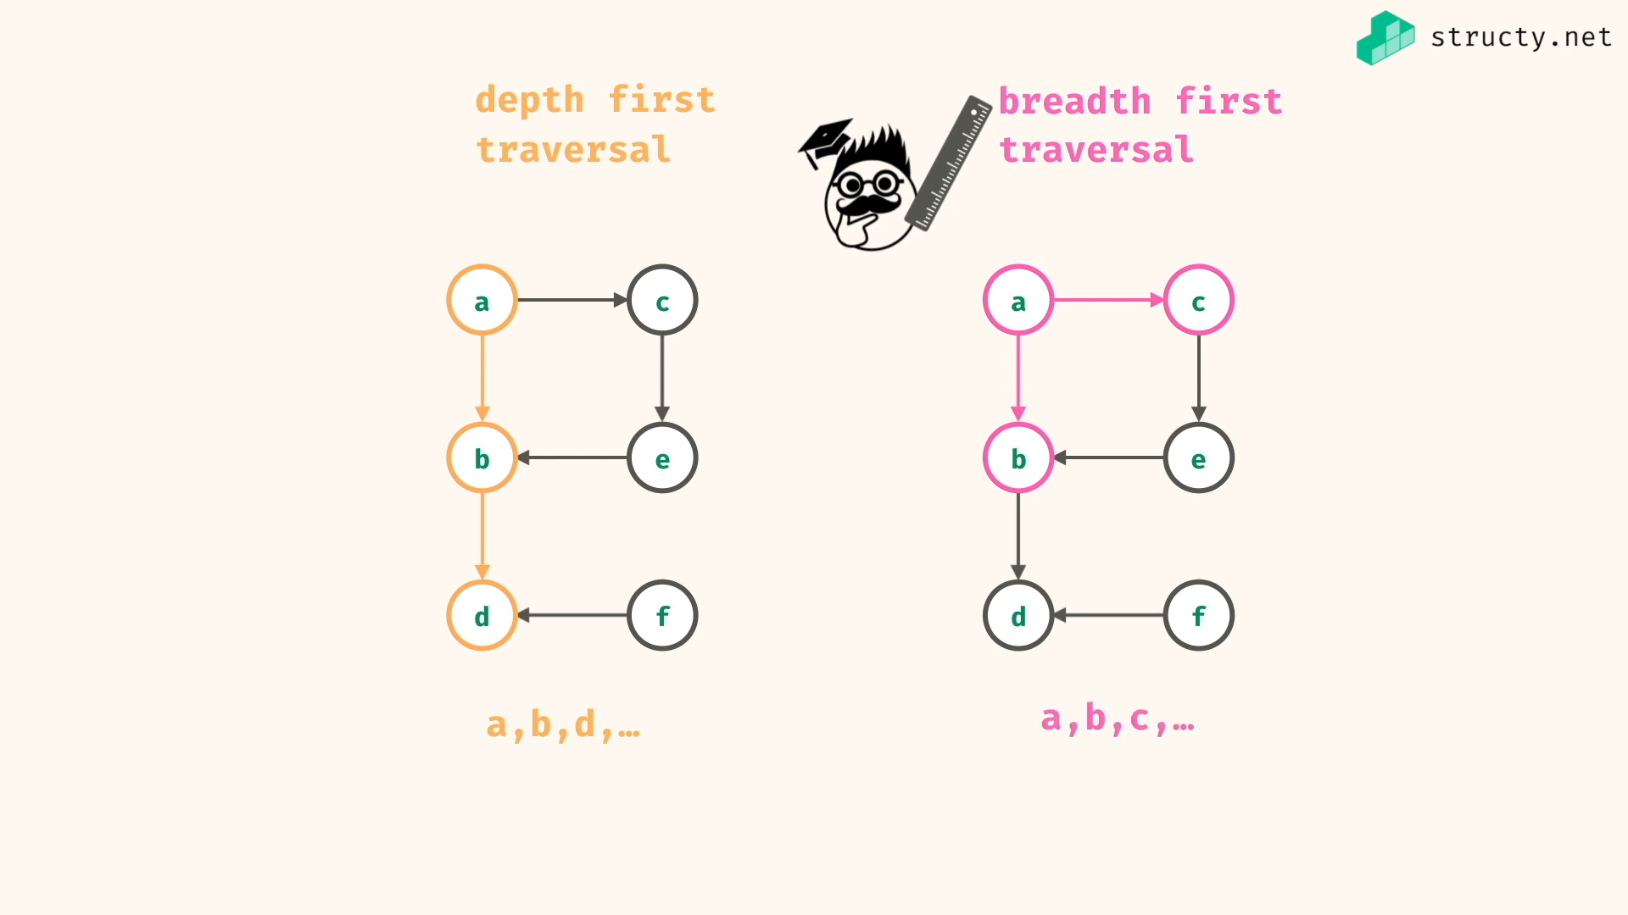

In BFS, all neighbours are visited one by one…

DFS:

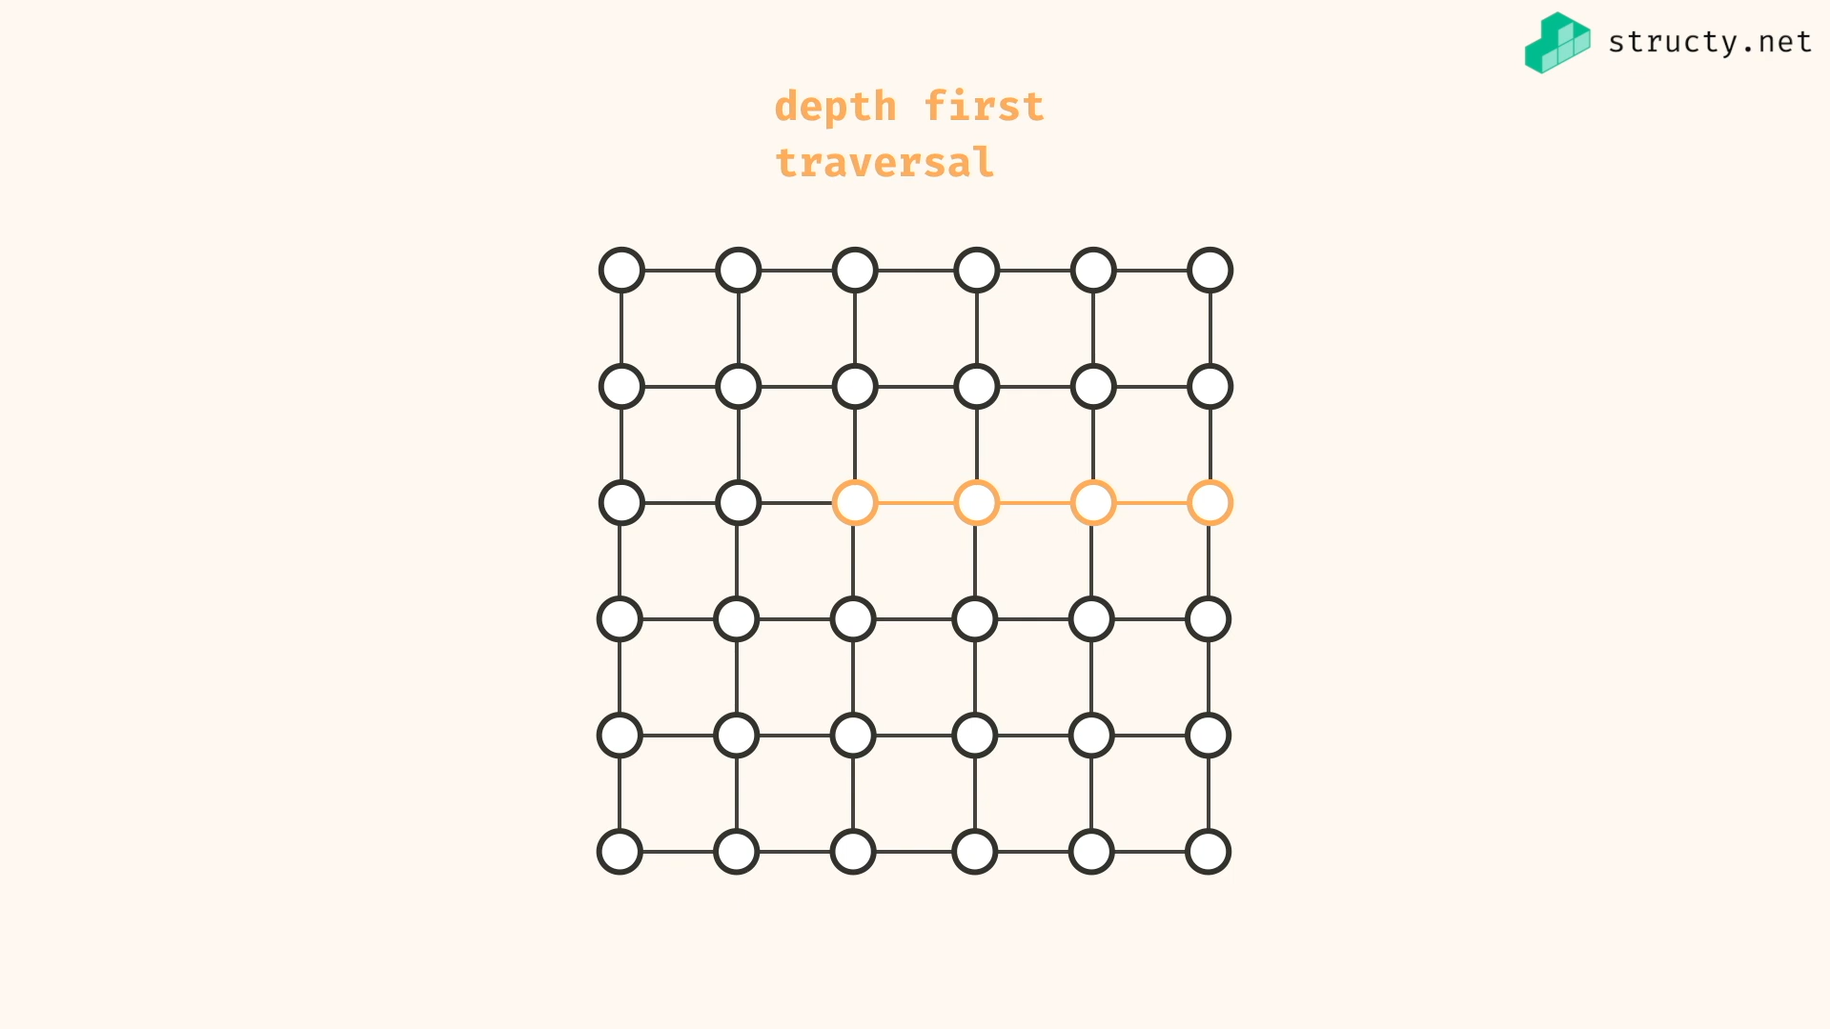

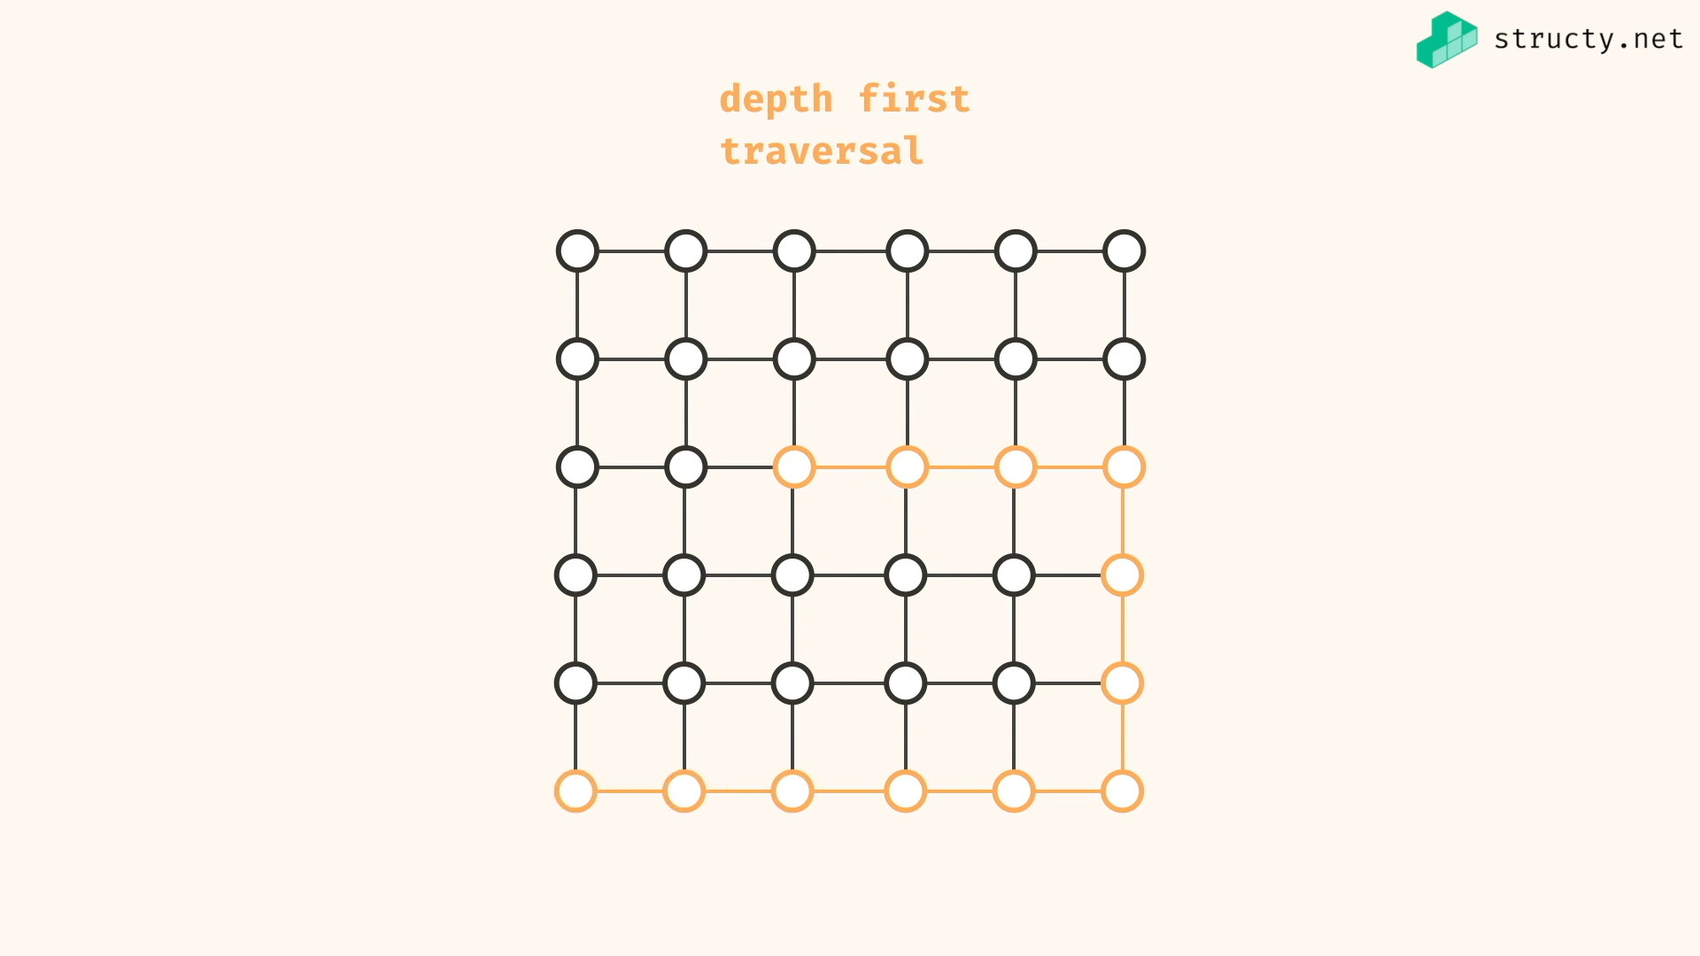

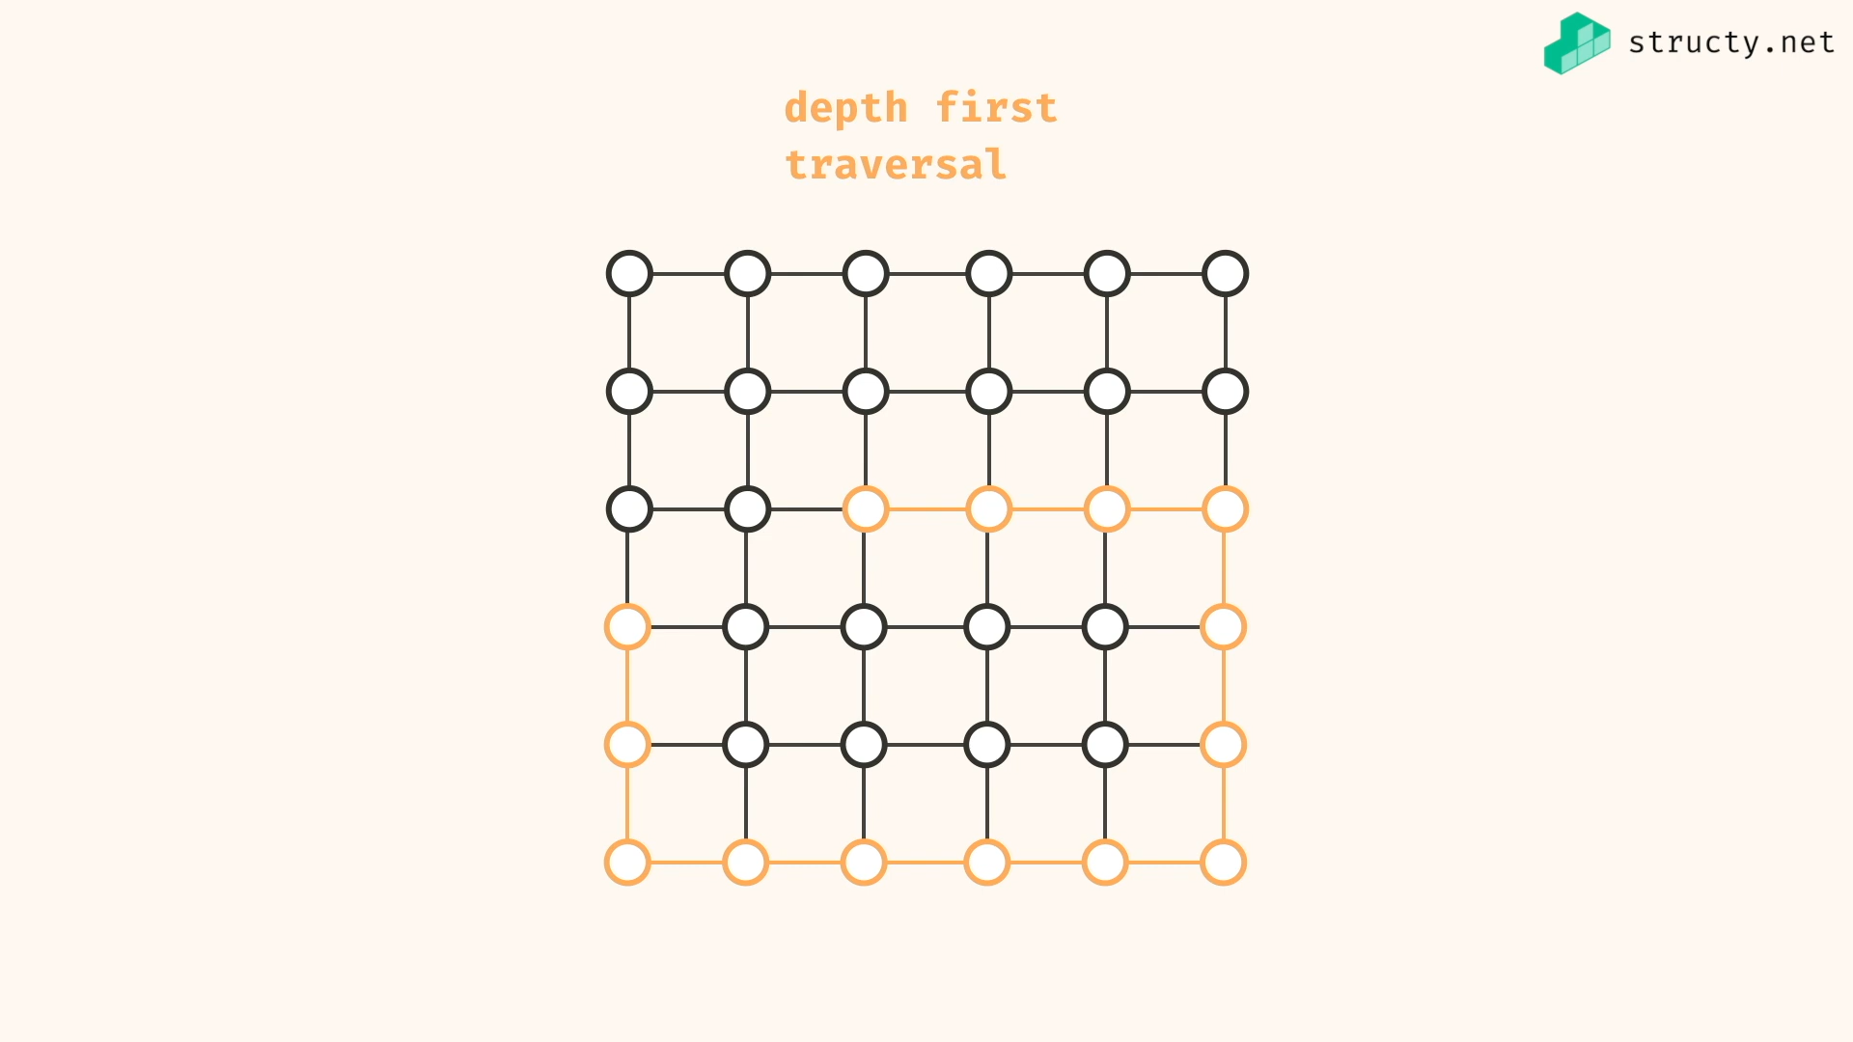

Explore one path as depth as possible before going to next path..

BFS:

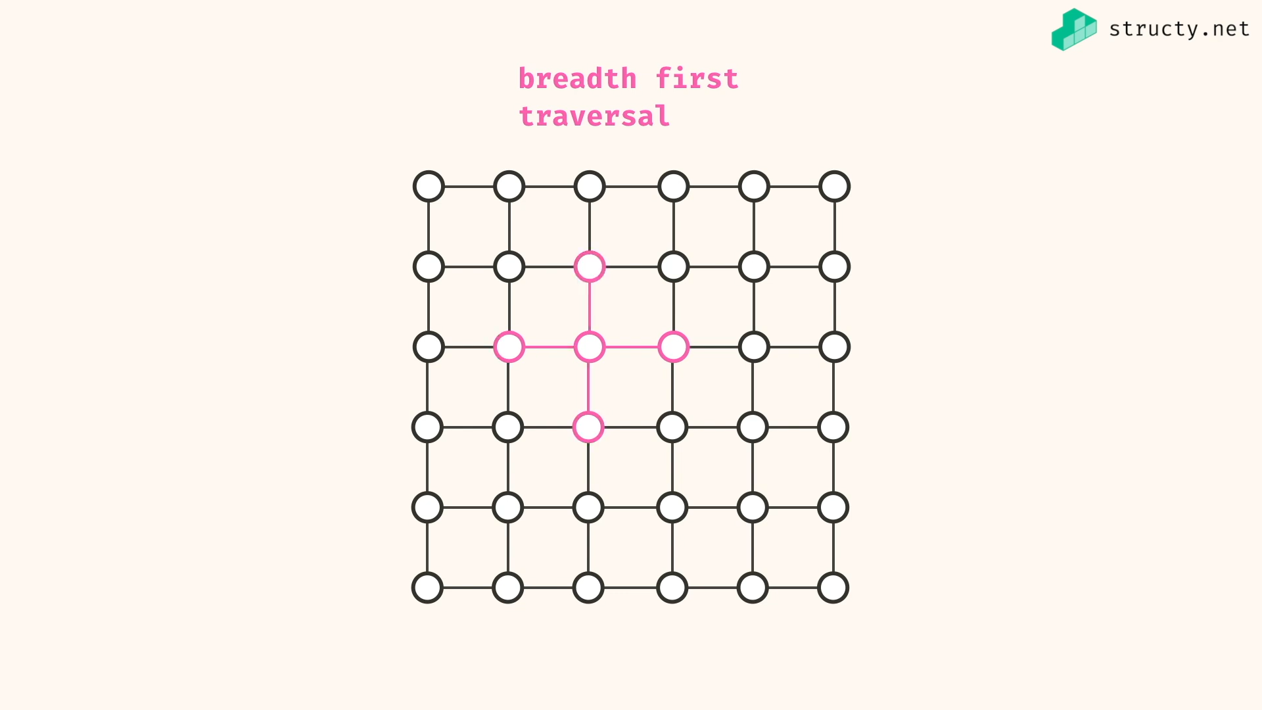

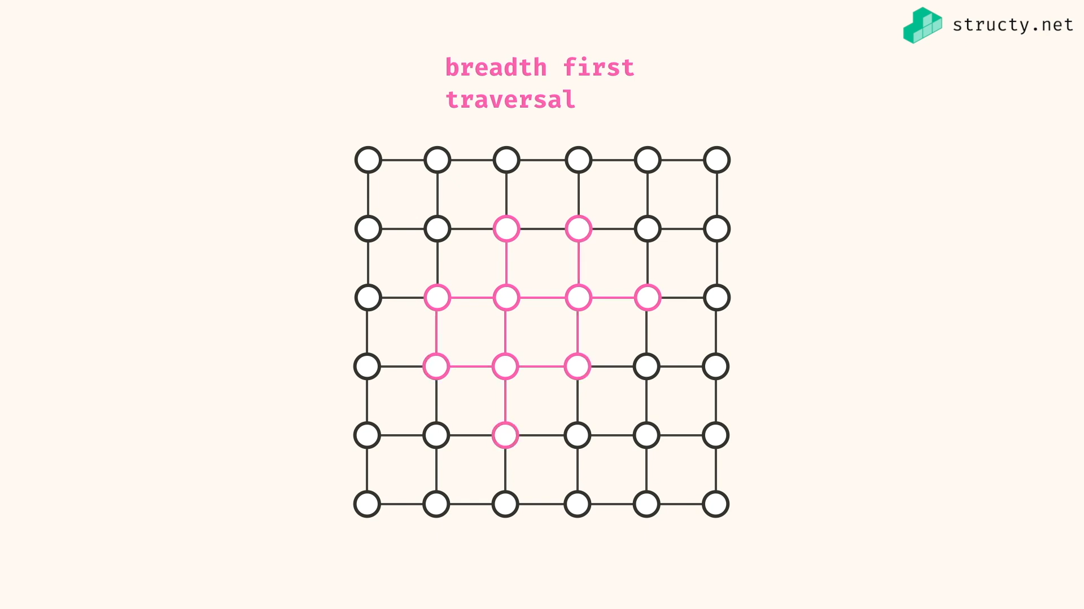

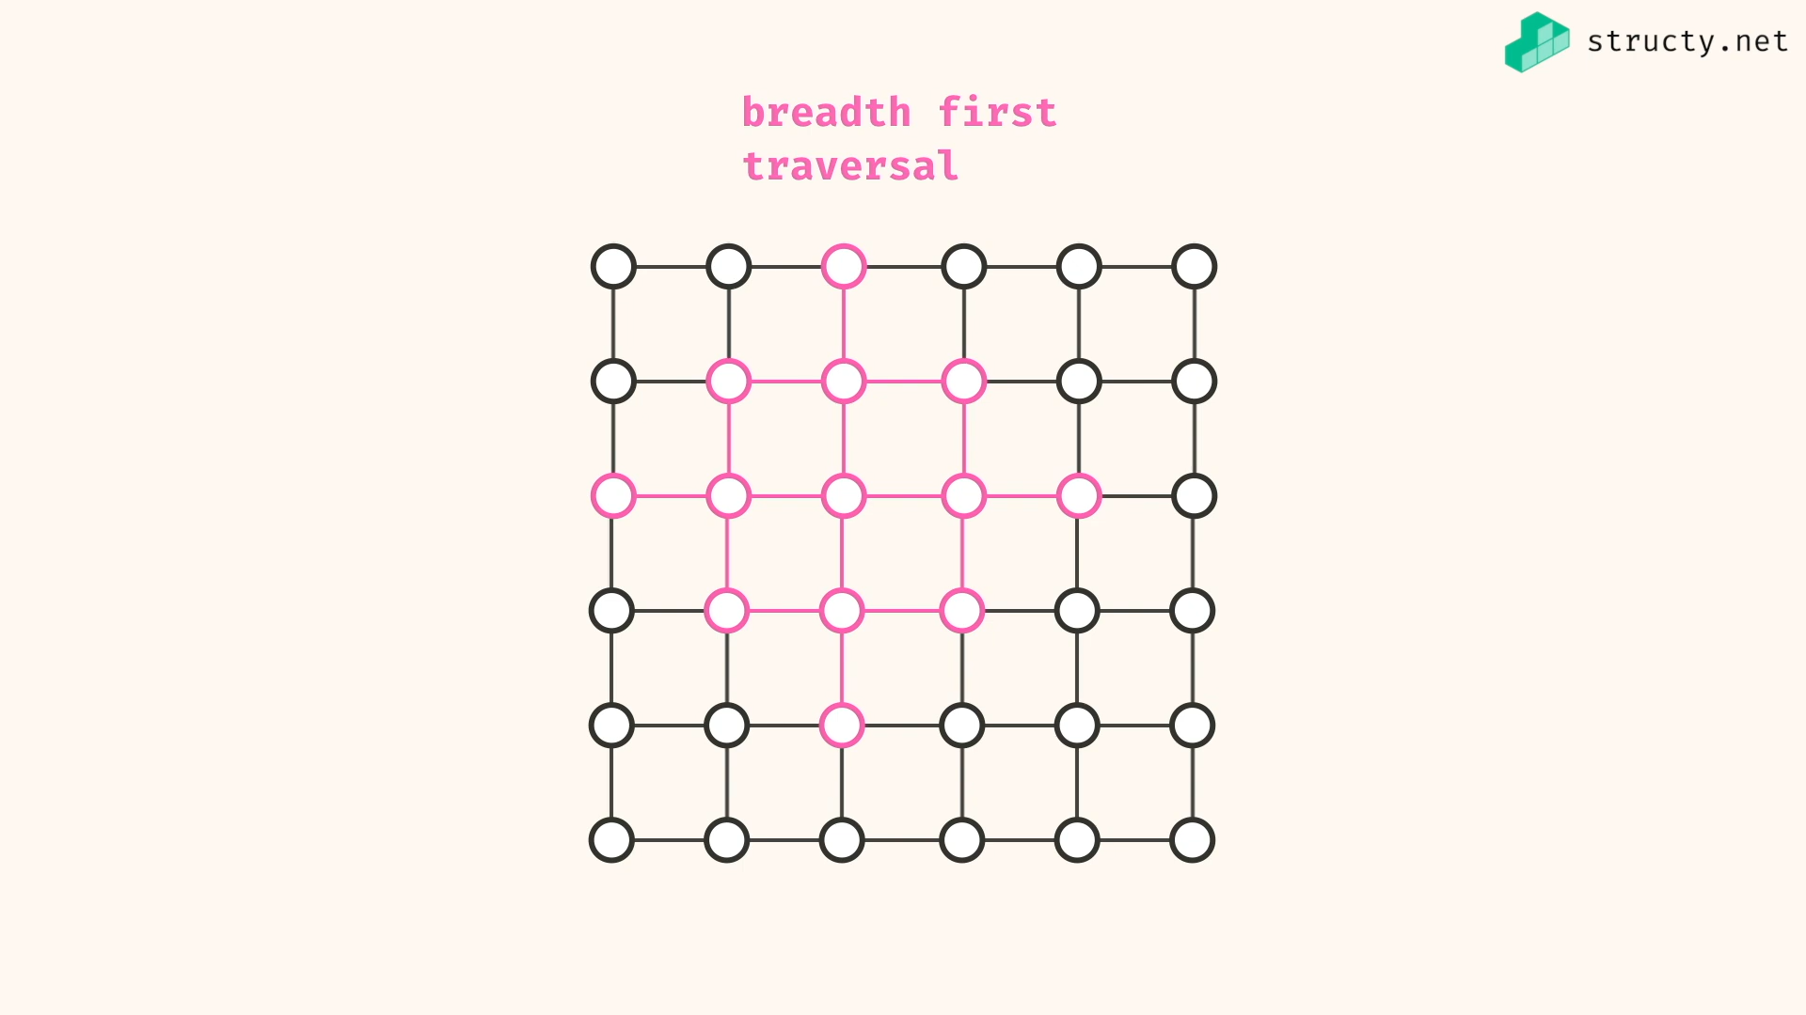

Explore all directions path evenly…

DFS and BFS:

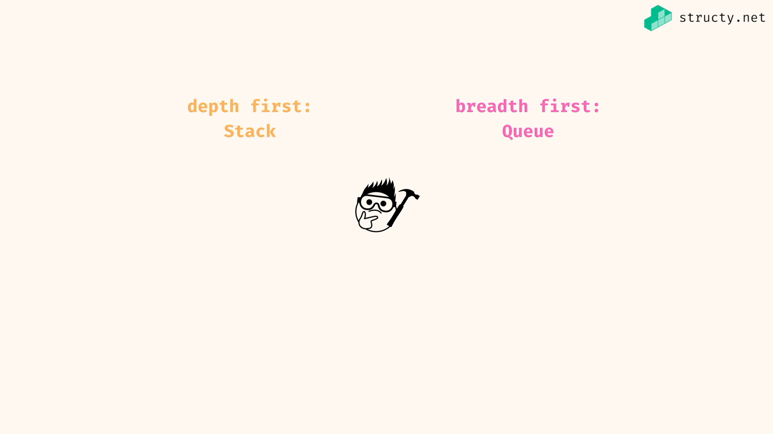

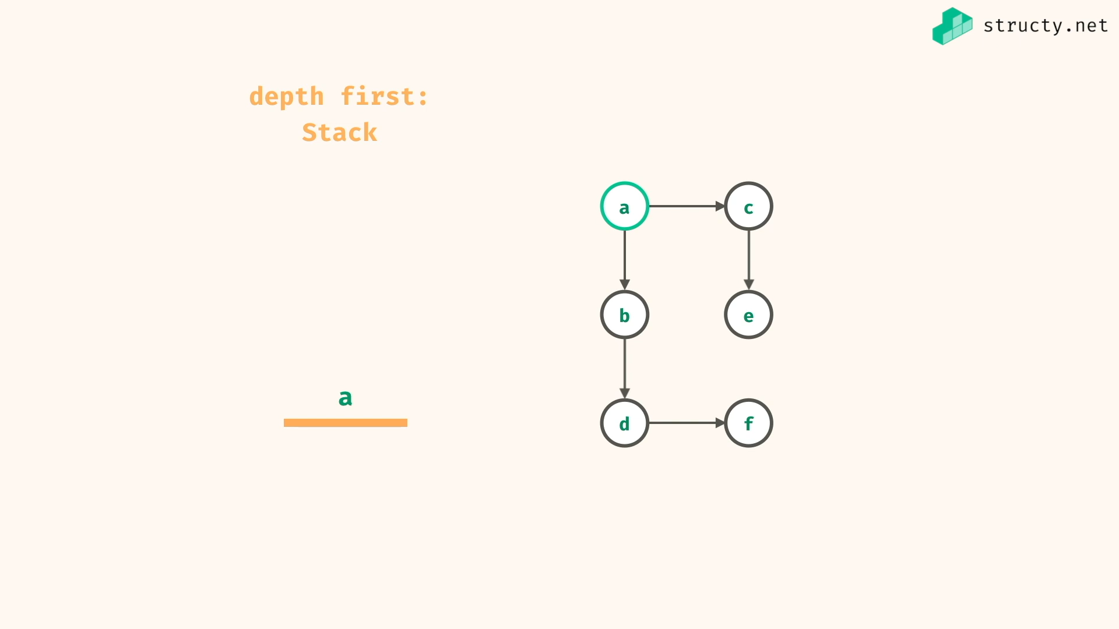

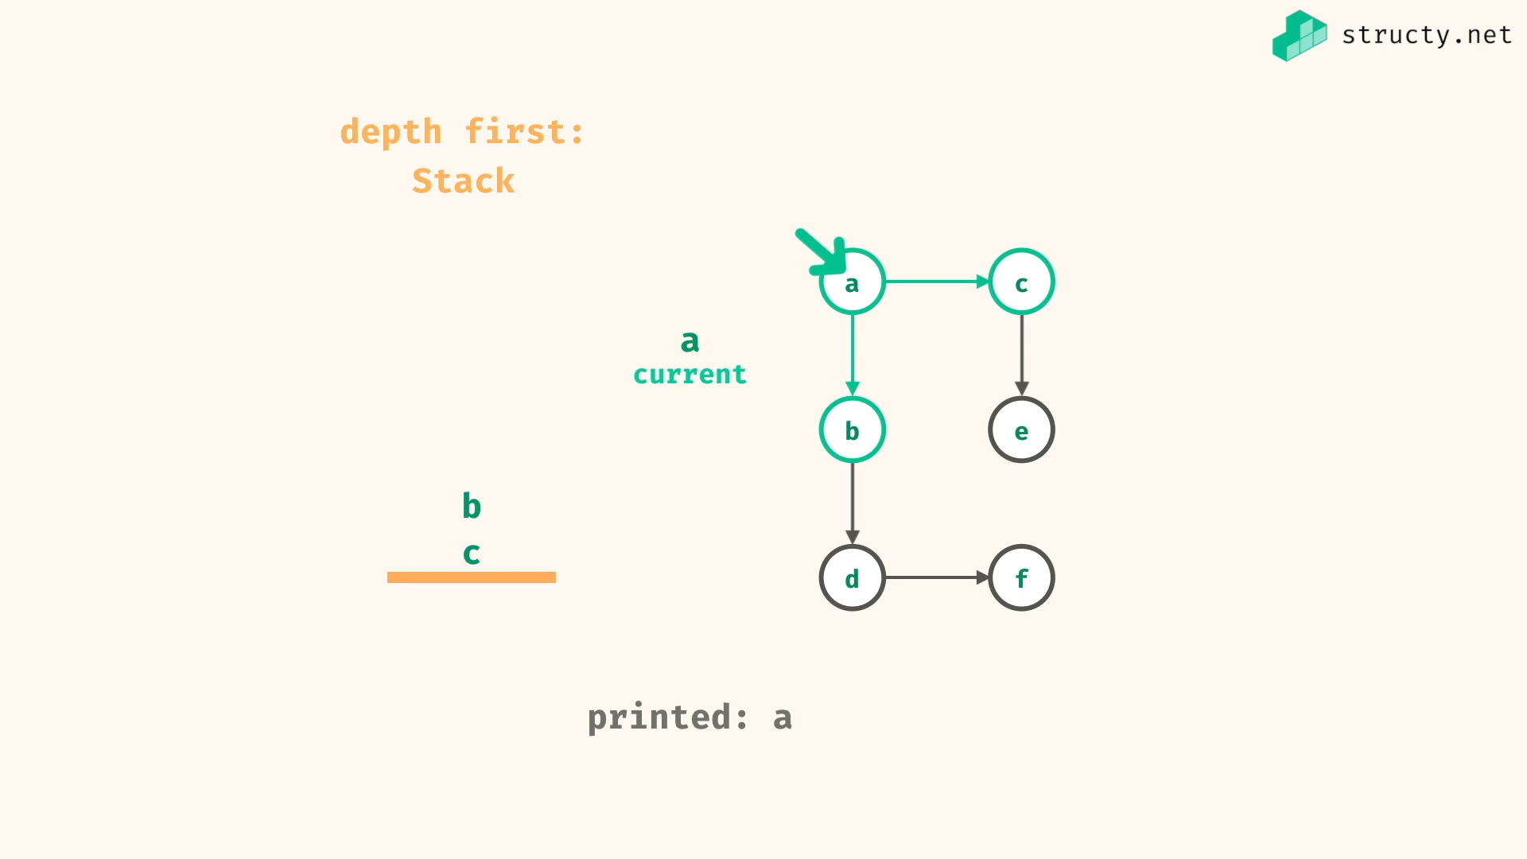

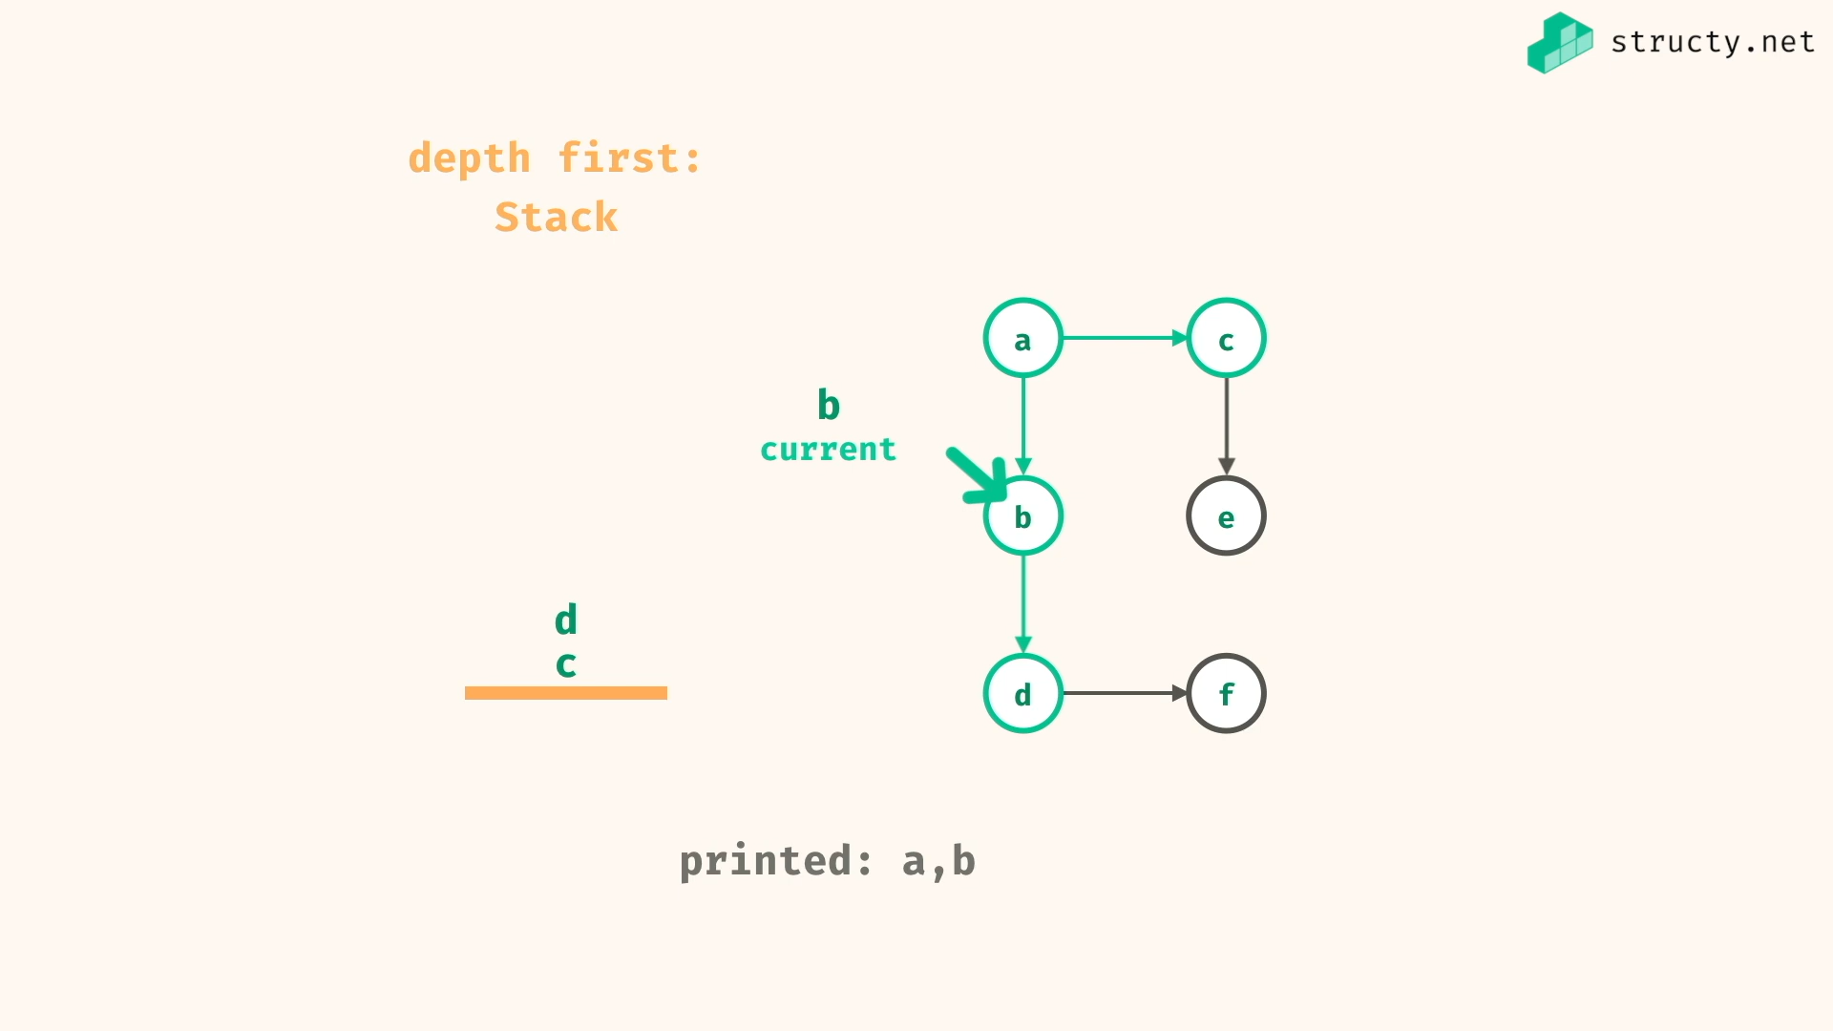

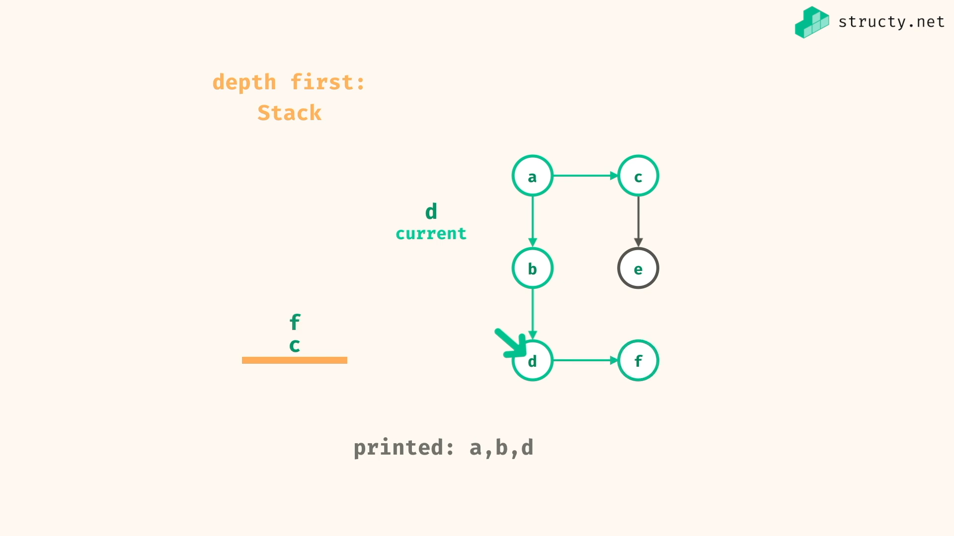

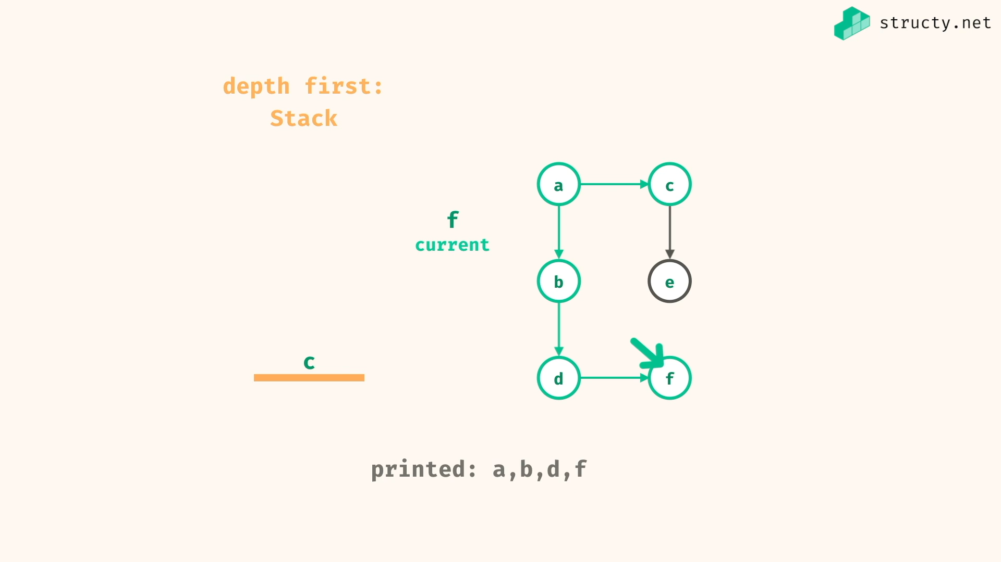

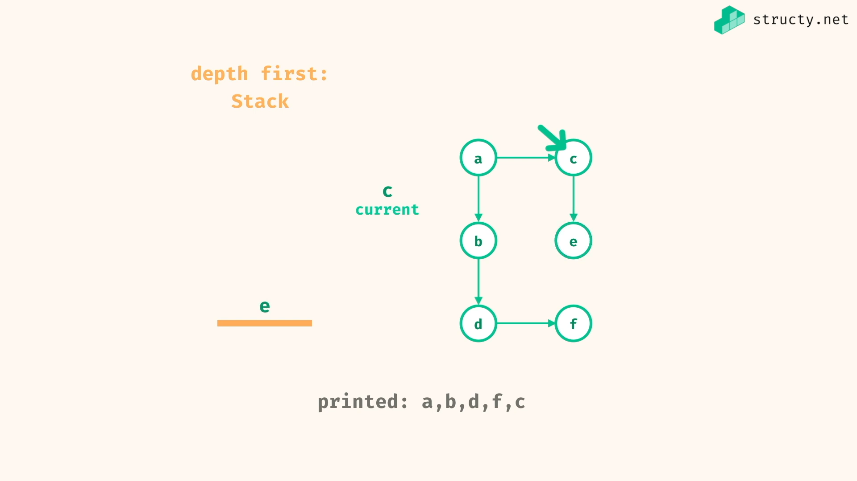

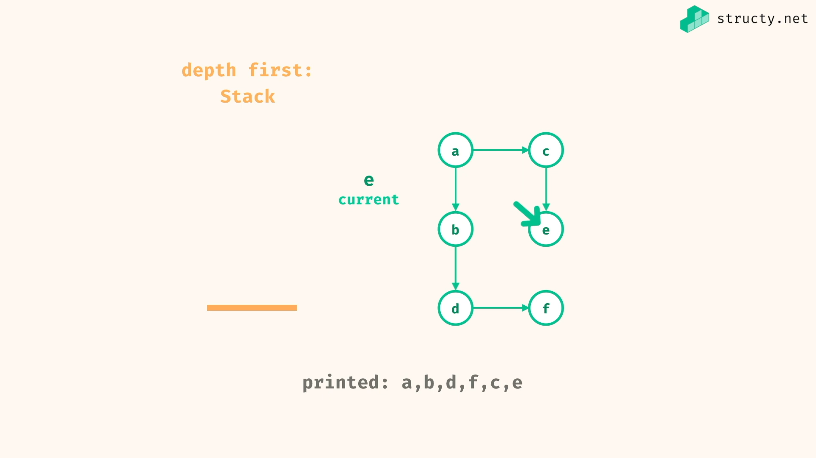

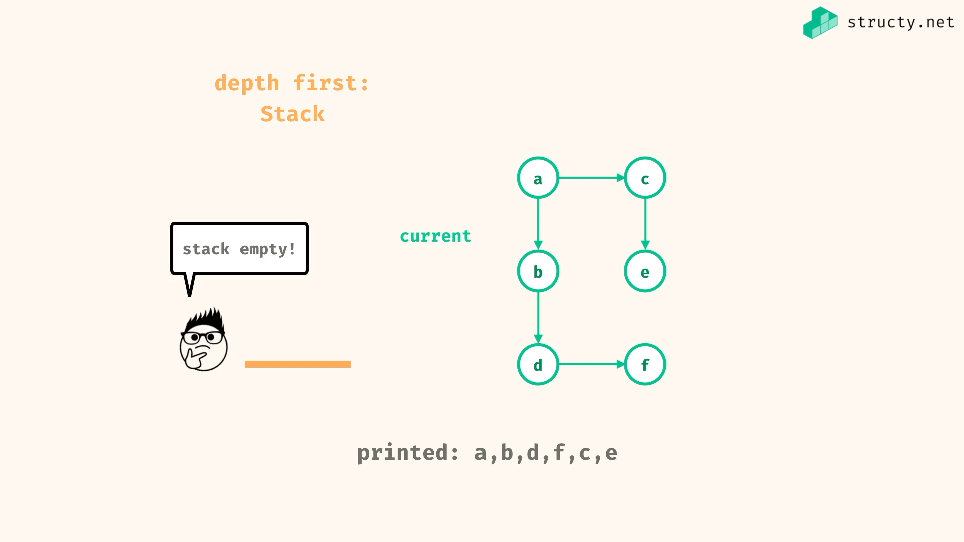

BFS:

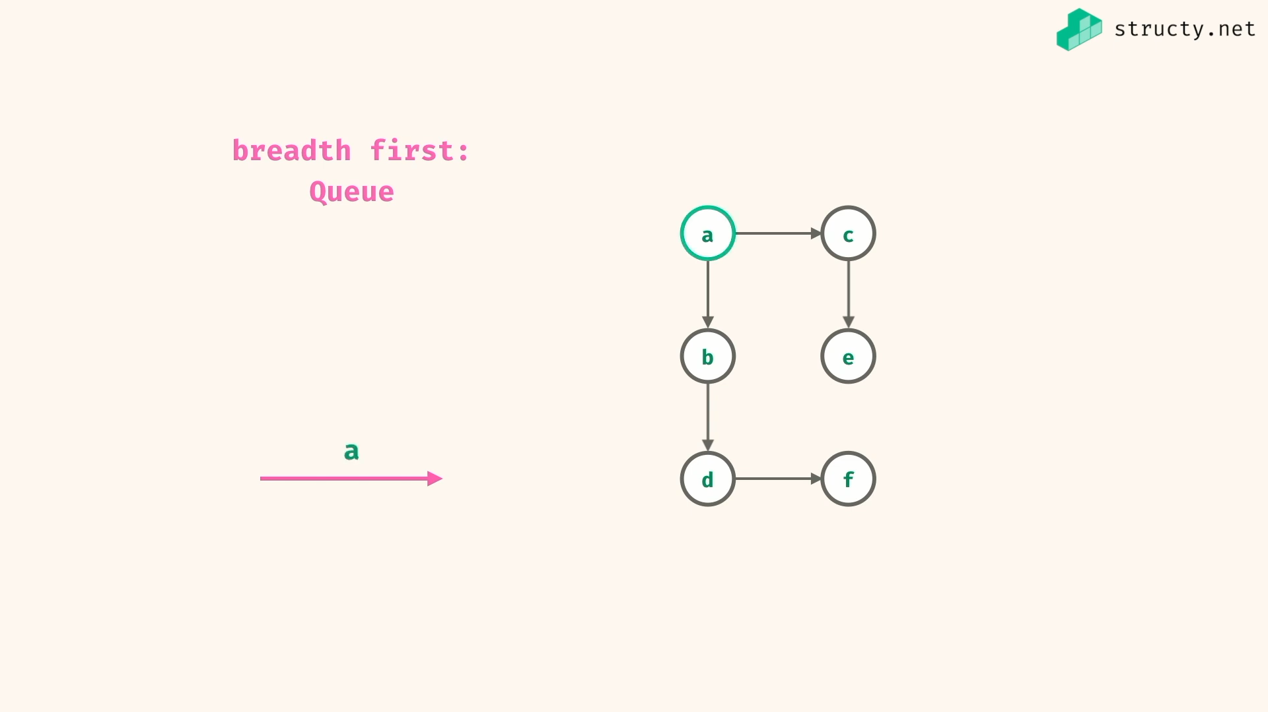

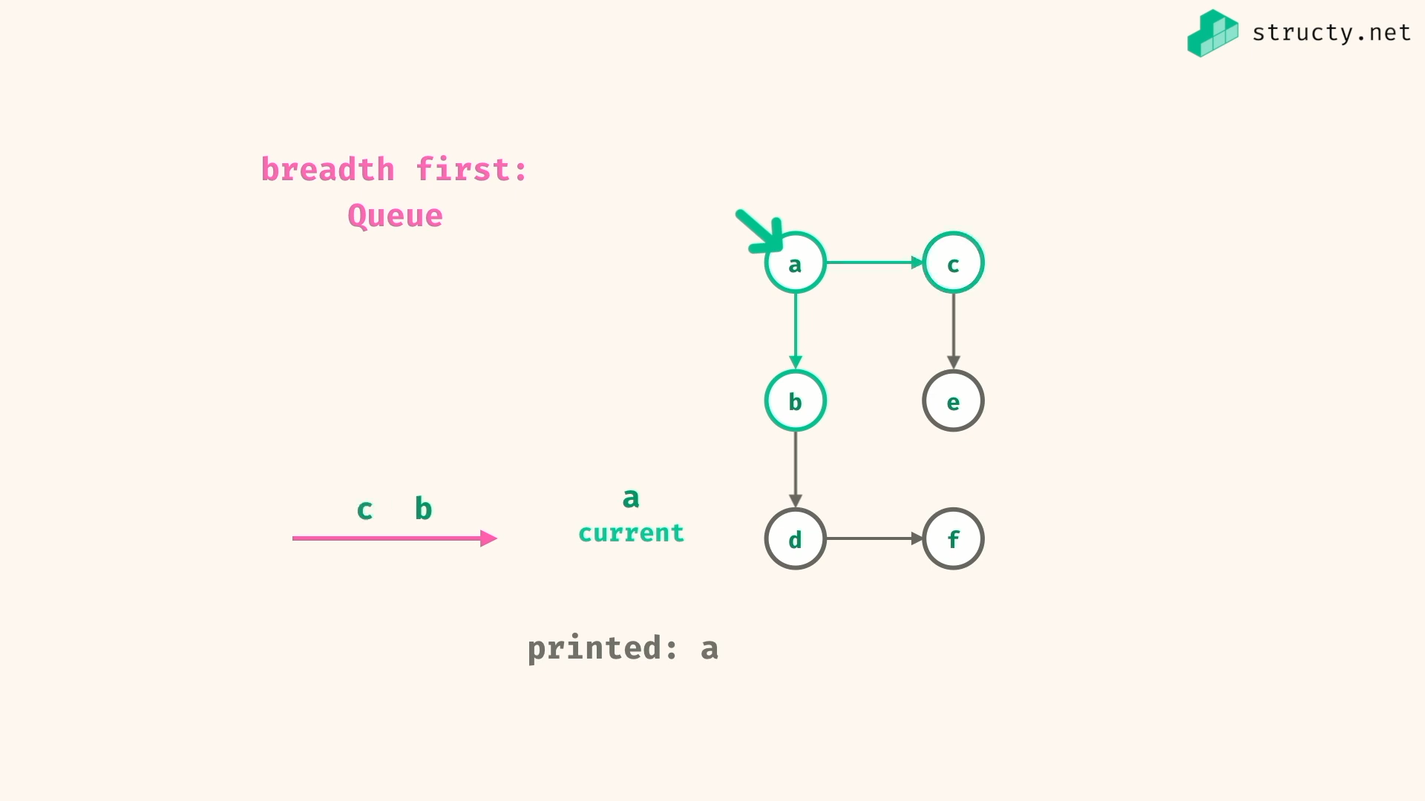

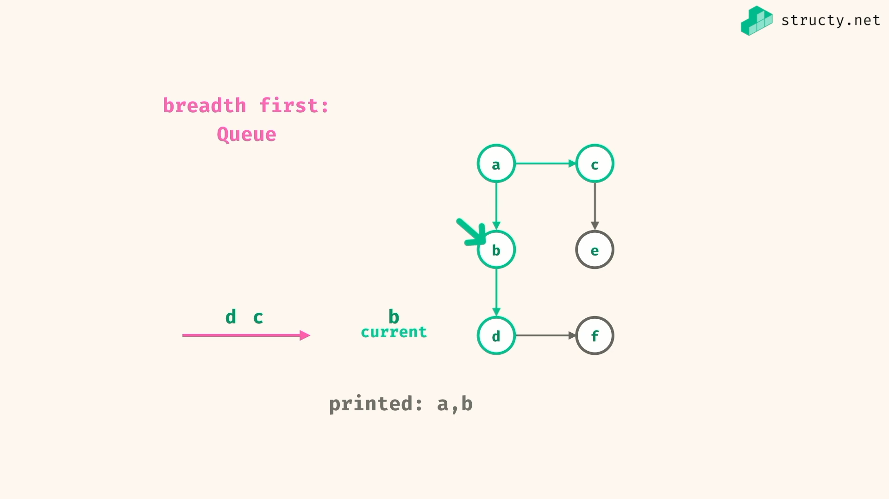

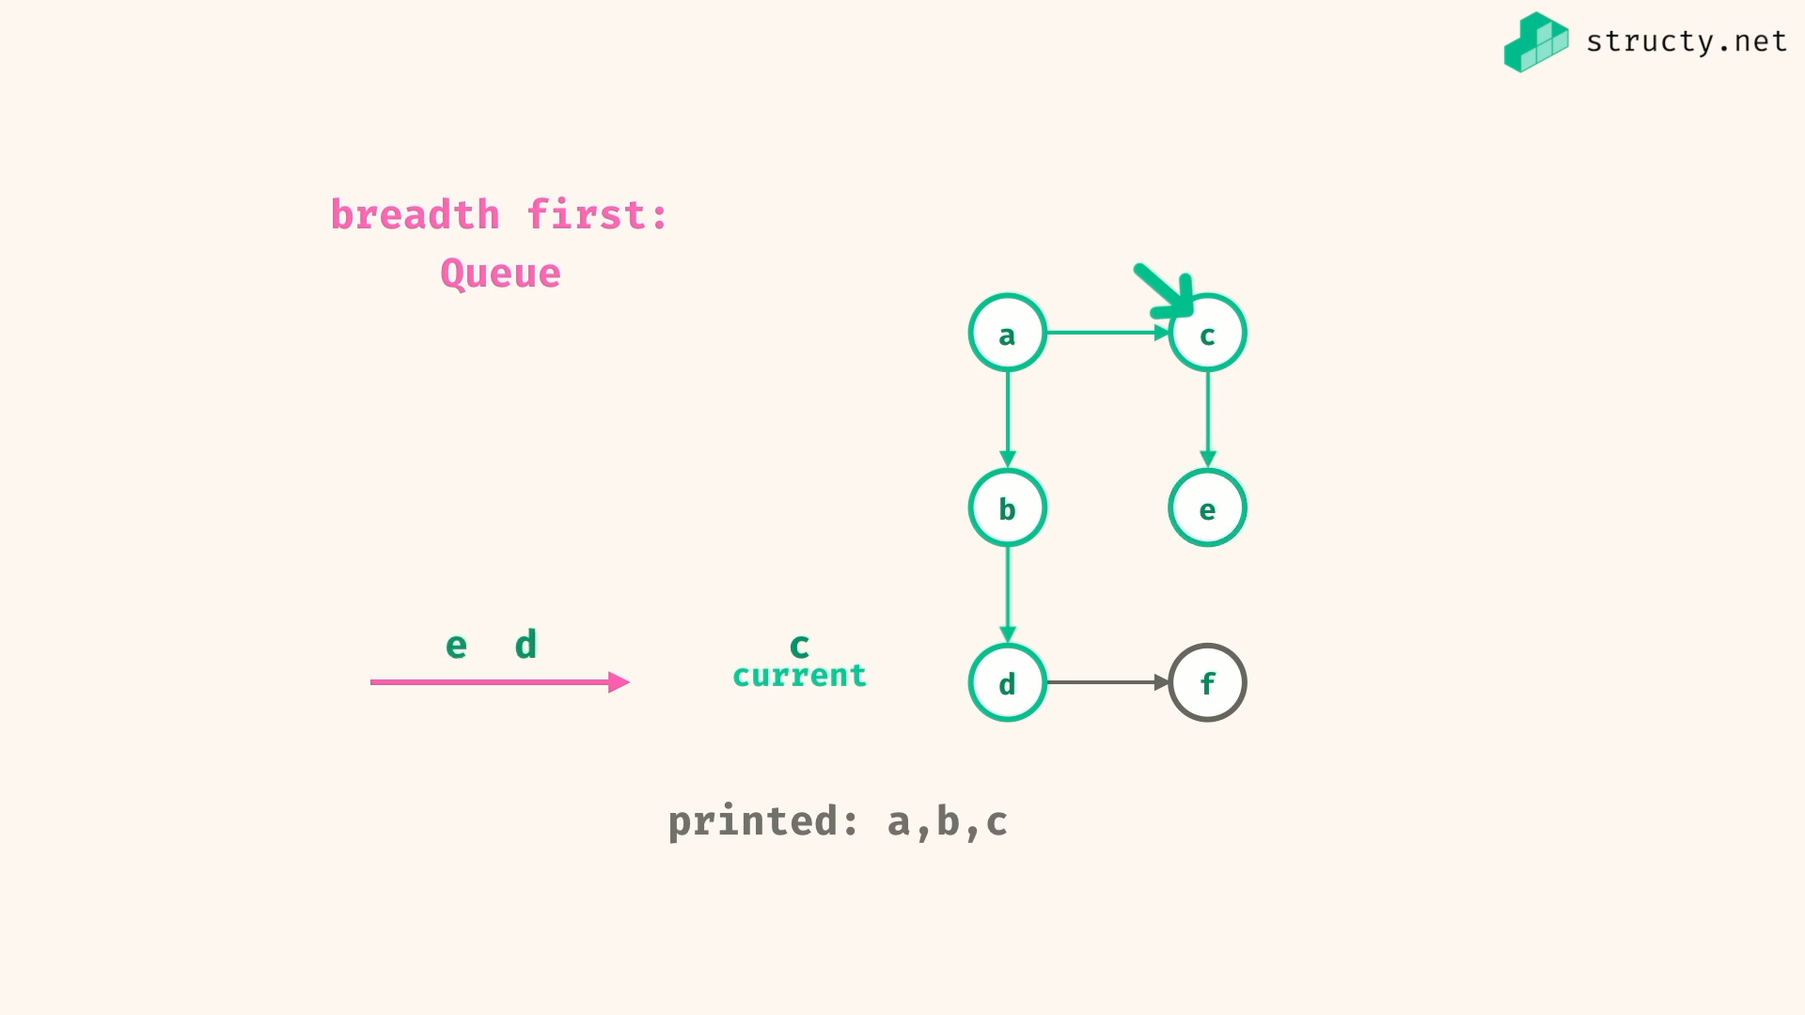

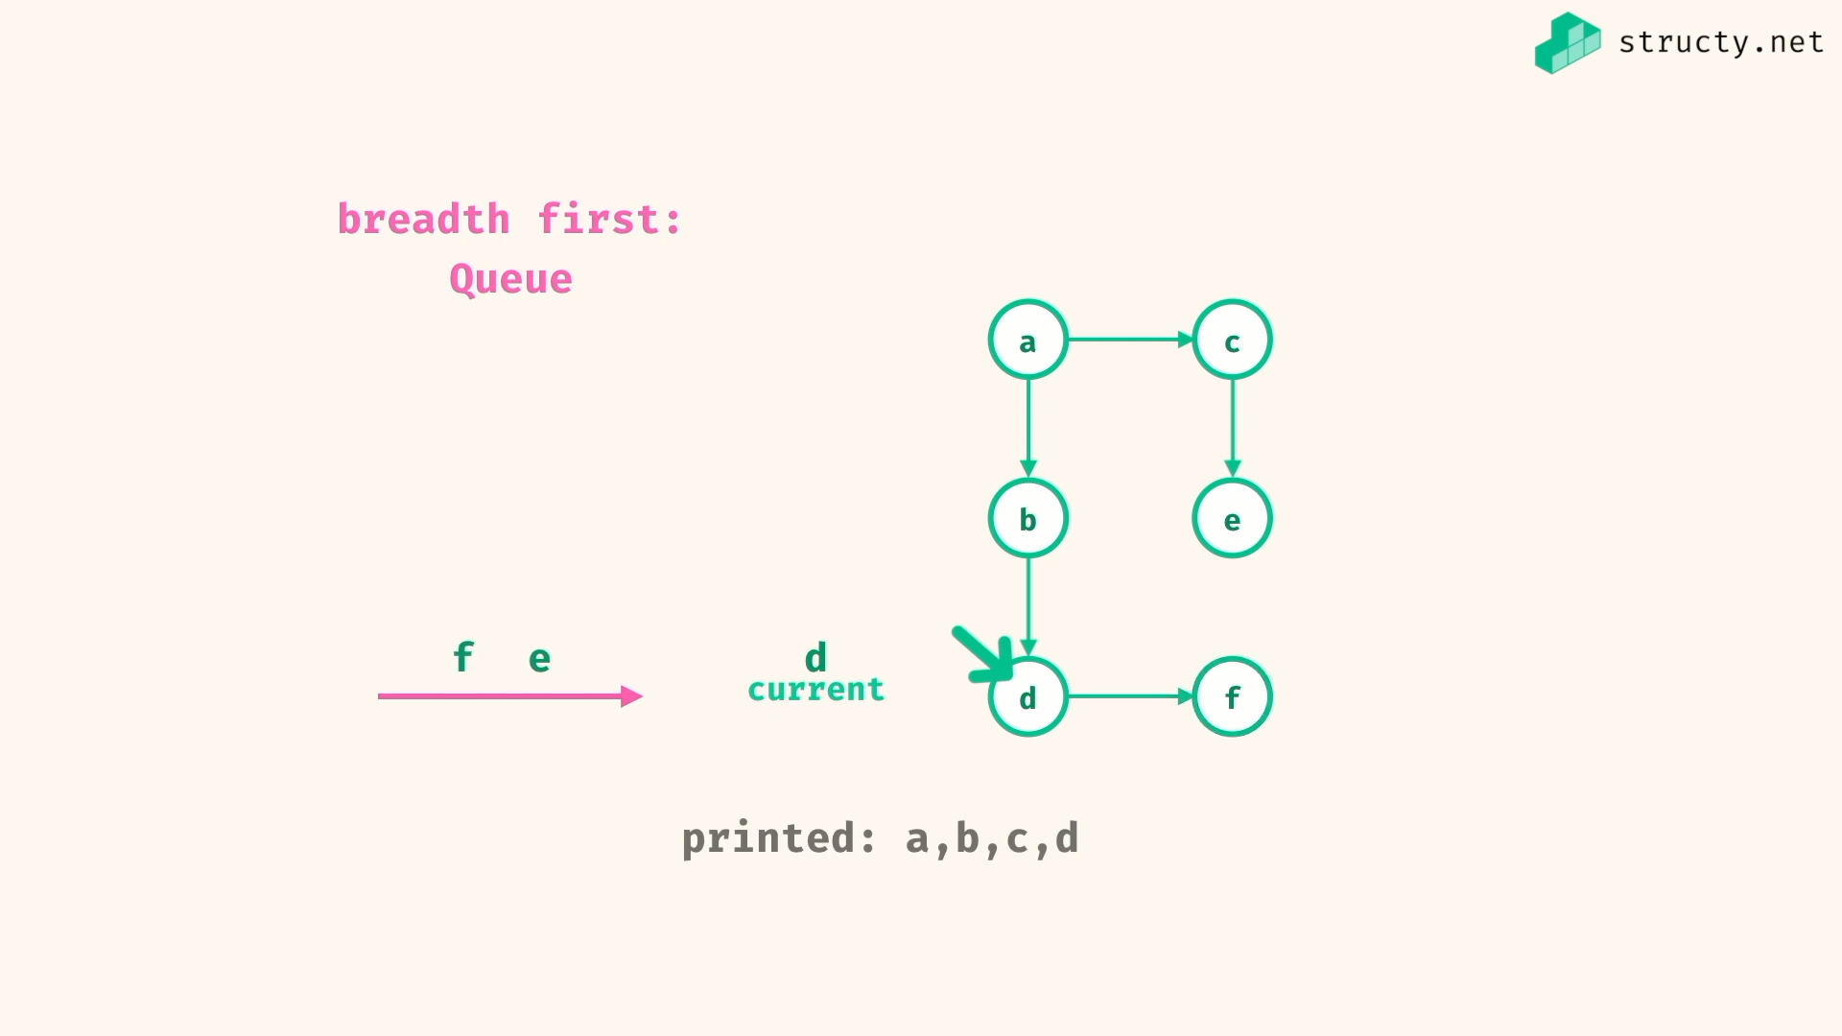

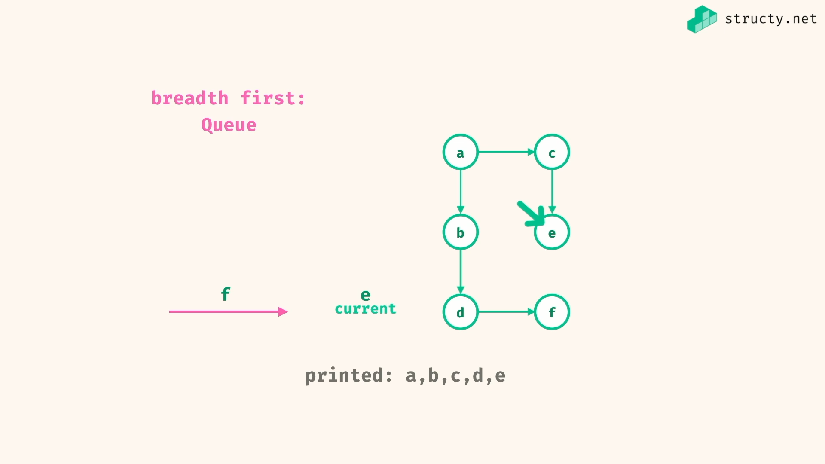

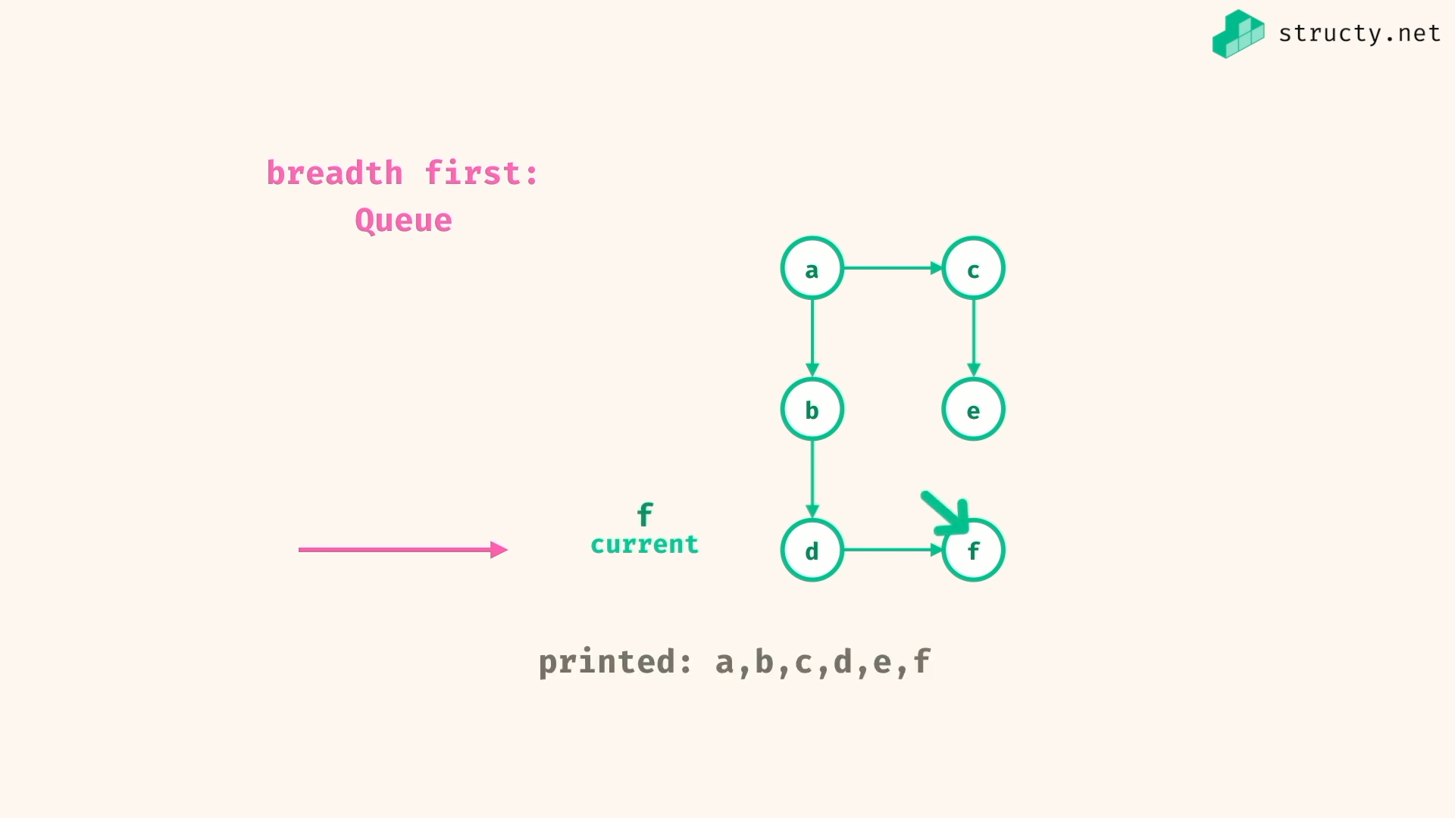

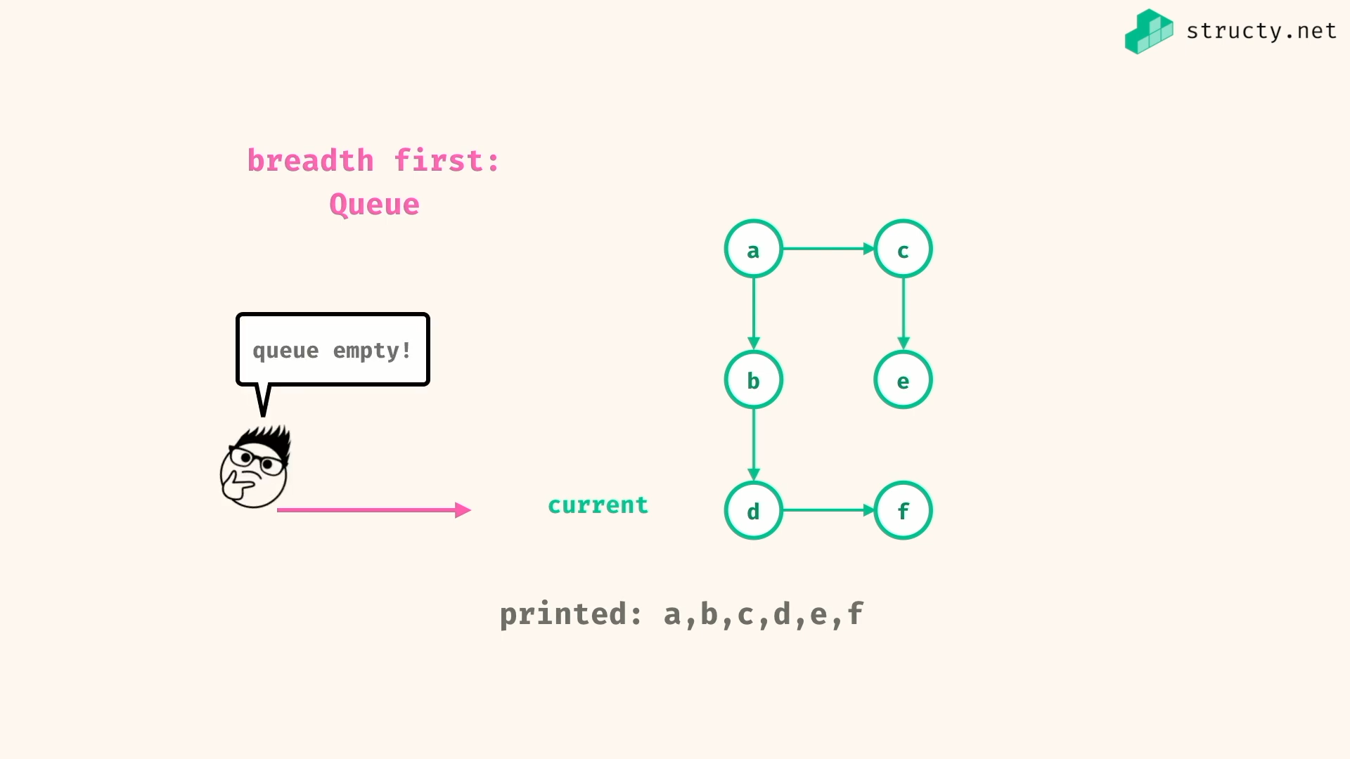

My try of DFS and BFS:

*const* dfs = (graph) *=>* {

*const* stack = []; //LIFO

*const* nodes = *Object*.*keys*(graph);

*const* ans = [];

if(!nodes.length) return stack;

stack.push(nodes[0]);

while(stack.length){

*const* current = stack[stack.length - 1];

if(ans.indexOf(current) === -1)

ans.push(current);

*let* goBack = *true*;

for (neighbour of graph[current]){

if([...stack,...ans].indexOf(neighbour) === -1){

stack.push(neighbour);

goBack = *false*;

break;

}

}

if(goBack)

stack.pop();

}

return ans;

}

*const* bfs = (graph) *=>* {

*const* queue = []; //FIFO

*const* nodes = *Object*.*keys*(graph);

*const* ans = [];

if(!nodes.length) return queue;

queue.push(nodes[0]);

while(queue.length){

*const* current = queue.shift();

ans.push(current);

for (neighbour of graph[current])

if([...queue,...ans].indexOf(neighbour) === -1)

queue.push(neighbour);

}

return ans;

}

*const* graph = {

a : ['b','c'],

b : ['d'],

c : ['e'],

d : ['f'],

e : [],

f : []

};

*console*.*log*(dfs(graph))

//=> [ 'a', 'b', 'd', 'f', 'c', 'e' ]

*console*.*log*(bfs(graph))

//=> [ 'a', 'b', 'c', 'd', 'e', 'f' ]

Simple DFS:

*const* depthFirstSearchIter = (*graph*,*source*) *=>* {

*const* stack = [source];

while(stack.length > 0){

*const* current = stack.pop();

*console*.log(current);

for(*let* neighbour of graph[current]){

stack.push(neighbour);

}

}

}

*const* depthFirstSearchRecur = (*graph*,*source*) *=>* {

*console*.log(source);

for(*let* neighbour of graph[source]){ // base case handled here itself

depthFirstSearchRecur(graph,neighbour)

}

}

*const* graph = {

a:['b','c'],

b:['d'],

c:['e'],

d:['f'],

e:[],

f:[]

}

// since iteration, taking last neighbour first

depthFirstSearchIter(graph,'a');

//=> a c e b d f

// since recursion, taking first neighbour first

depthFirstSearchRecur(graph,'a')

//=> a b d f c e

Simple BFS:

For BFS, recursion solution is not recommended, since recursion uses stack.. so we need more code to handle that stack to work like queue…

*const* breadthFirstSearch = (*graph*,*source*) *=>* {

*const* stack = [source];

while(stack.length > 0){

*const* current = stack.shift();

*console*.log(current);

for(*let* neighbour of graph[current]){

stack.push(neighbour);

}

}

}

*const* graph = {

a:['b','c'],

b:['d'],

c:['e'],

d:['f'],

e:[],

f:[]

}

breadthFirstSearch(graph,'a');

//=> a b c d e f

Problems:

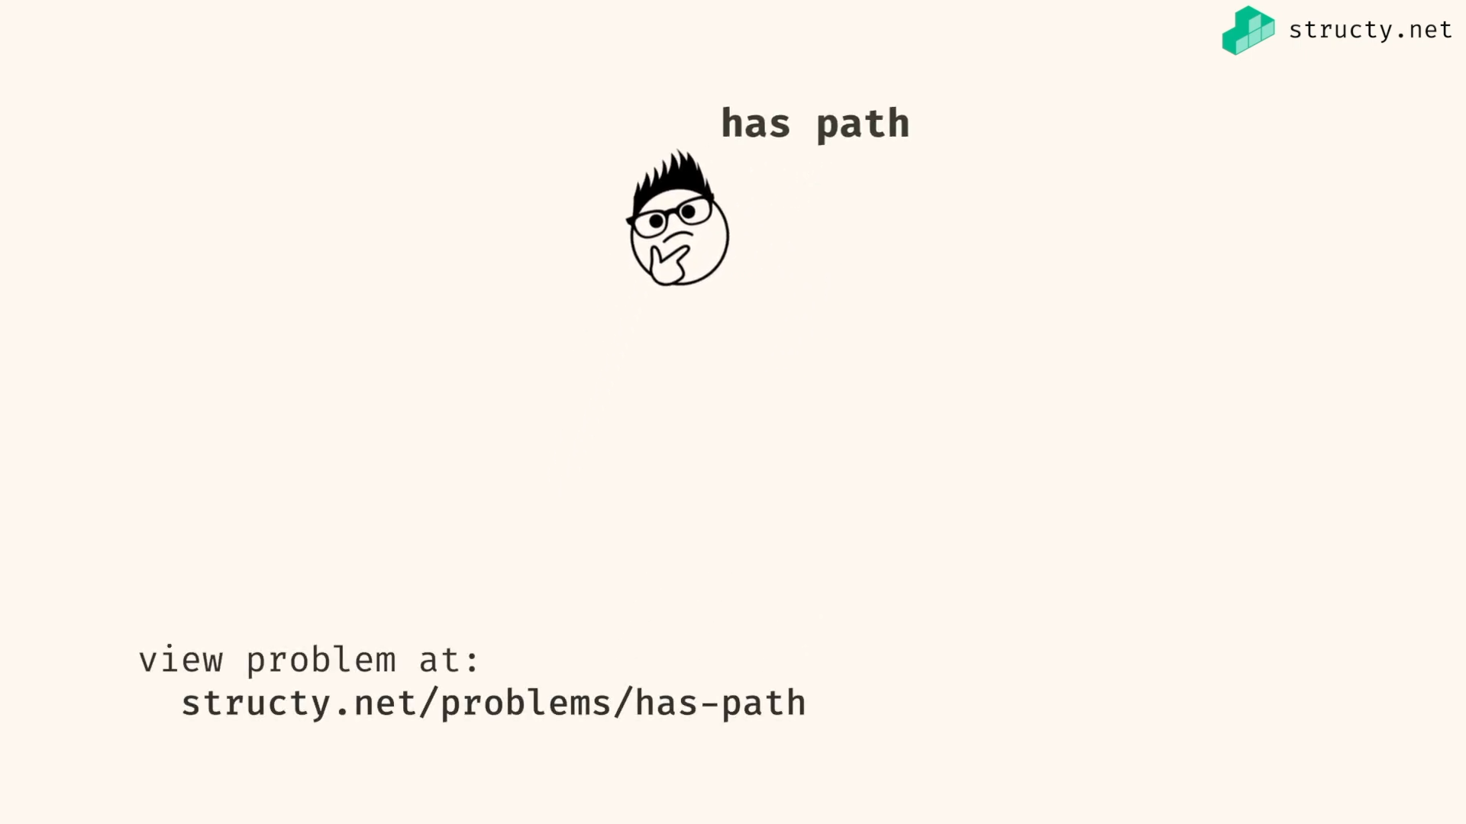

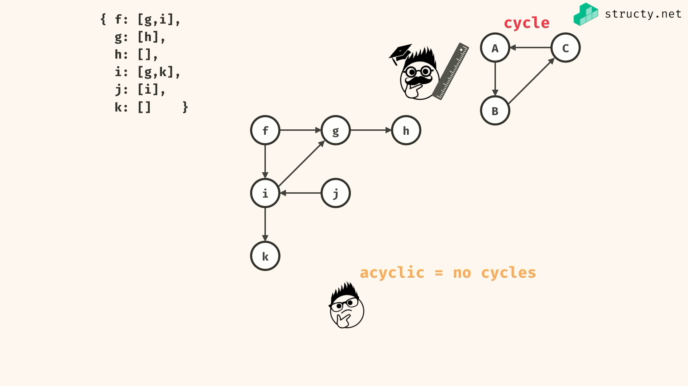

Our input is directed and acyclic…

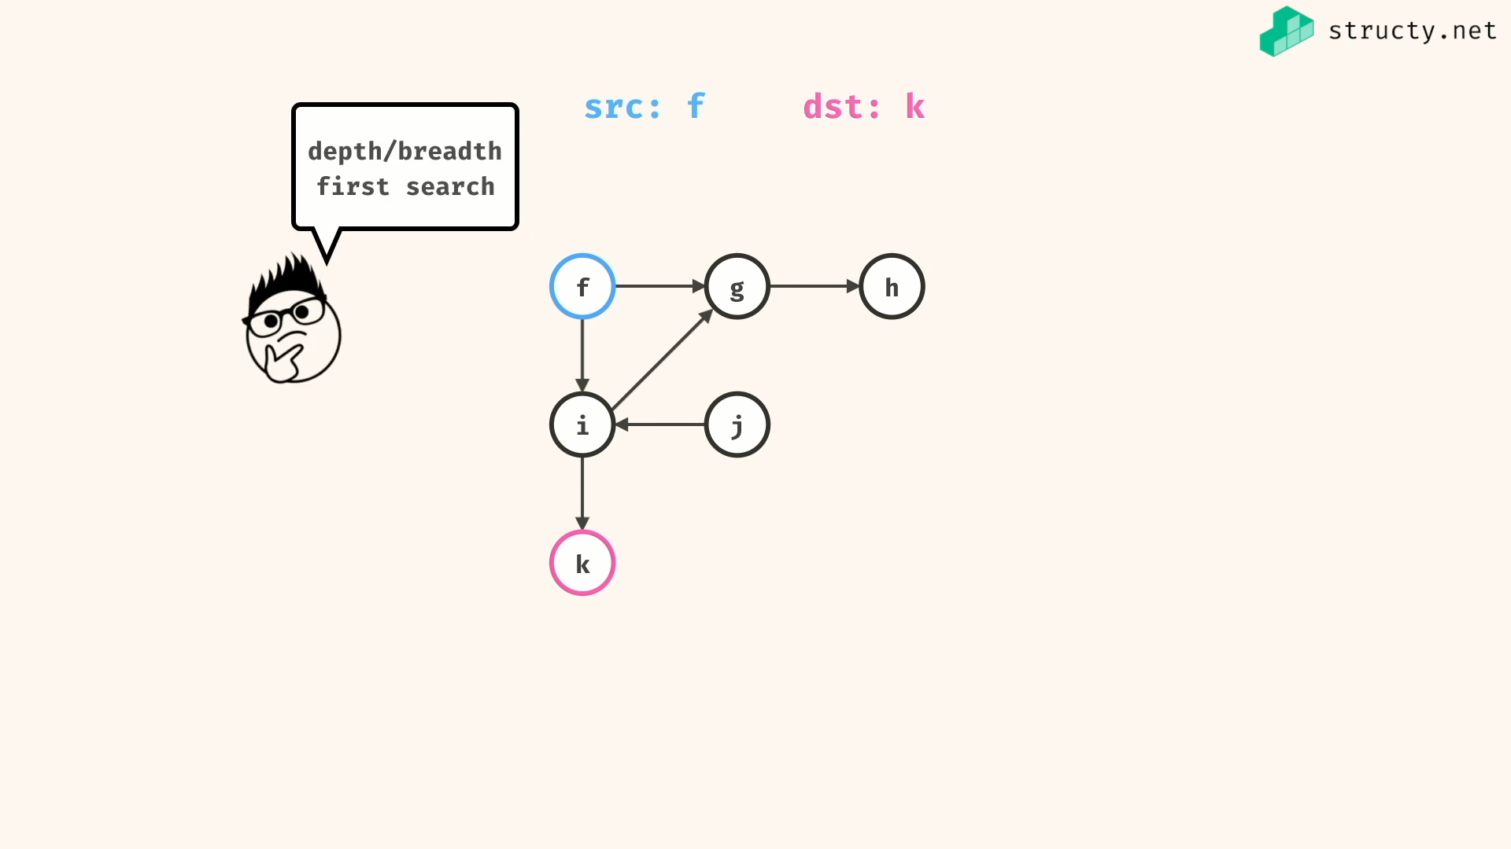

We can use both dept and breath first search for this problem…

DFS for this problem:

HasPath -> true

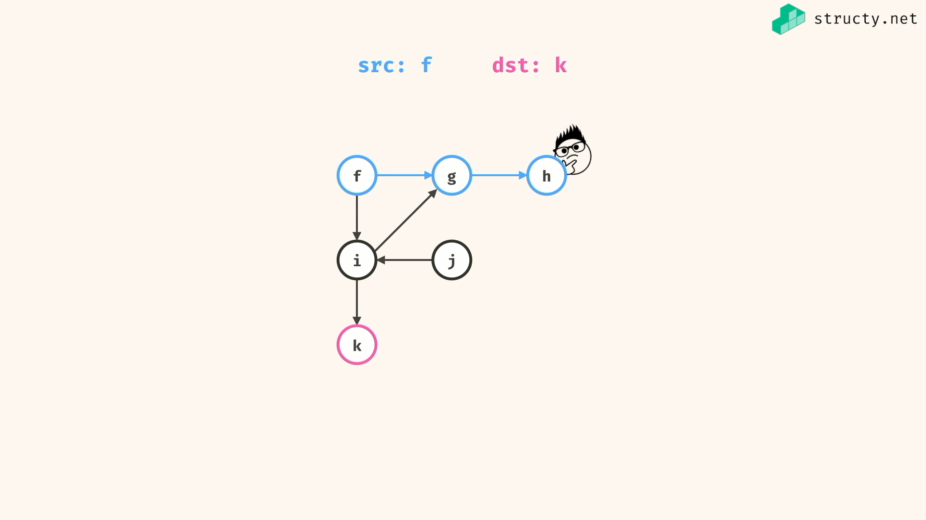

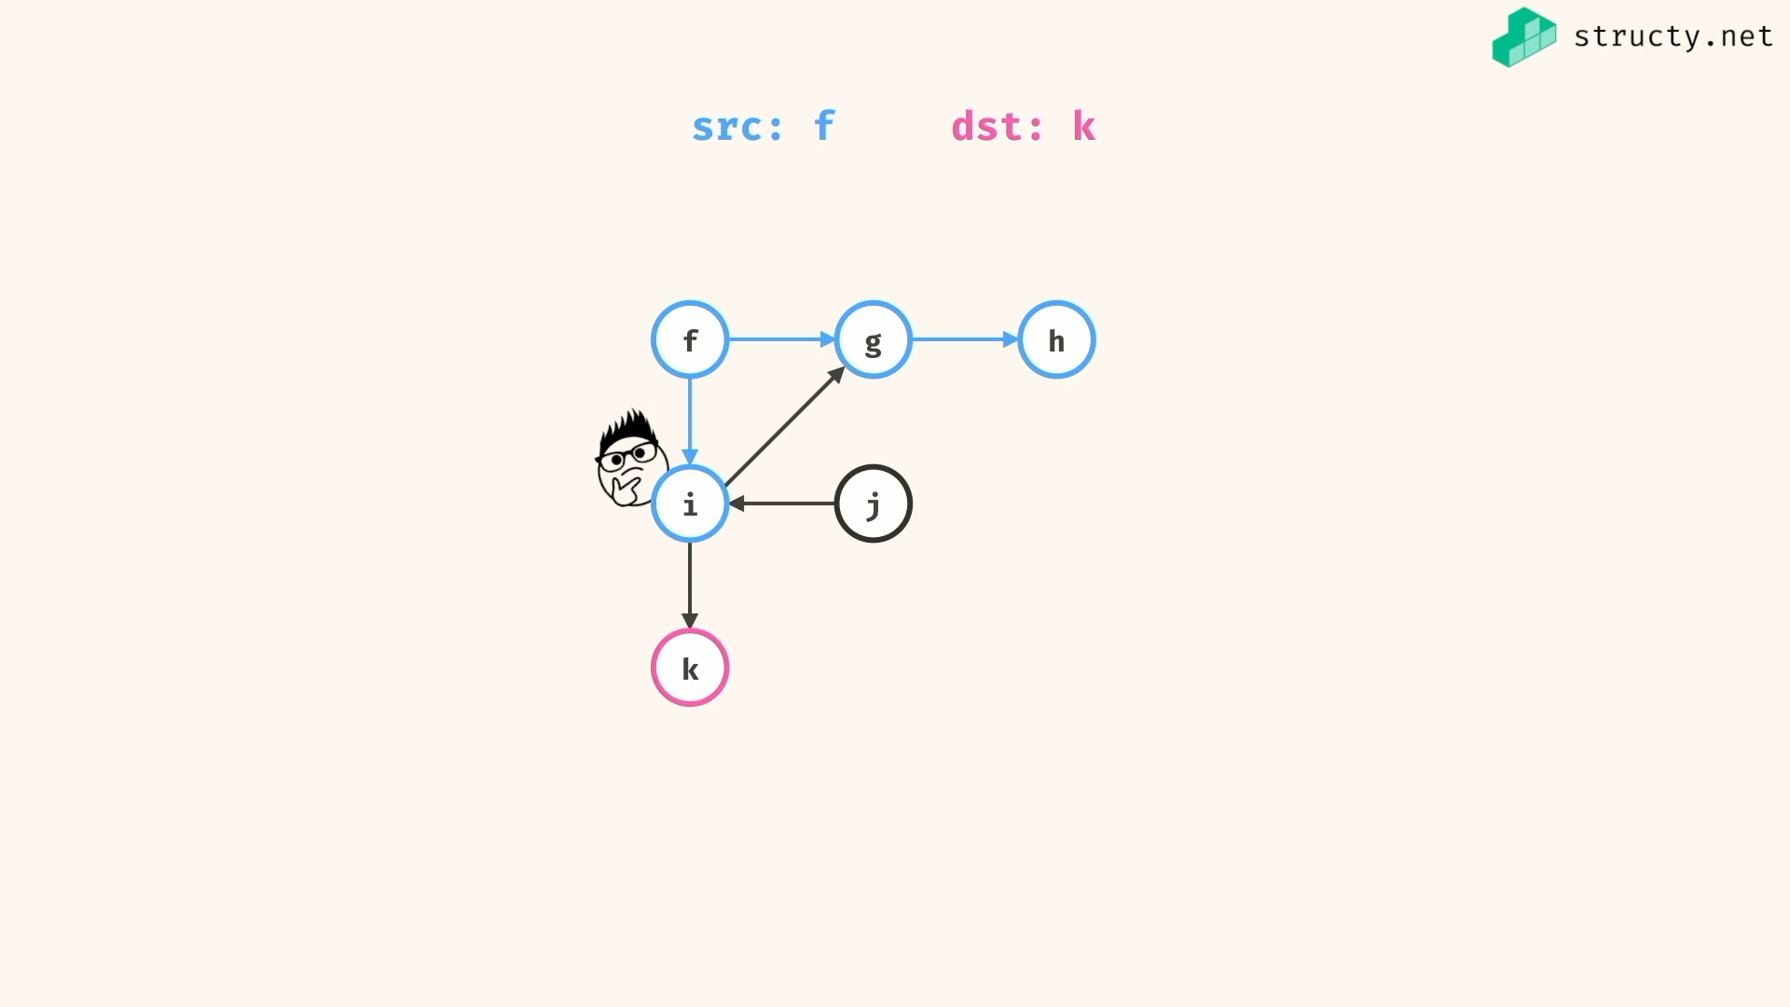

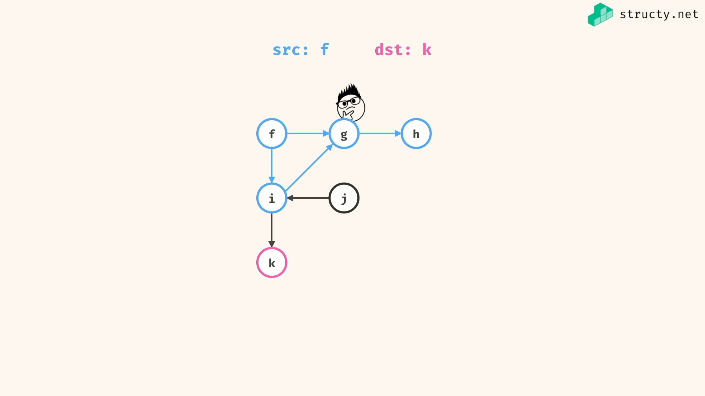

Revisiting same node is happening here, which will be optimized later…

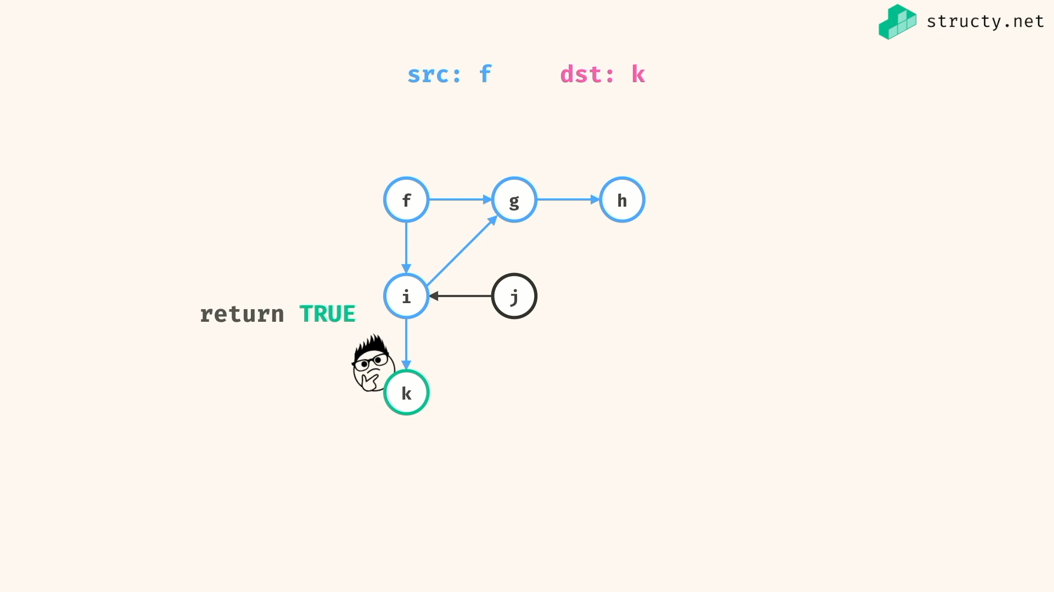

HasPath -> false

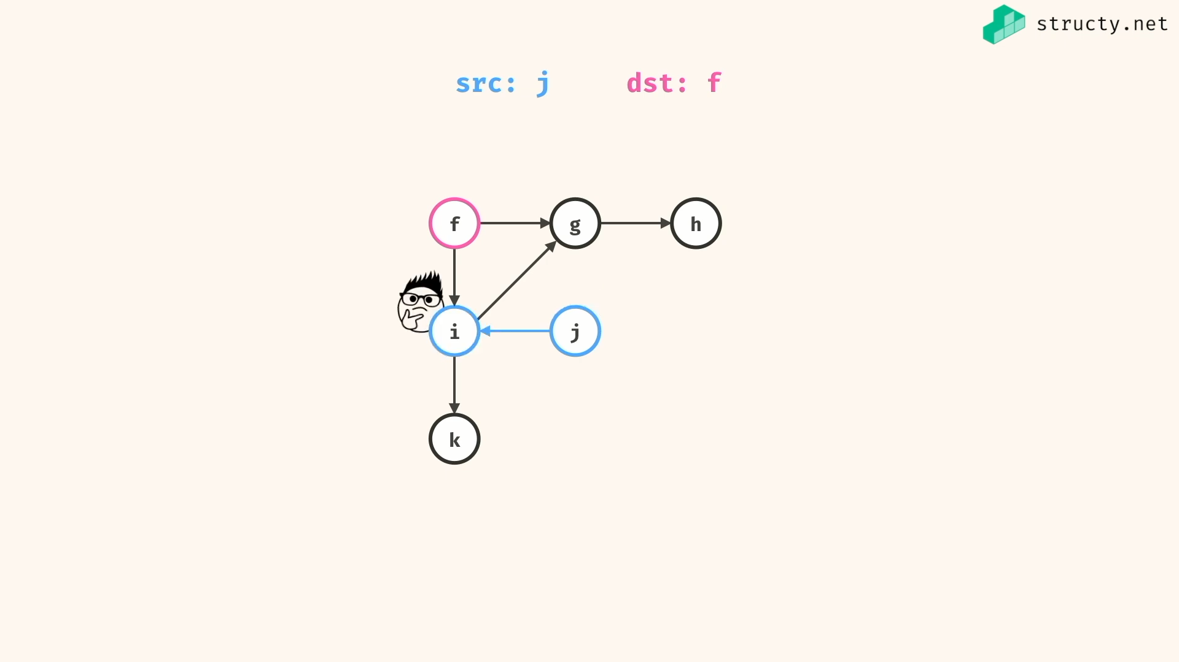

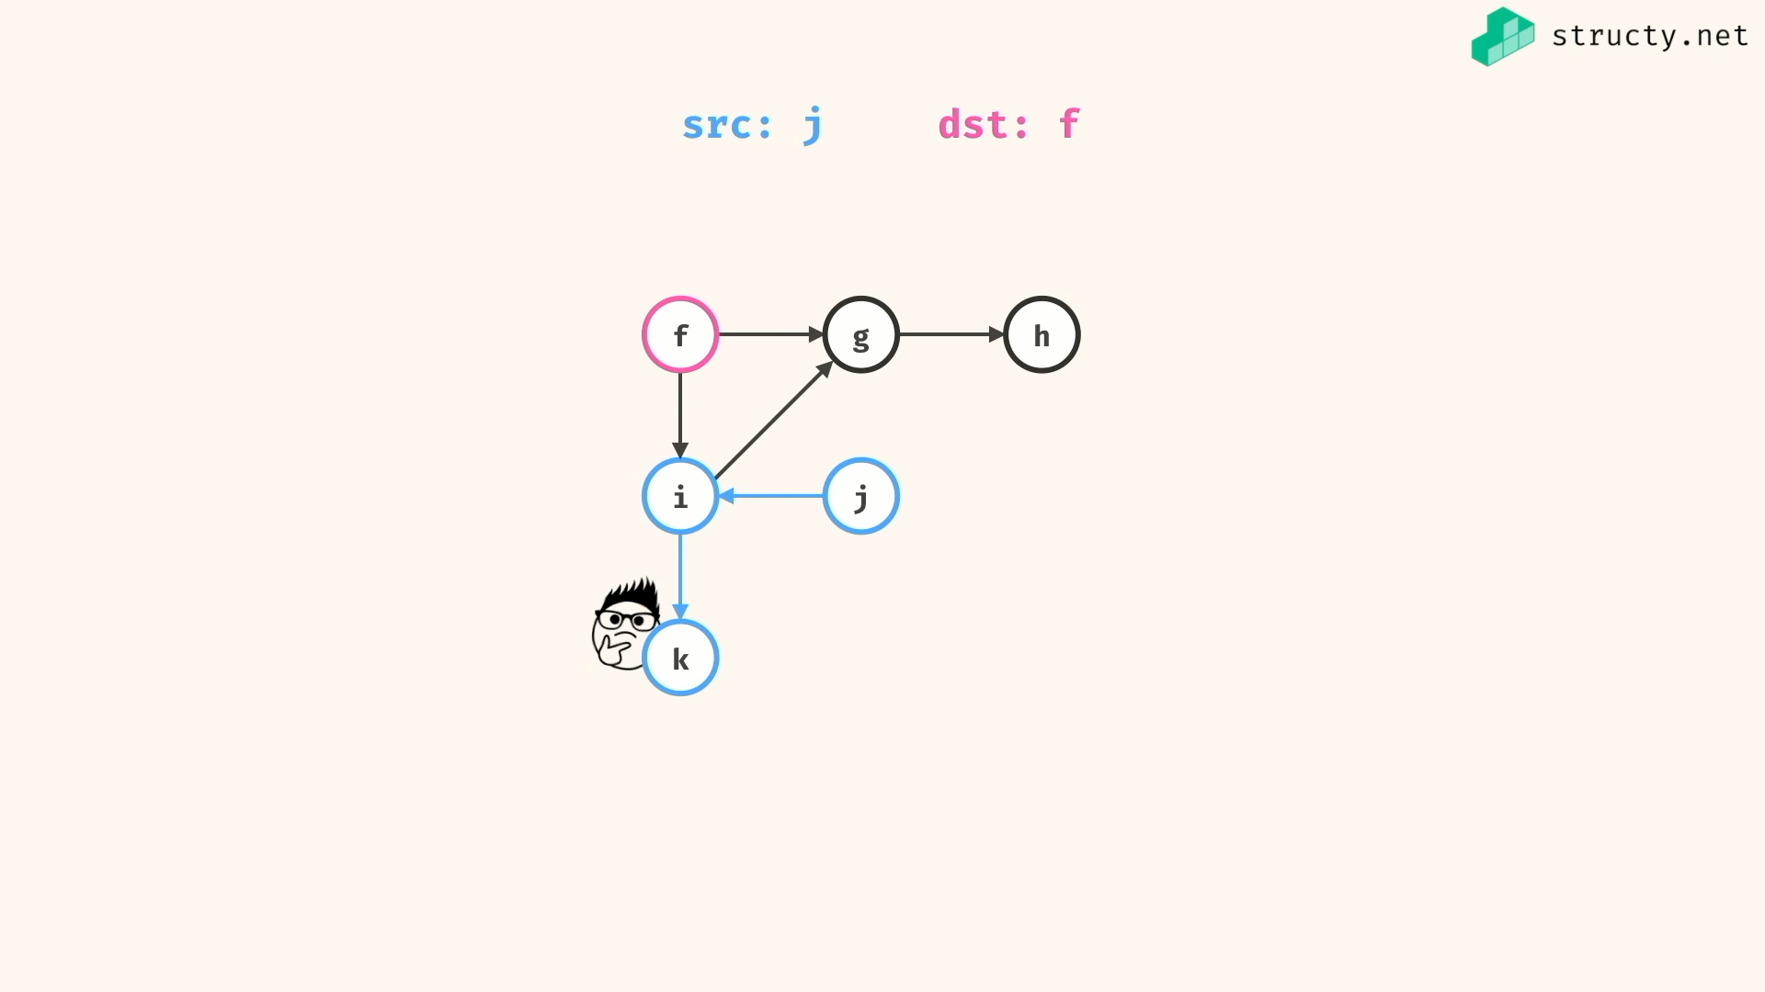

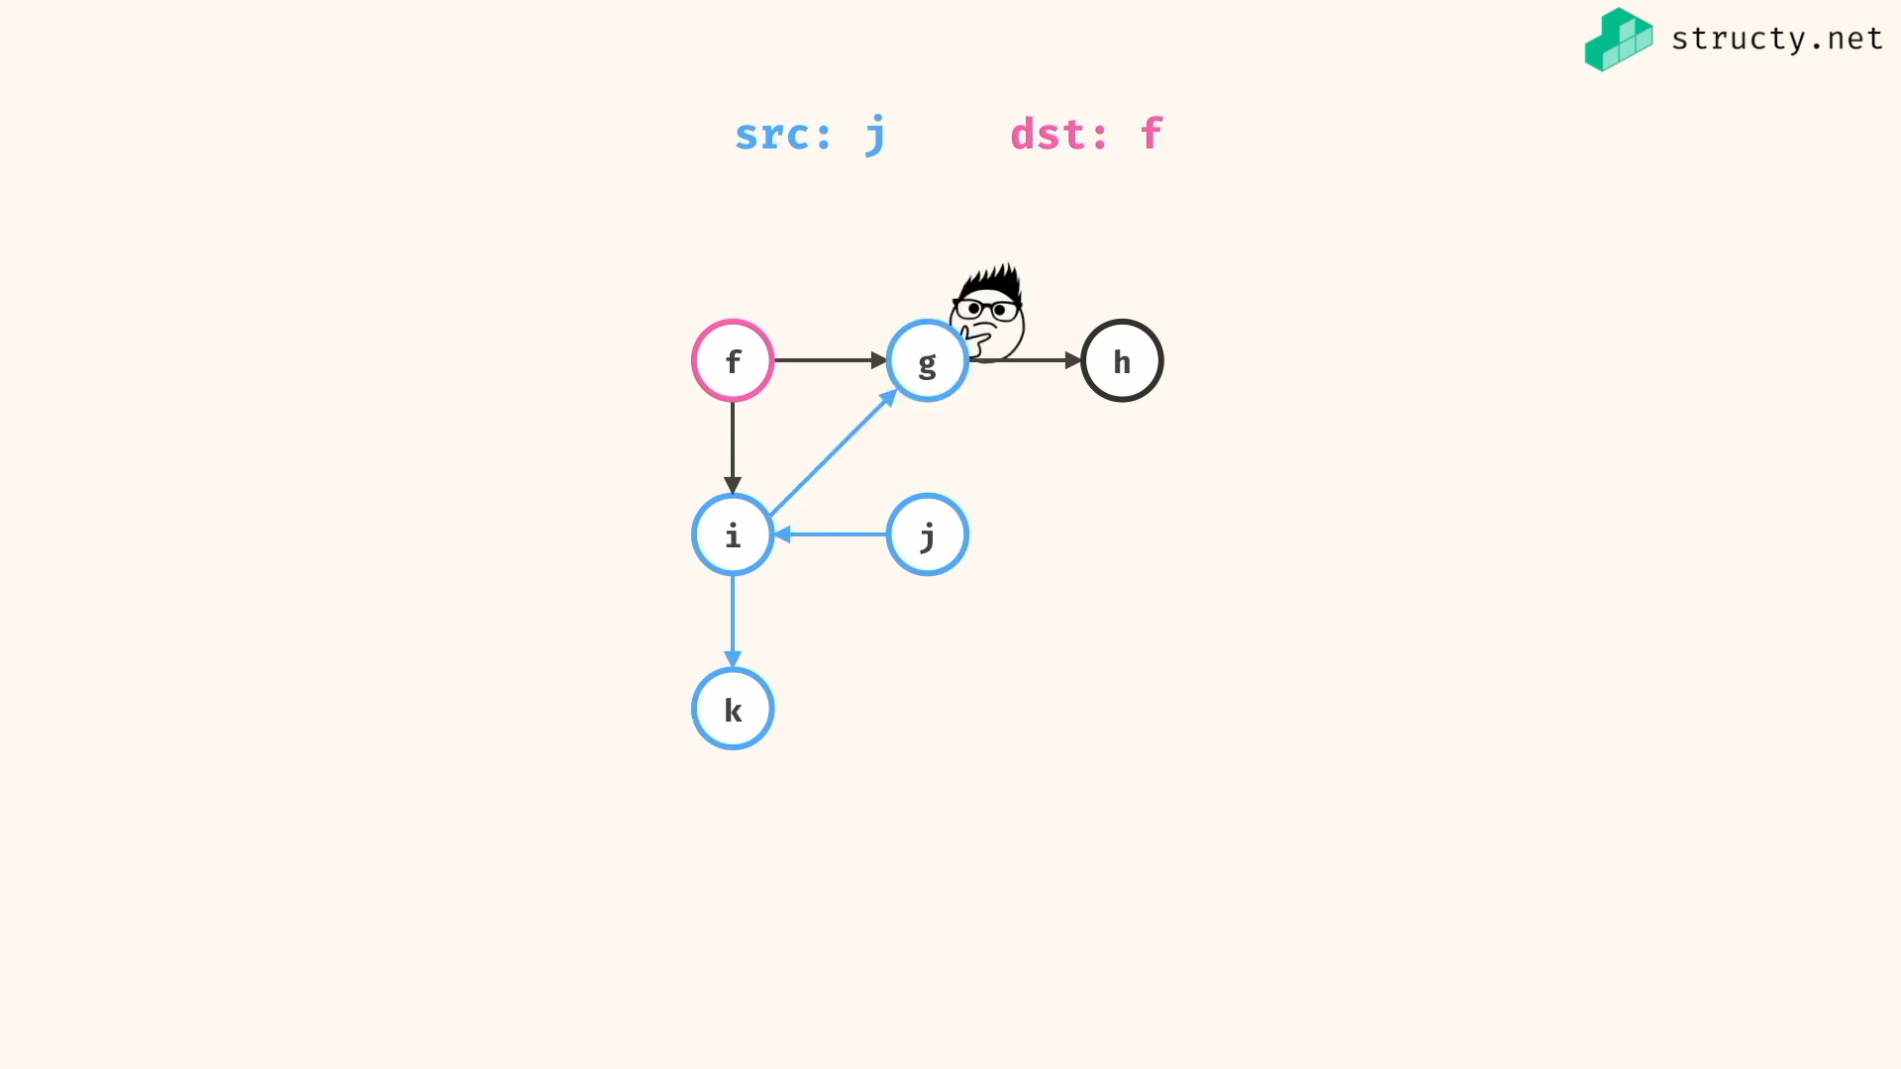

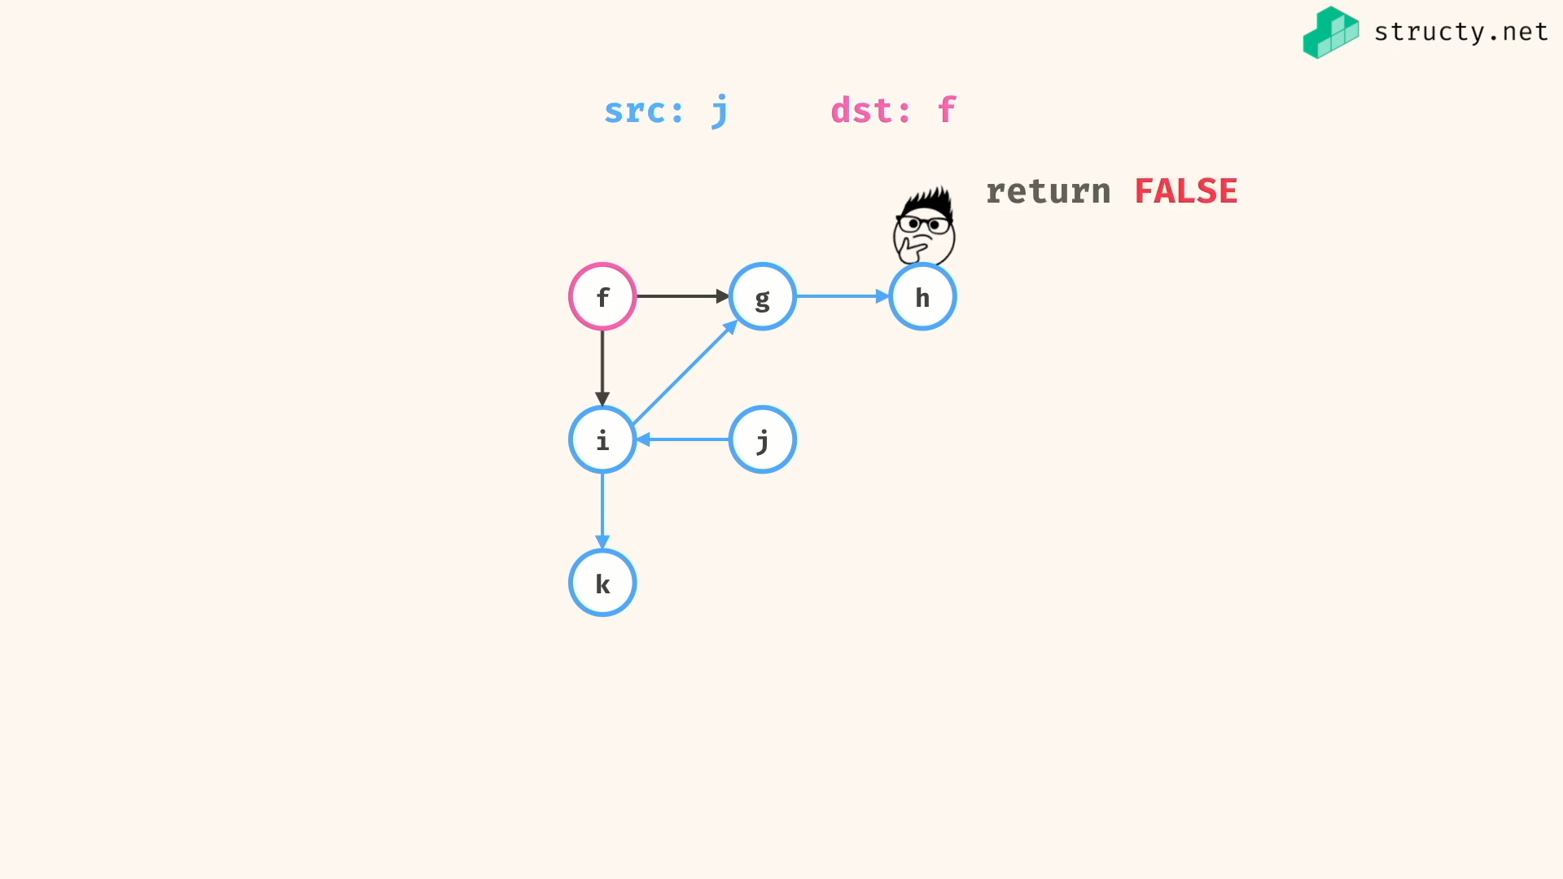

Analysing complexity :

Method 1:

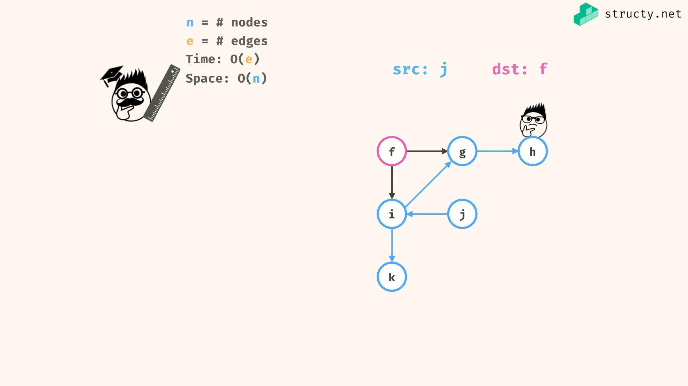

Method 2:

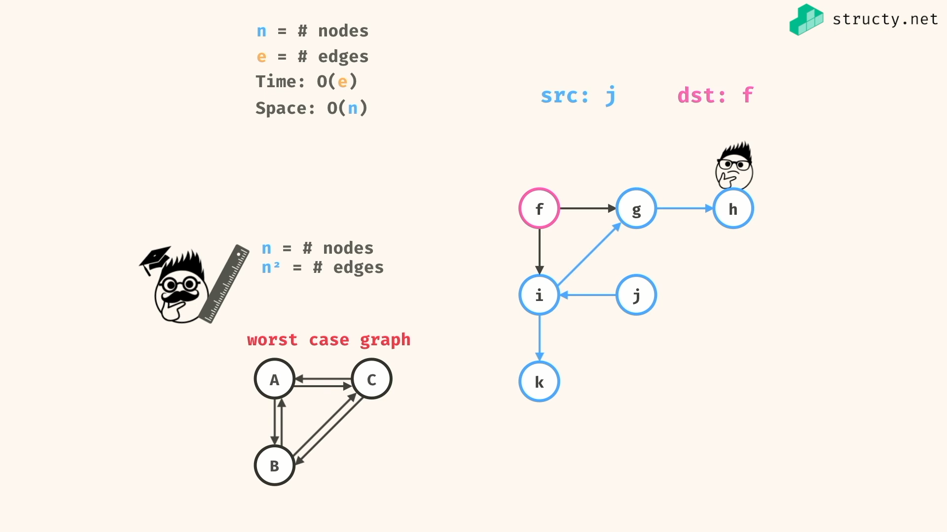

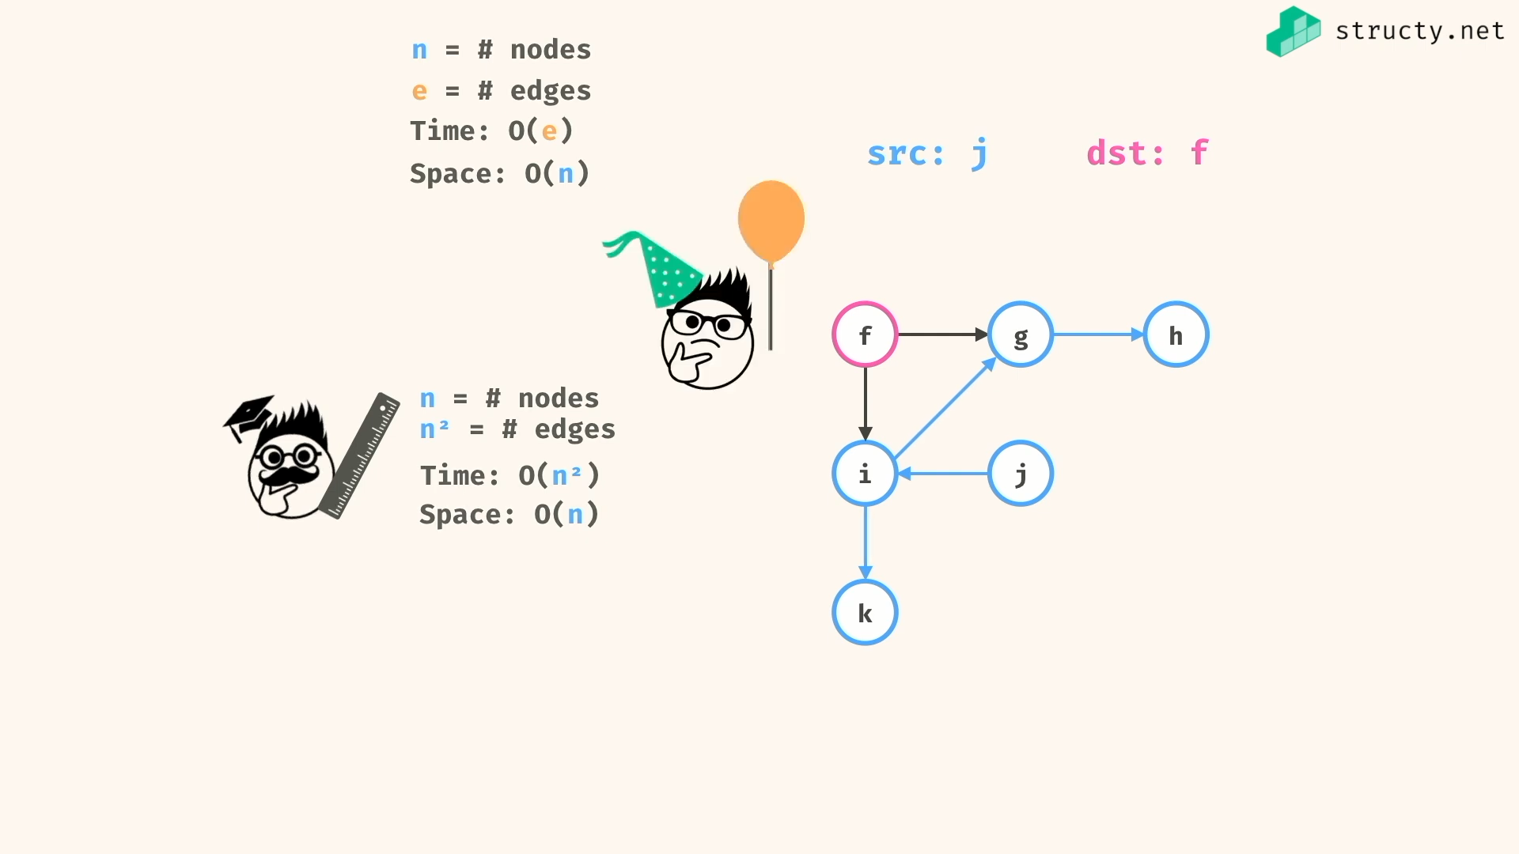

Solving the hasPath problem:

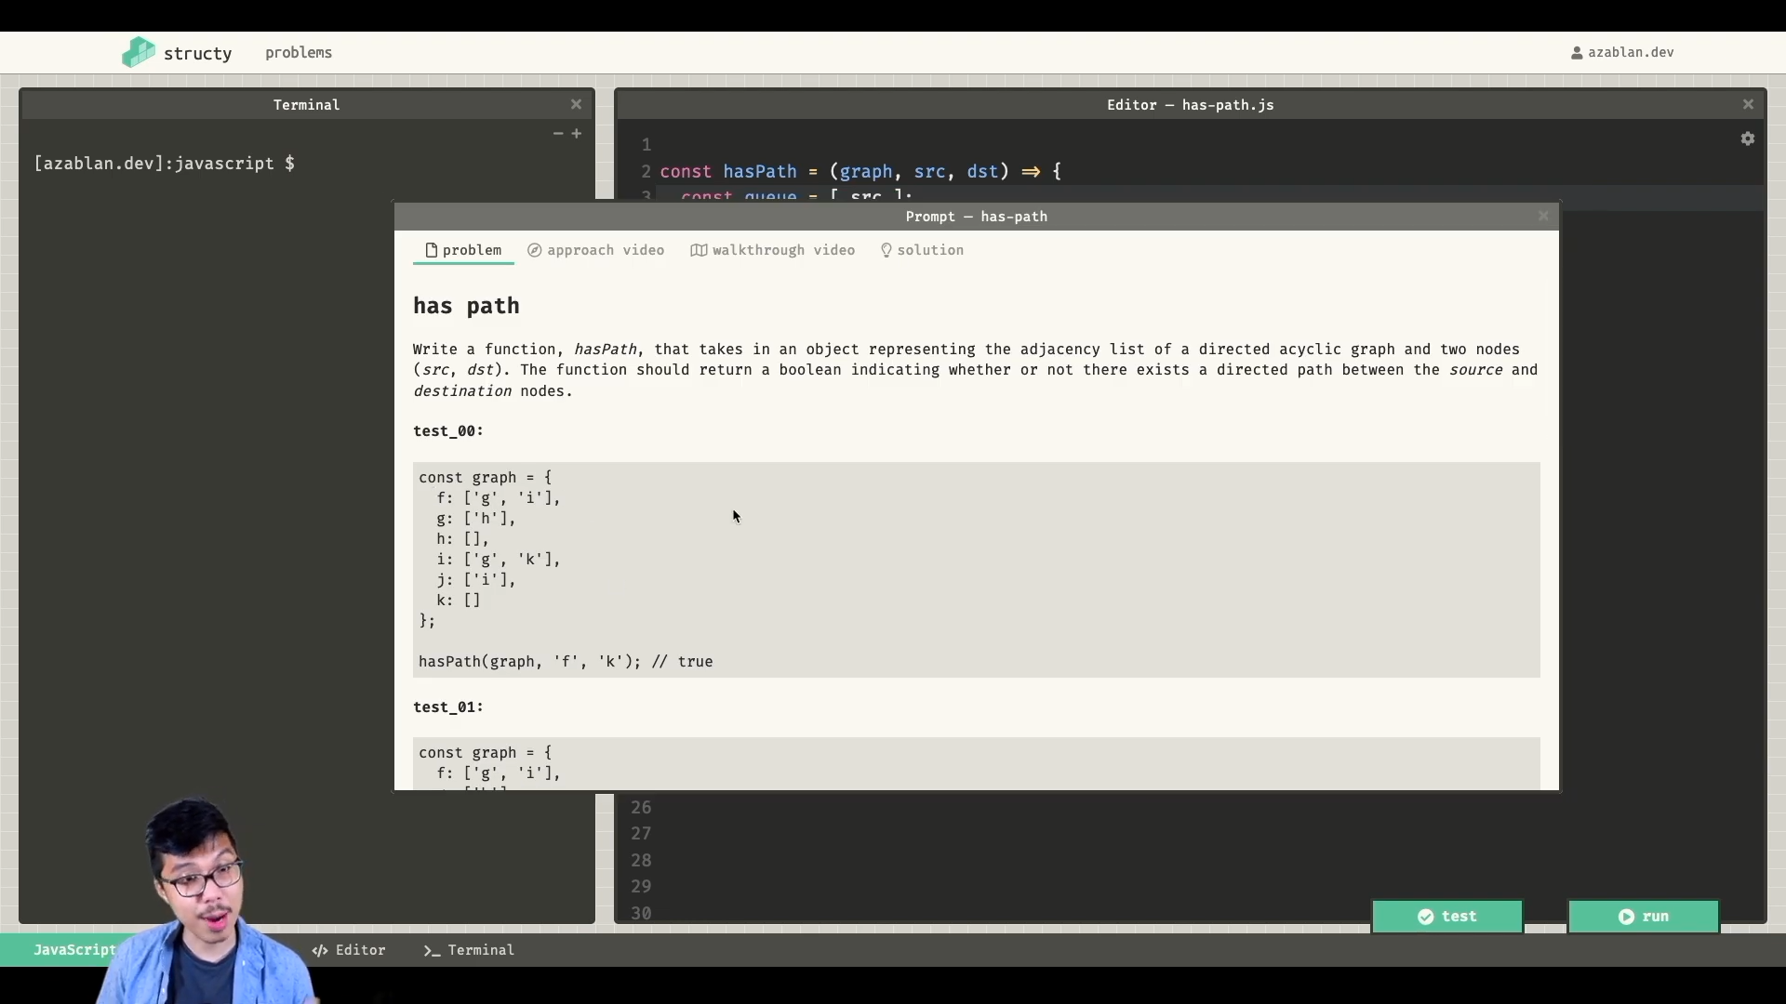

Solutions:

*const* hasPathDfs = (*graph*,*src*,*dst*) *=>*{

if(src === dst)

return true;

for (*let* neighbour of graph[src])

if(hasPathDfs(graph,neighbour,dst))

return true

return false;

}

*const* hasPathBfs = (*graph*,*src*,*dst*) *=>*{

*const* queue = [ src ];

while(queue.length){

*const* current = queue.shift();

if(current === dst)

return true

queue.push(...graph[current]);

}

return false;

}

graph = {

f:['g','i'],

g:['h'],

h:[],

i:['g','k'],

j:['i'],

k:[]

}

*console*.log(hasPathDfs(graph,'f','k')) //=> true

*console*.log(hasPathDfs(graph,'j','f')) //=> false

*console*.log(hasPathBfs(graph,'f','k')) //=> true

*console*.log(hasPathBfs(graph,'j','f')) //=> false

{

I think DFS will be more effective that BFS for this problem…., but not sure…

}



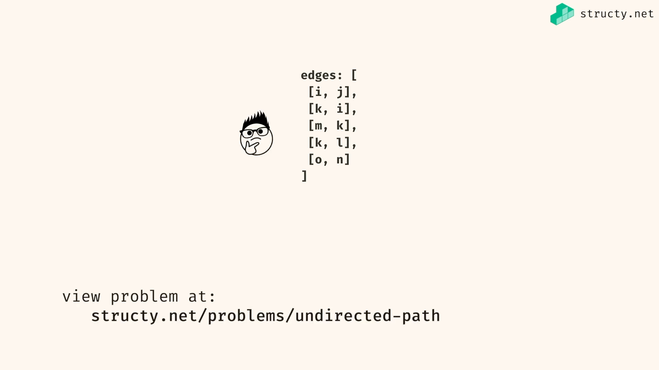

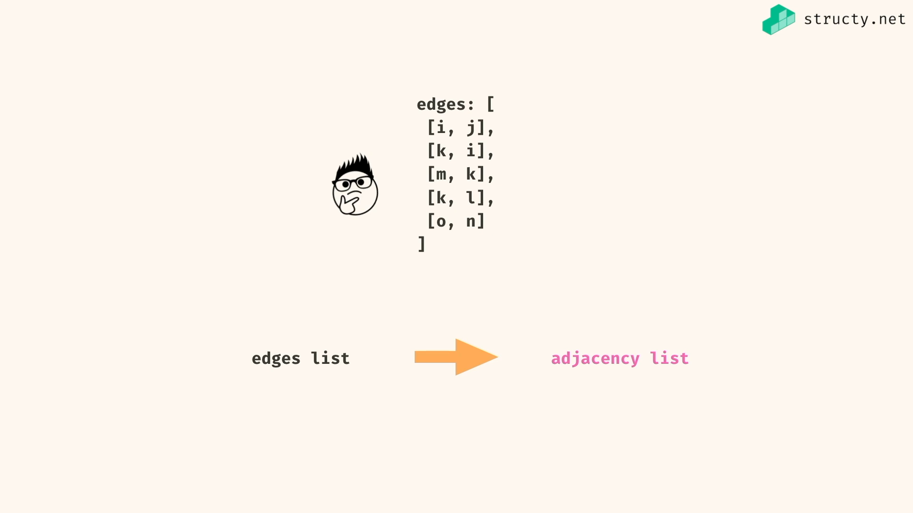

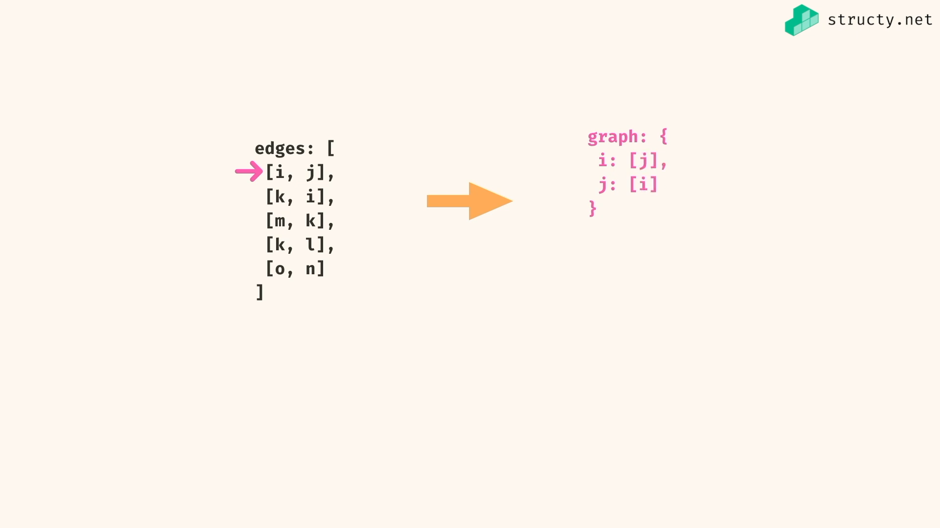

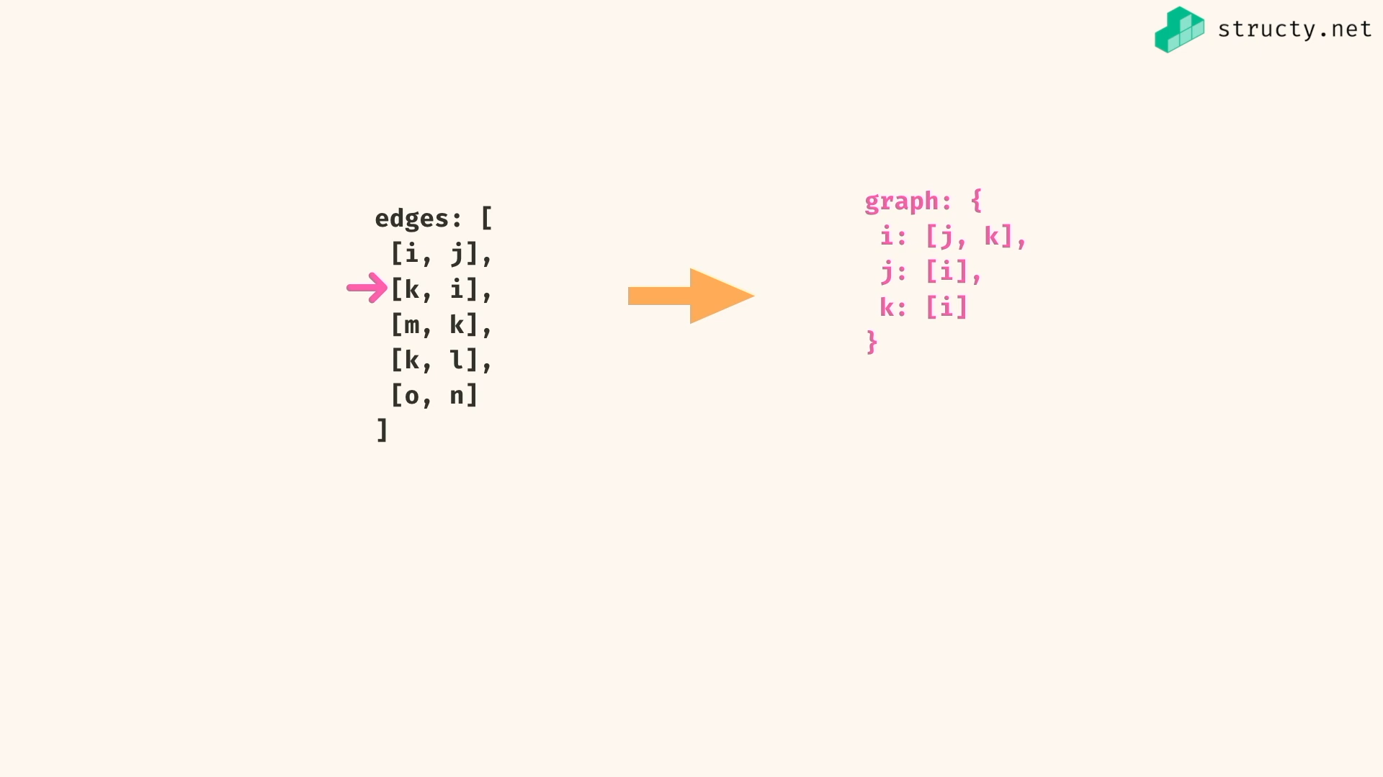

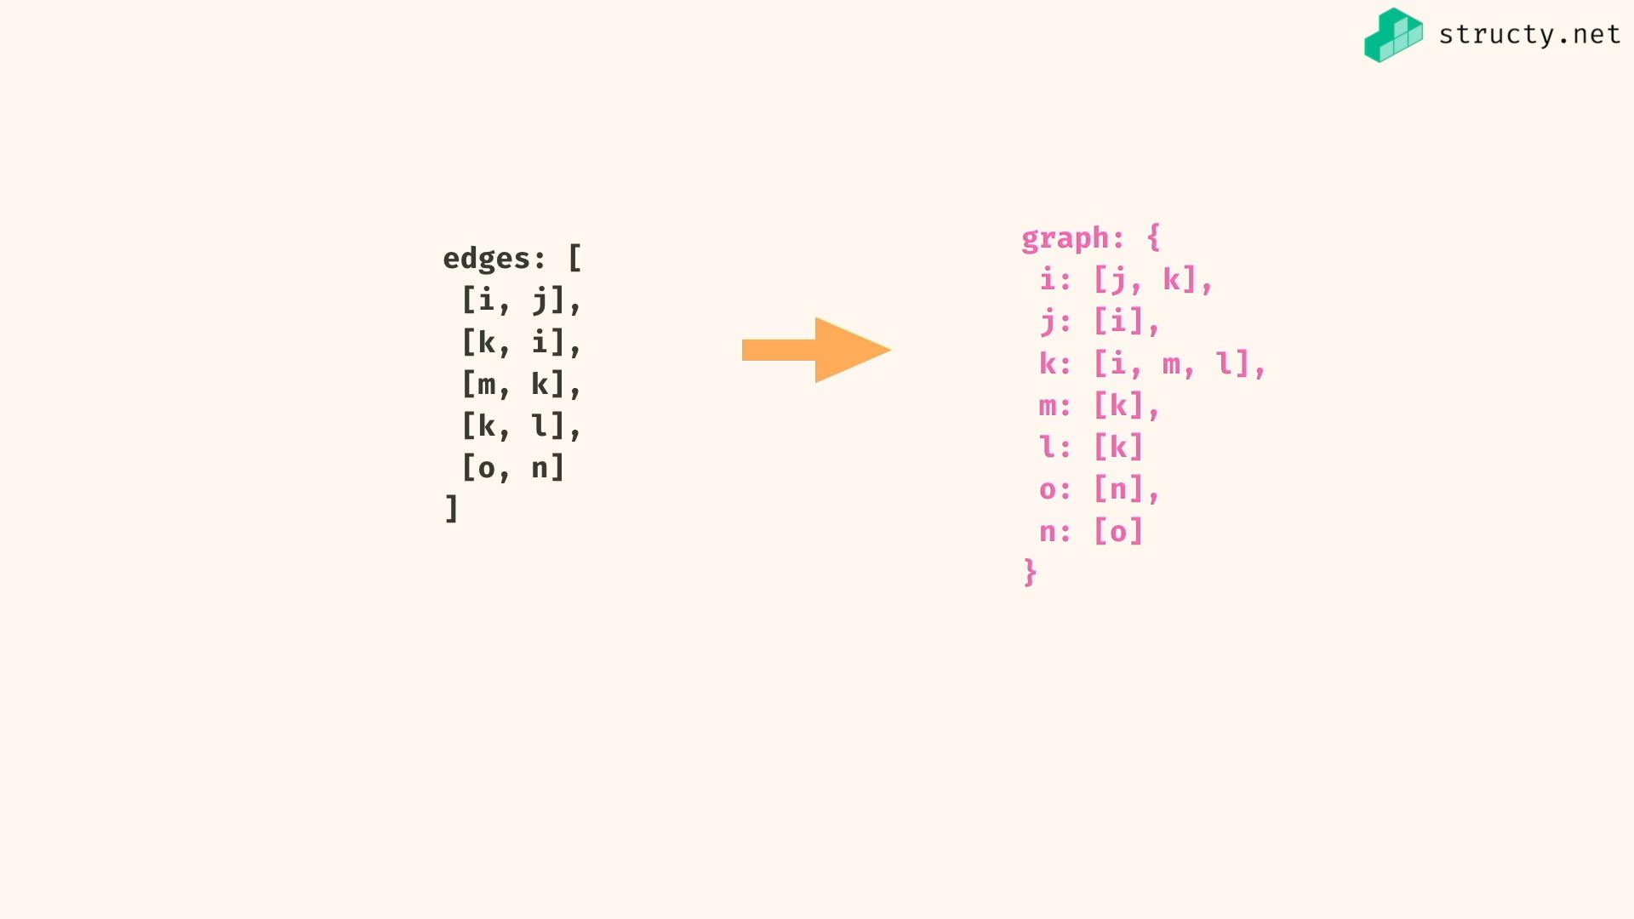

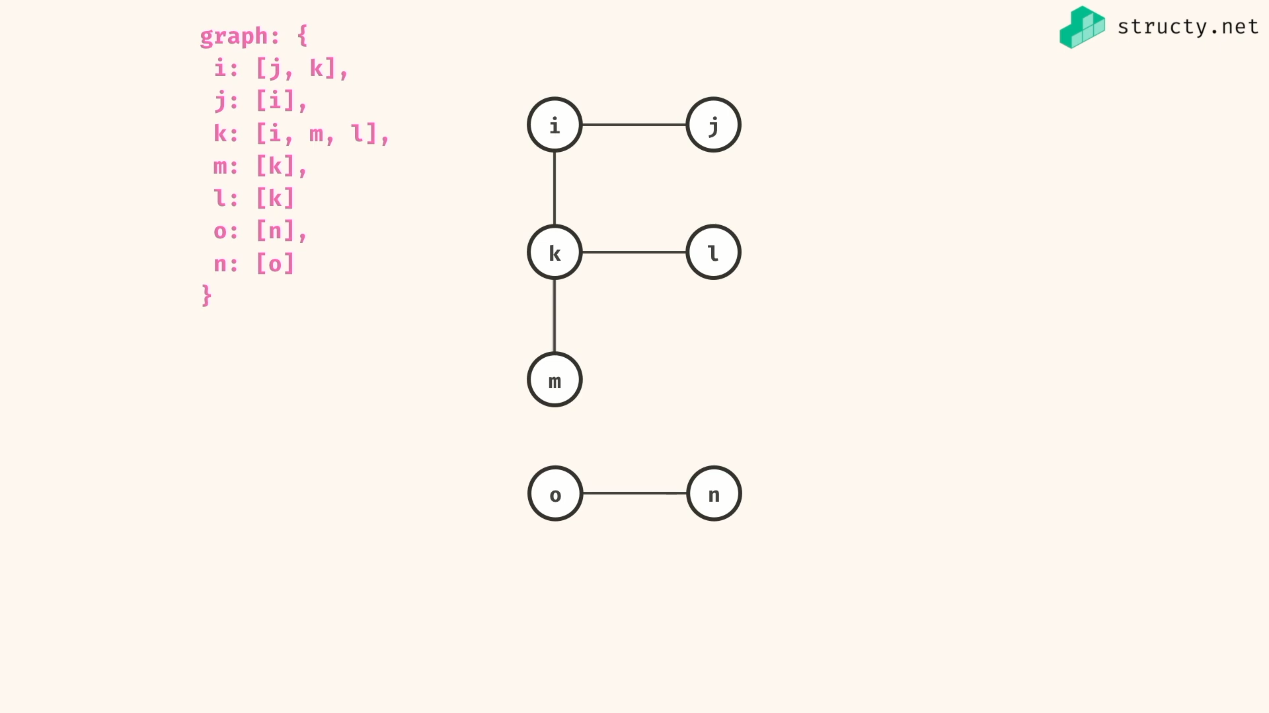

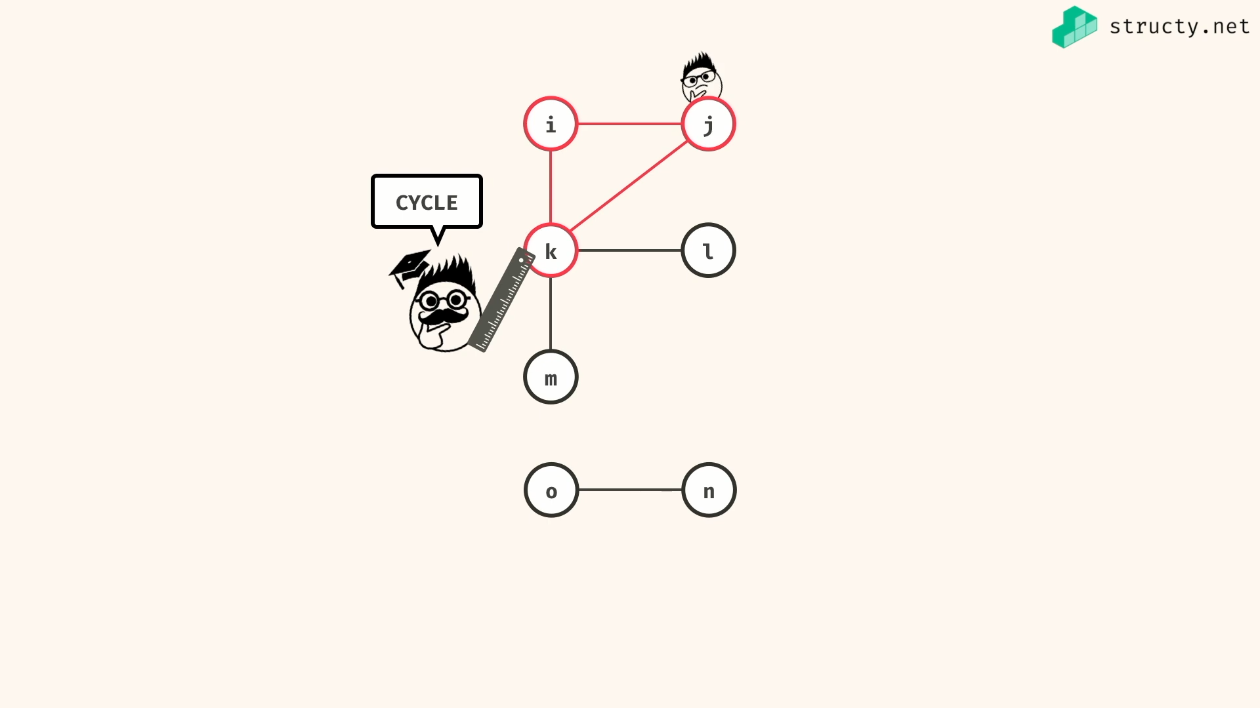

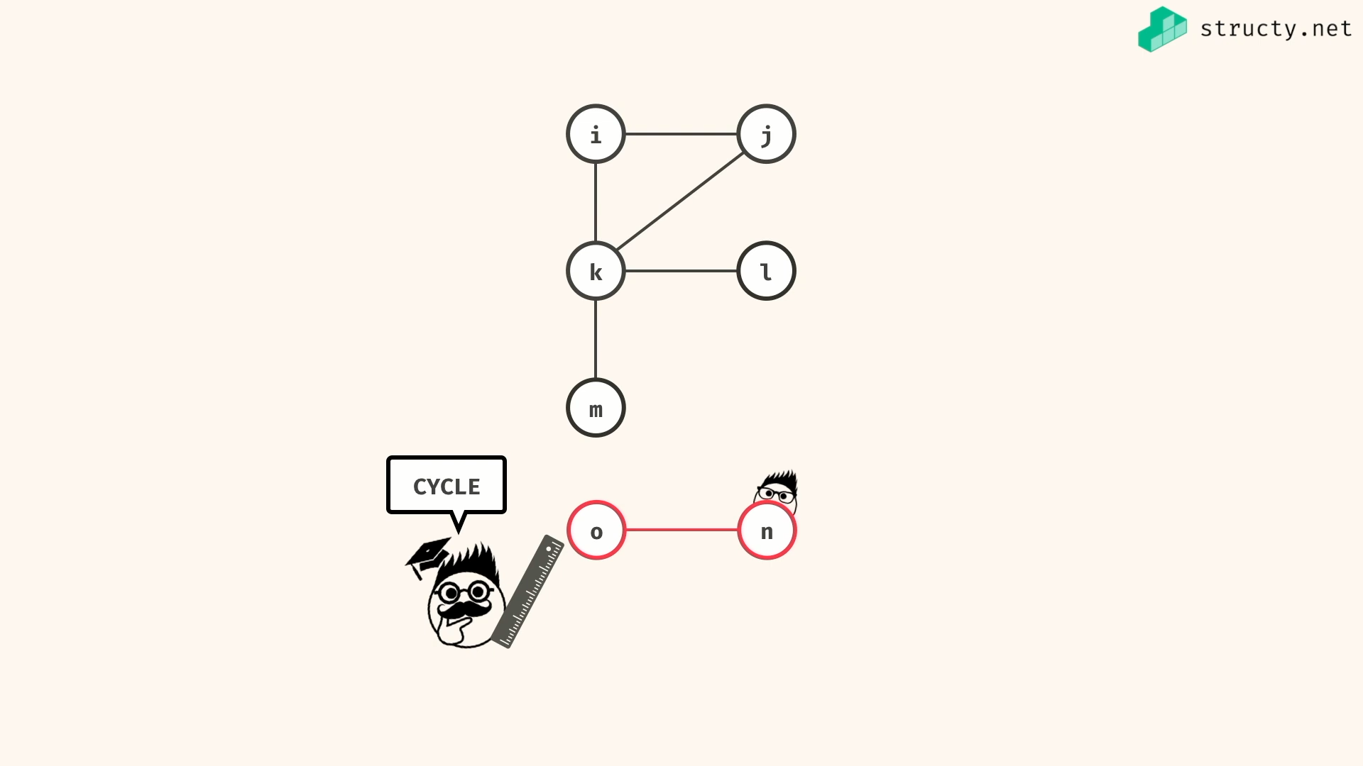

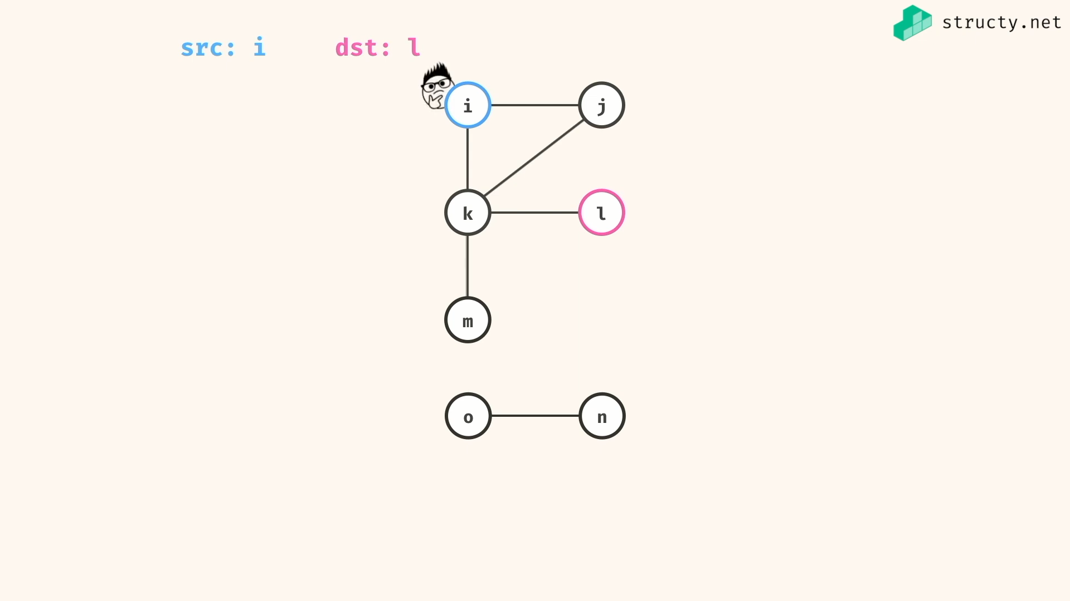

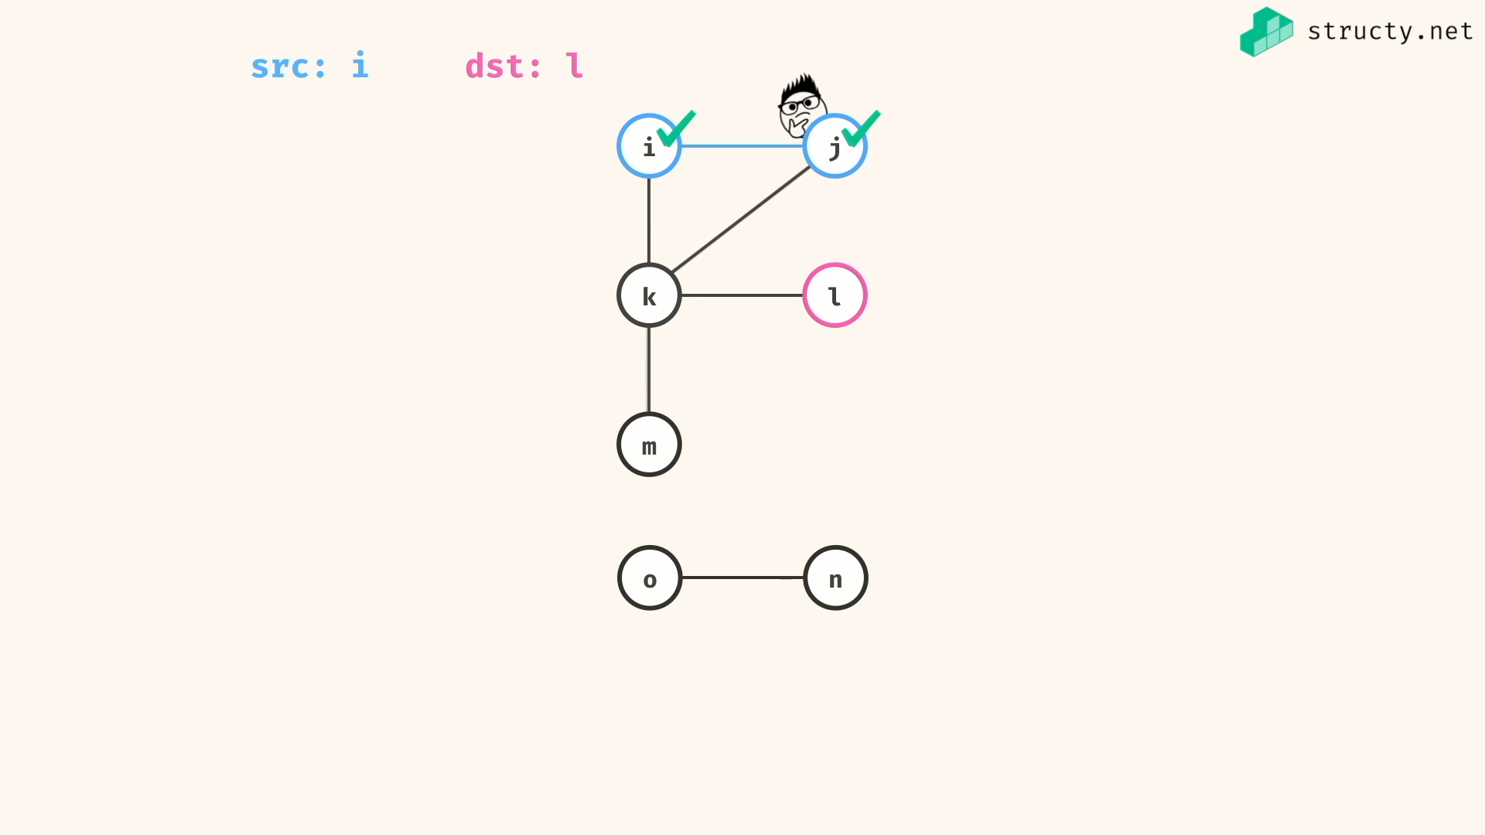

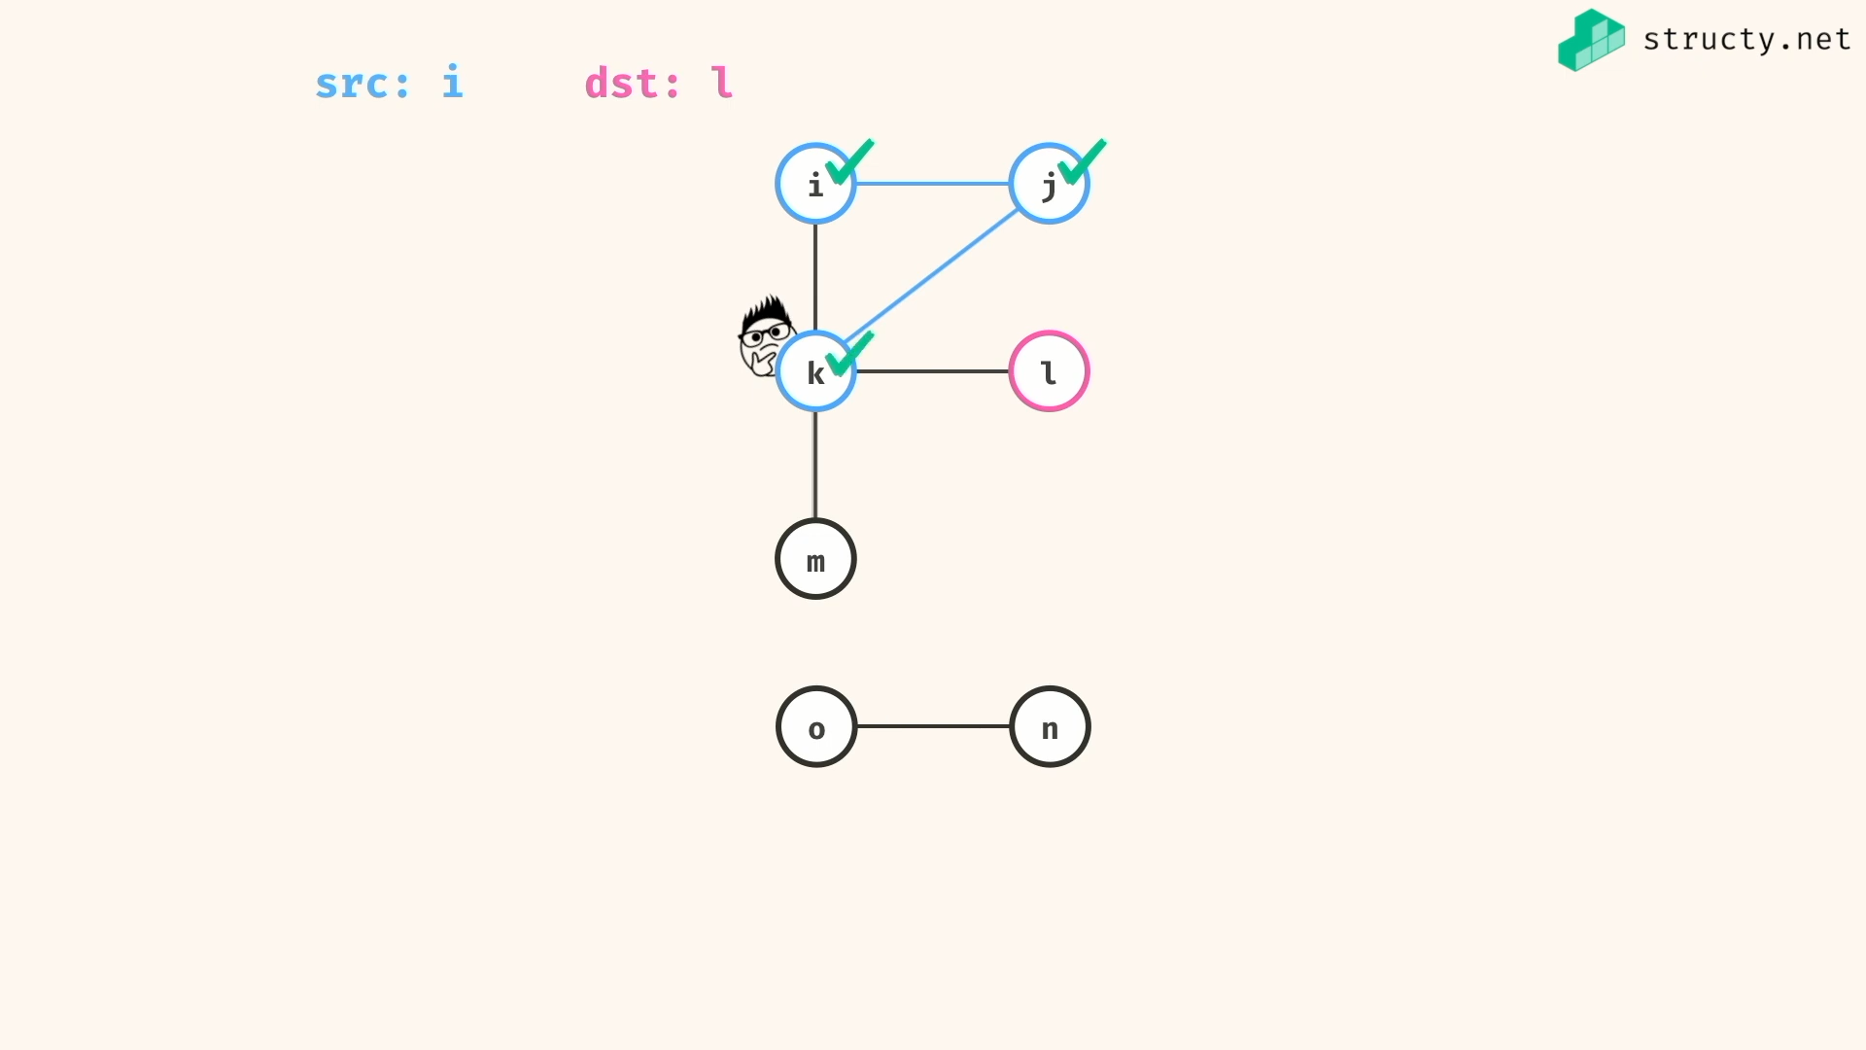

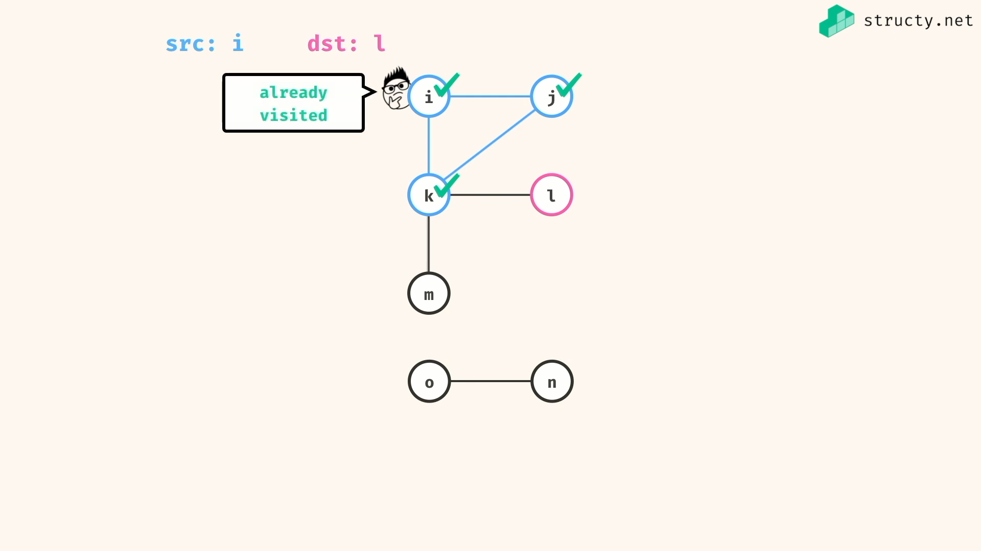

Avoid cycle by managing already visited nodes…

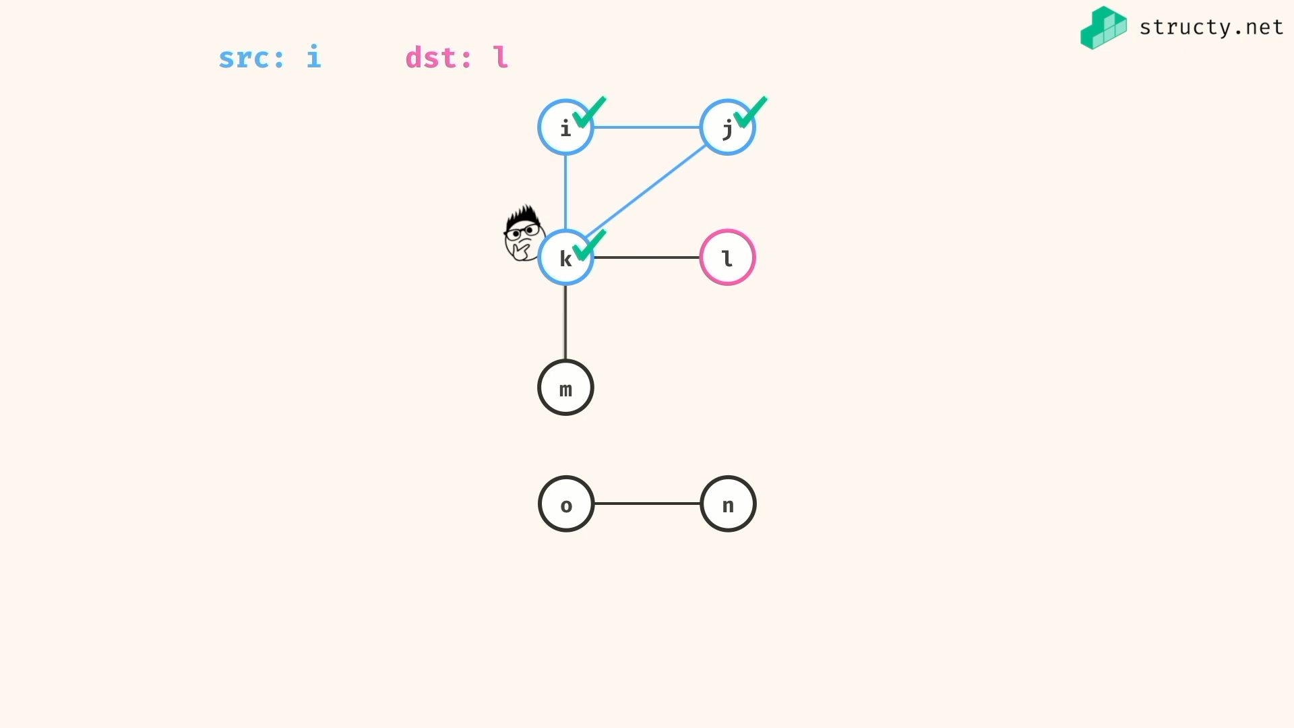

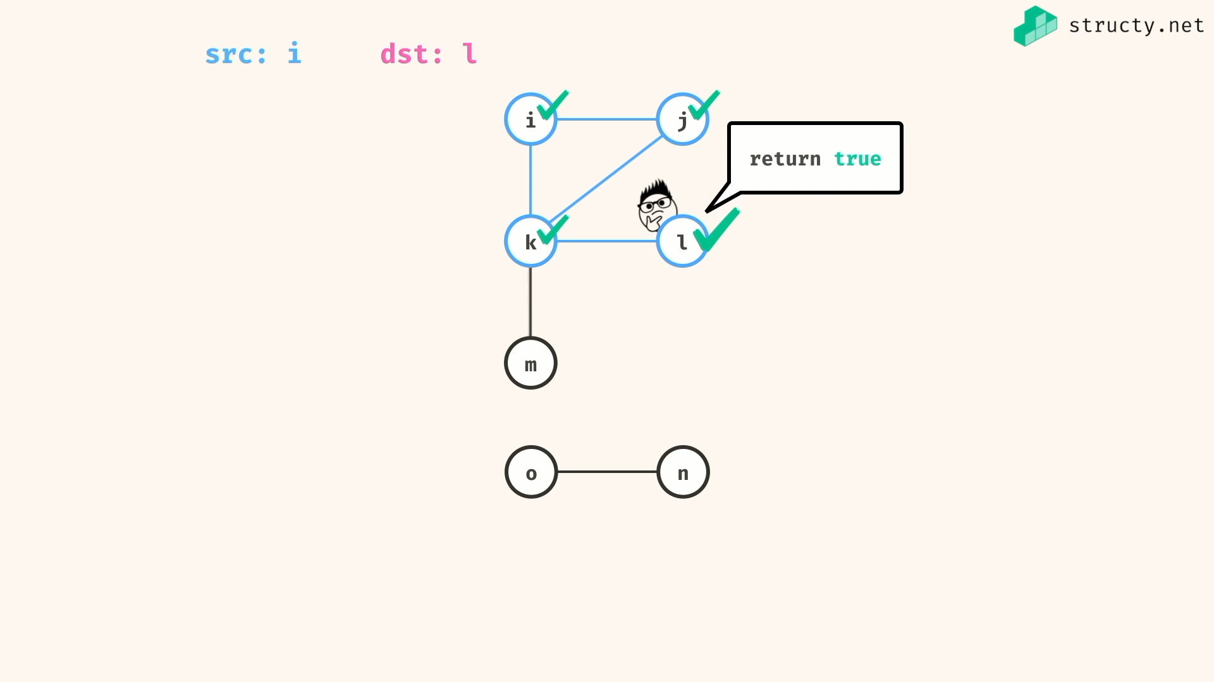

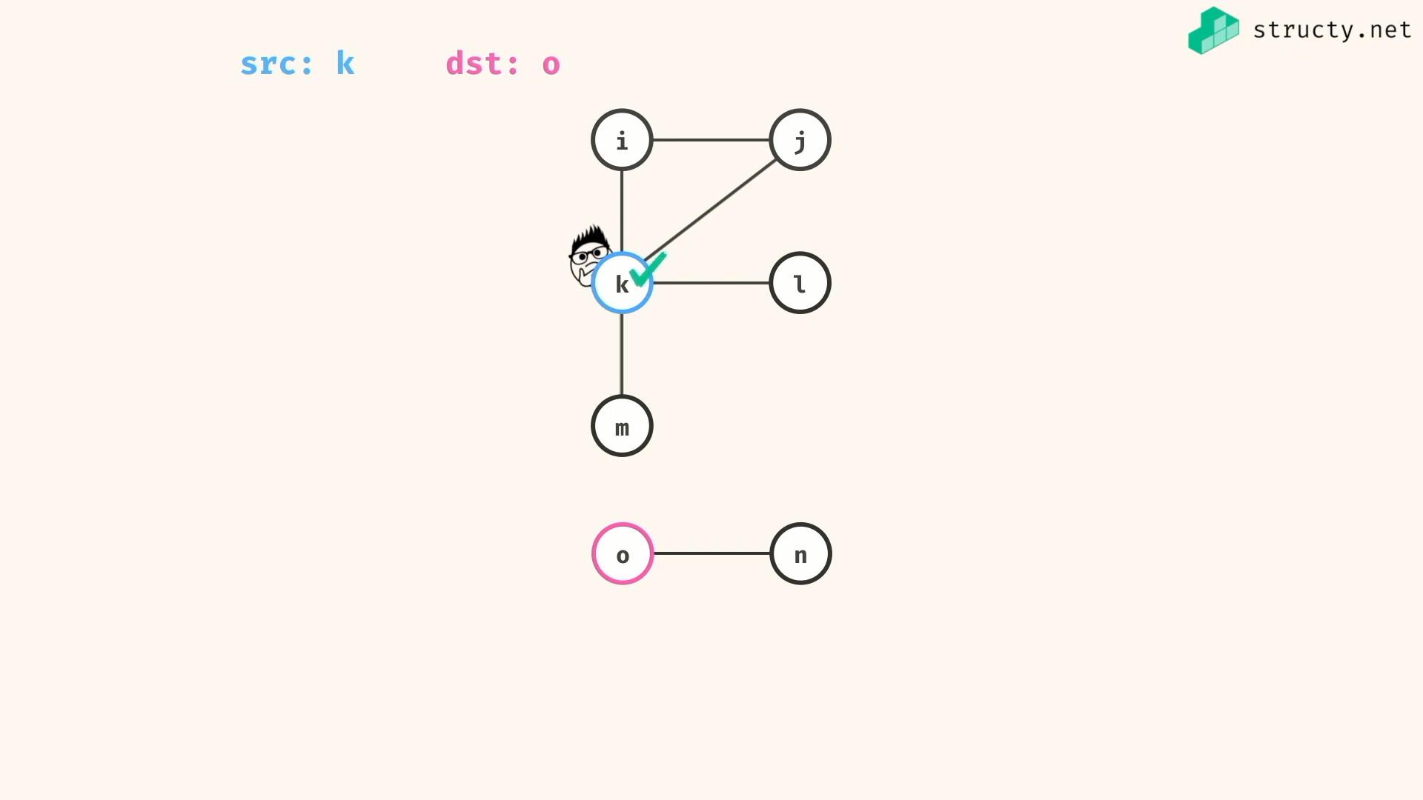

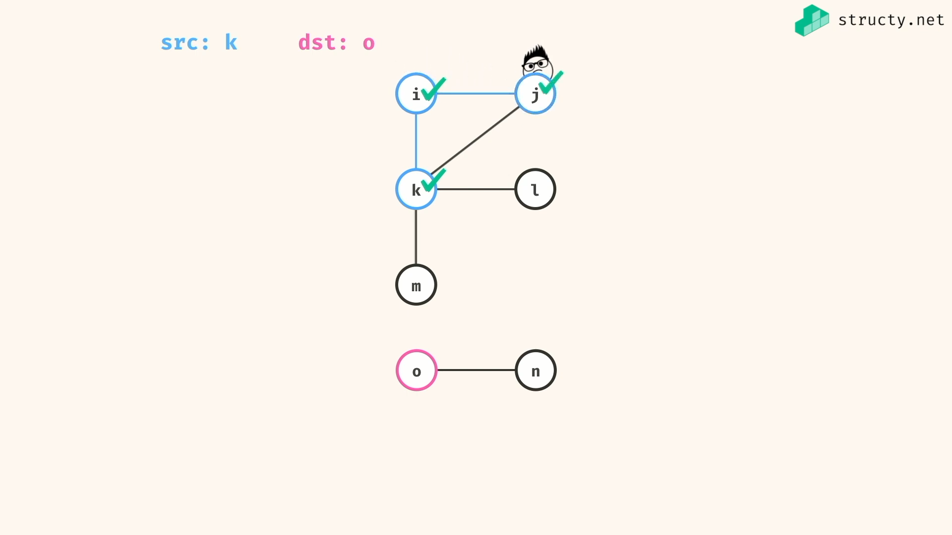

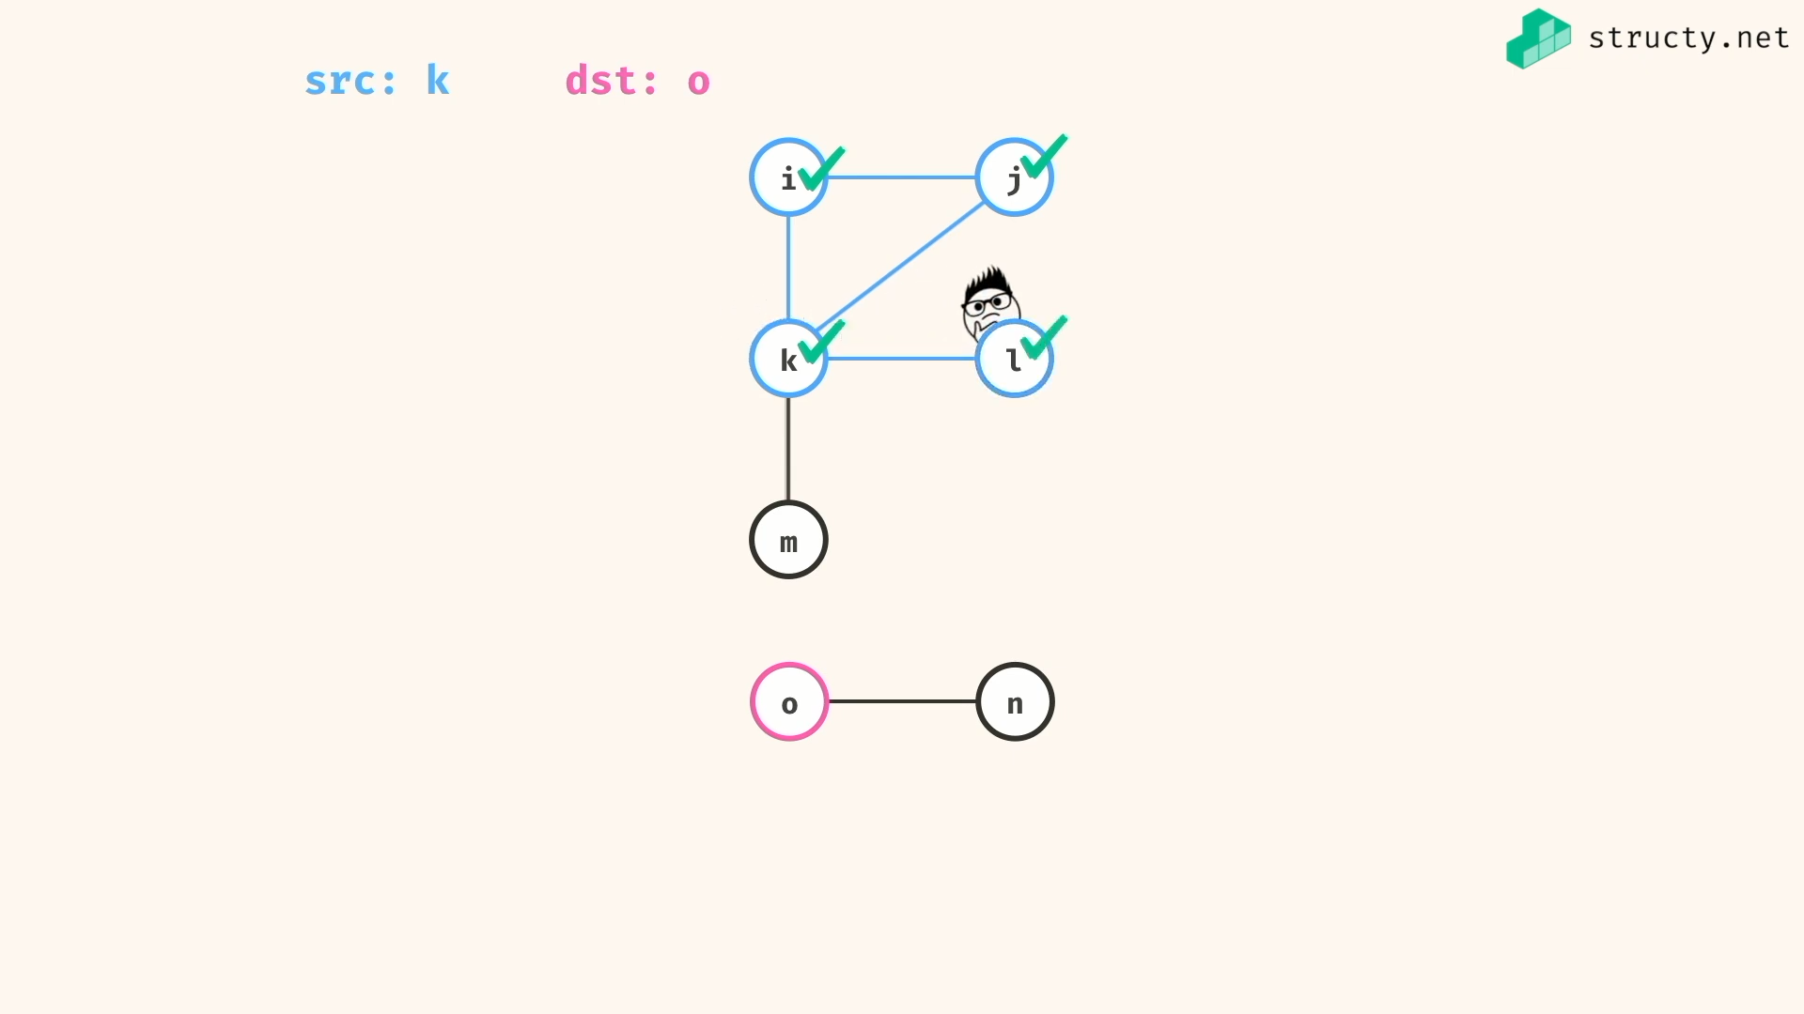

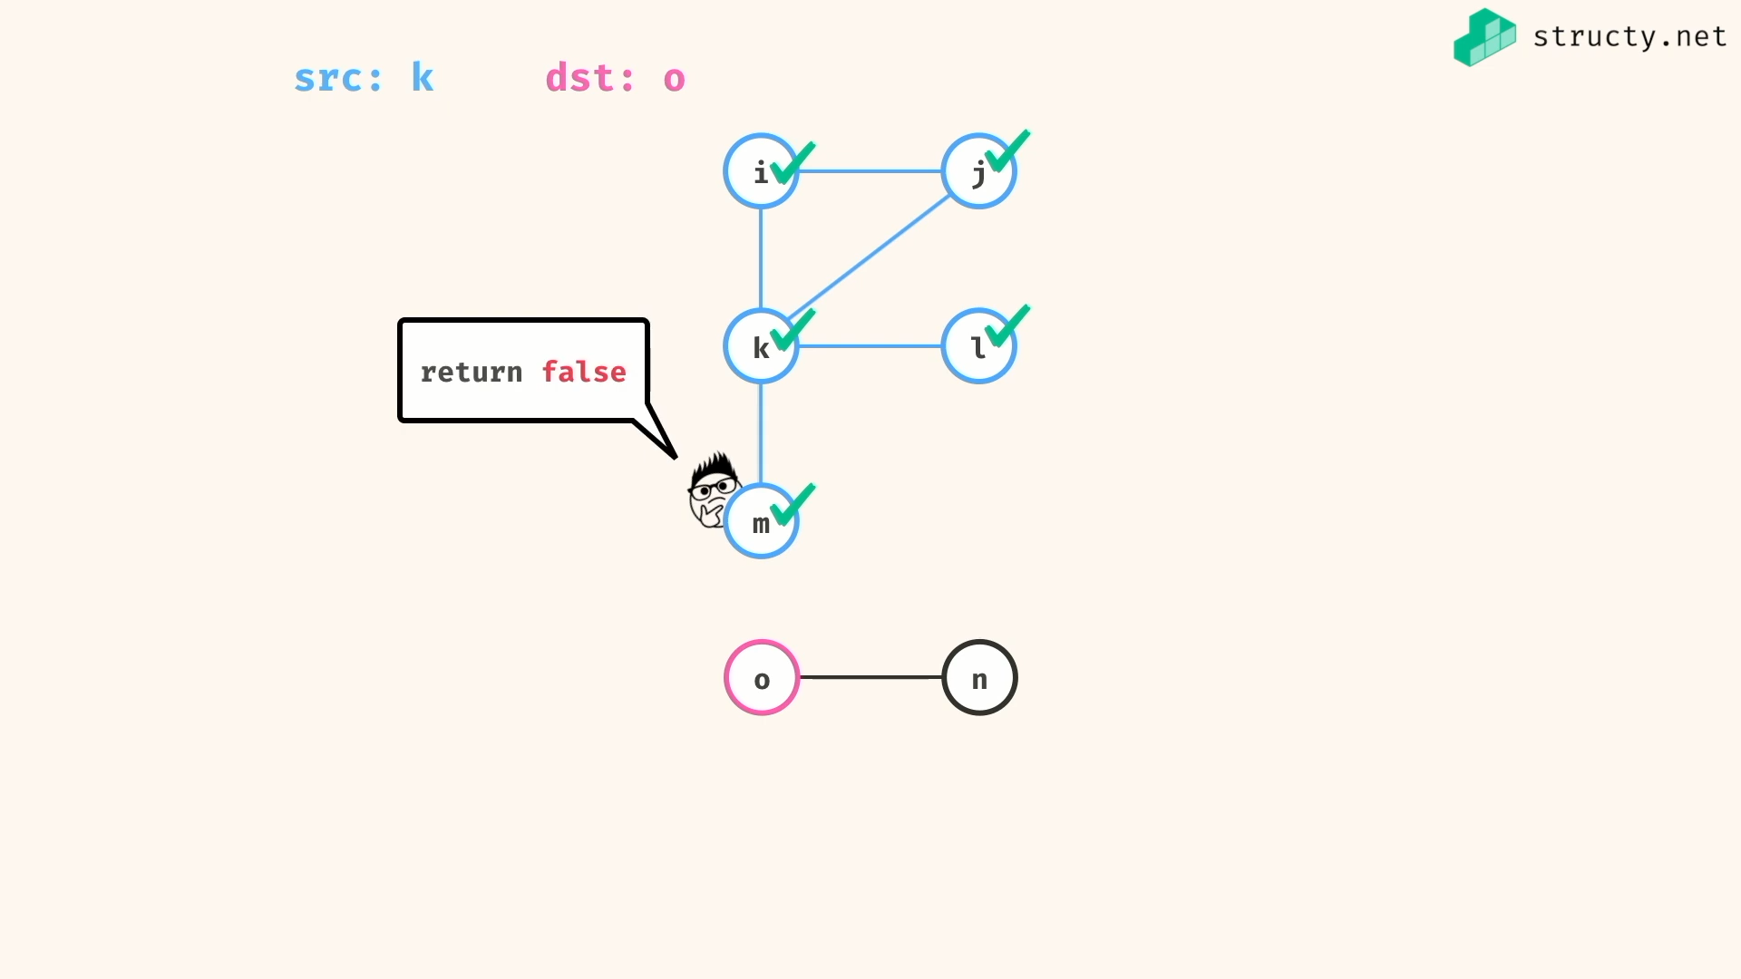

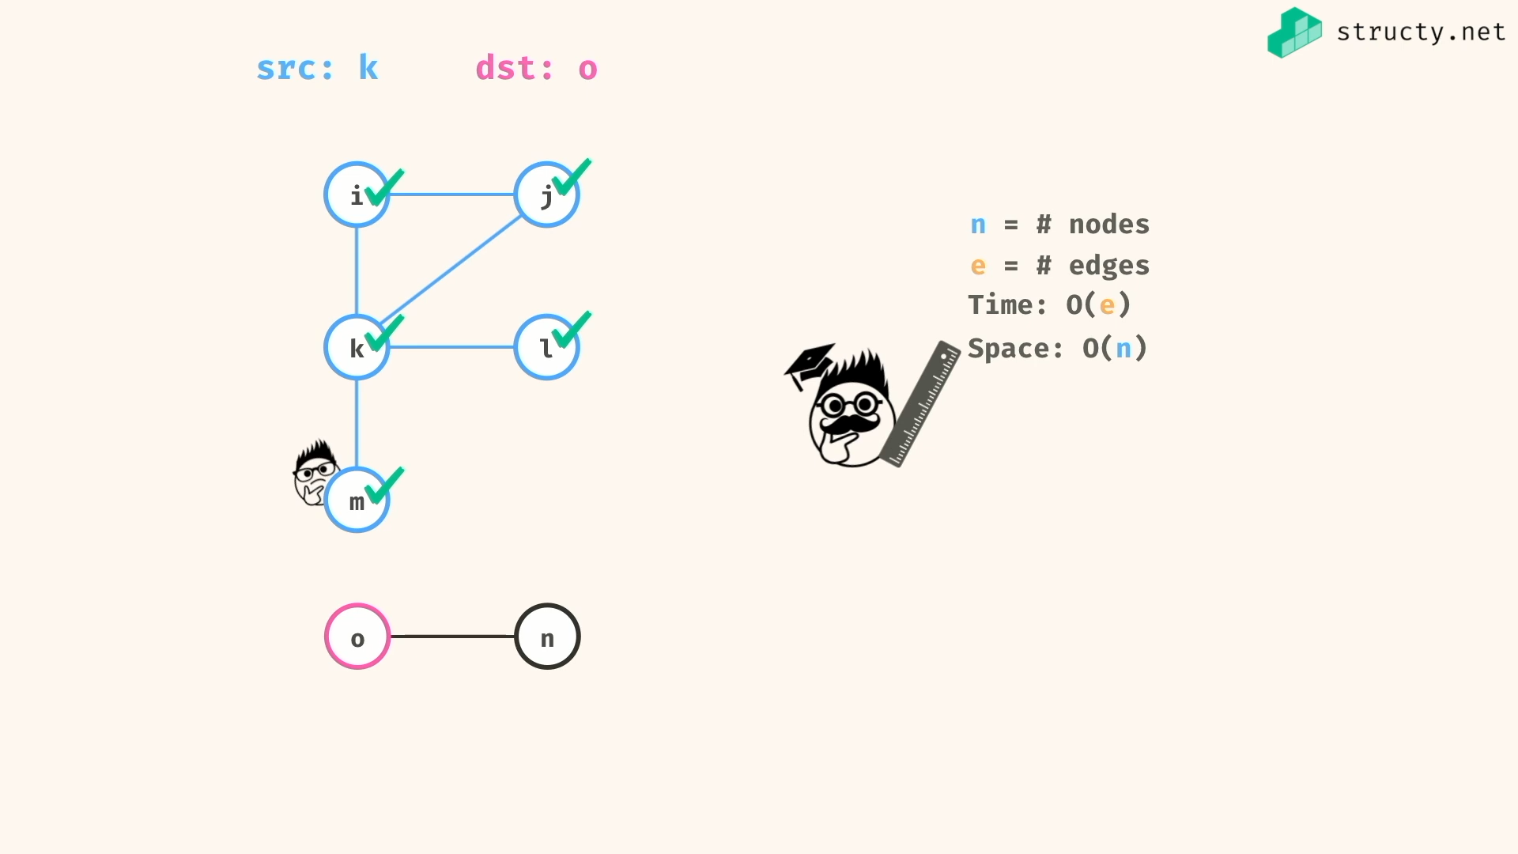

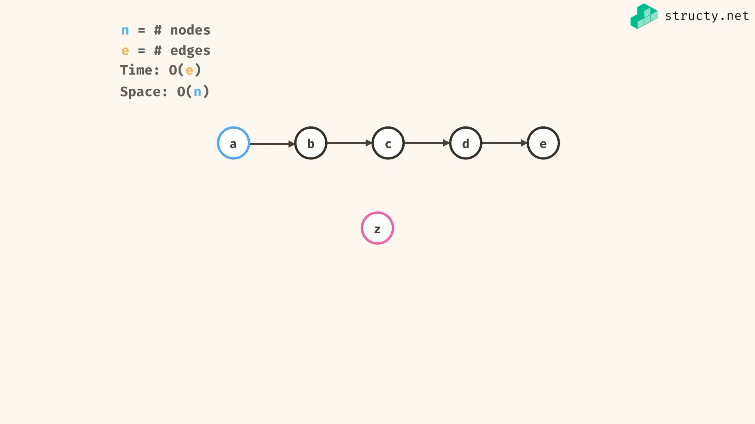

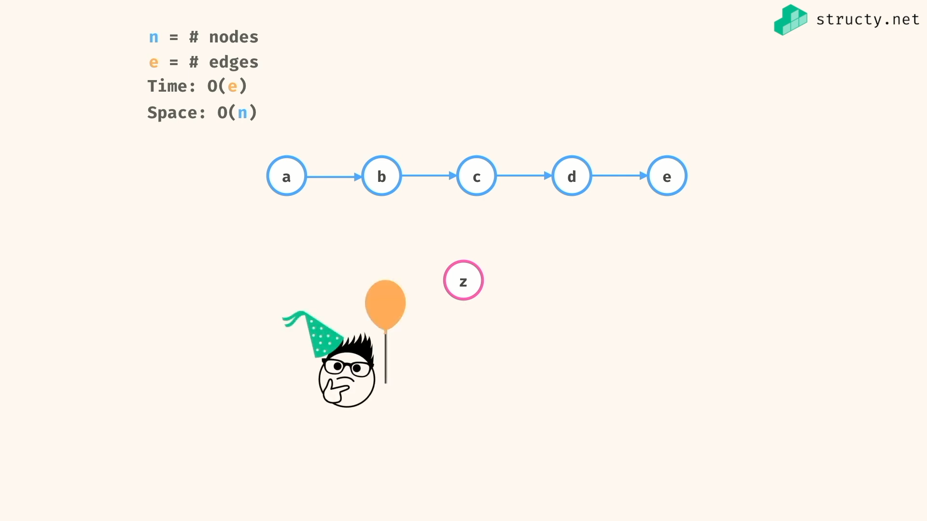

Regular graph algo have time complexity of O(E) , since at worst case… the program cover all the edgest…

Have space complexity of O(n), since at worst case .. the stack or queue only fill with below or equal to all nodes….

Problem solving:

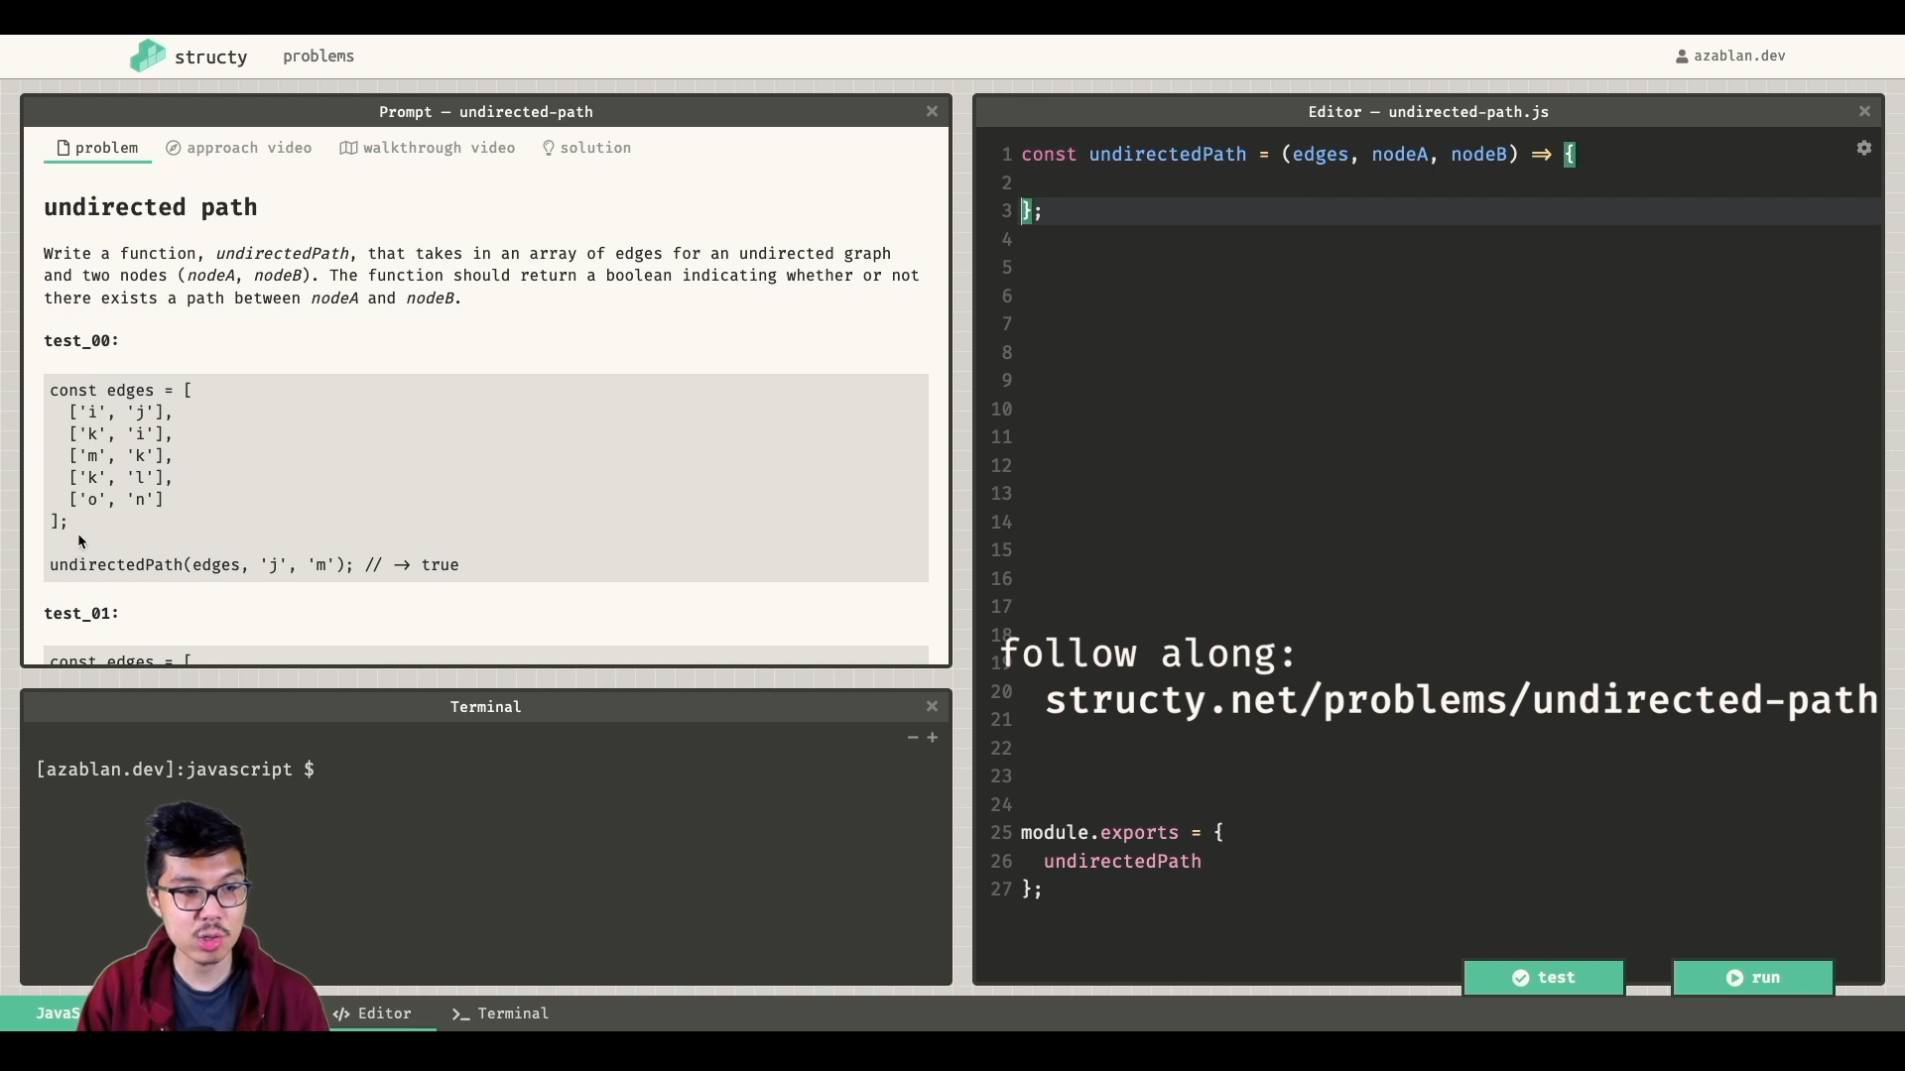

To avoid cycles in graph, visited set is necessary…

My soln:

*const* getGraph = (*edges*) *=>* {

*const* graph = {};

for (*let* edge of edges){

graph[edge[0]] = graph[edge[0]]? [...graph[edge[0]],edge[1]] : [edge[1]];

graph[edge[1]] = graph[edge[1]]? [...graph[edge[1]],edge[0]] : [edge[0]];

}

return graph;

}

*const* hasUndirectedPathDfs = (*graph*, *src*, *dst*, *visited* = new *Set*()) *=>* {

if(visited.has(src)){

return false;

}else{

visited.add(src);

}

if(src === dst )

return true

for(*let* neighbour of graph[src]){

if(hasUndirectedPathDfs(graph, neighbour, dst, visited)){

return true

}

}

return false;

}

*const* hasUndirectedPathBfs = (*graph*,*src*,*dst*,*visited* = new *Set*()) *=>* {

if(src === dst )

return true;

*const* queue = [ src ];

while(queue.length){

*const* current = queue.shift();

if(!visited.has(current)){

visited.add(current);

if(current === dst)

return true

queue.push(...graph[current])

}

}

return false;

}

*const* edges = [

['i','j'],

['k','i'],

['m','k'],

['k','l'],

['o','n']

]

*const* graph = getGraph(edges);

// => {

// i: [ 'j', 'k' ],

// j: [ 'i' ],

// k: [ 'i', 'm', 'l' ],

// m: [ 'k' ],

// l: [ 'k' ],

// o: [ 'n' ],

// n: [ 'o' ]

// }

*console*.log(hasUndirectedPathDfs(graph,'j','m')) //=> true

*console*.log(hasUndirectedPathBfs(graph,'j','m')) //=> true

Alvin the programmer soln:

*const* buildGraph = (*edges*) *=>* {

*const* graph = {};

for (*let* edge of edges){

*const* [a,b] = edge;

if(!(a in graph)) graph[a] = [];

if(!(b in graph)) graph[b] = [];

graph[a].push(b);

graph[b].push(a);

}

return graph;

}

*const* hasPath = (*graph*,*src*,*dst*, *visited*) *=>* {

if(src === dst) return true;

if(visited.has(src)) return false;

visited.add(src);

for(*let* neighbour of graph[src])

if(hasPath(graph,neighbour,dst,visited)) return true;

return false;

}

*const* undirectedPath = (*edges*, *src*, *dst*) *=>* {

*const* graph = buildGraph(edges);

return hasPath(graph,src,dst,new *Set*());

}

*const* edges = [

['i','j'],

['k','i'],

['m','k'],

['k','l'],

['o','n']

]

*console*.log(undirectedPath(edges,'j','m'));

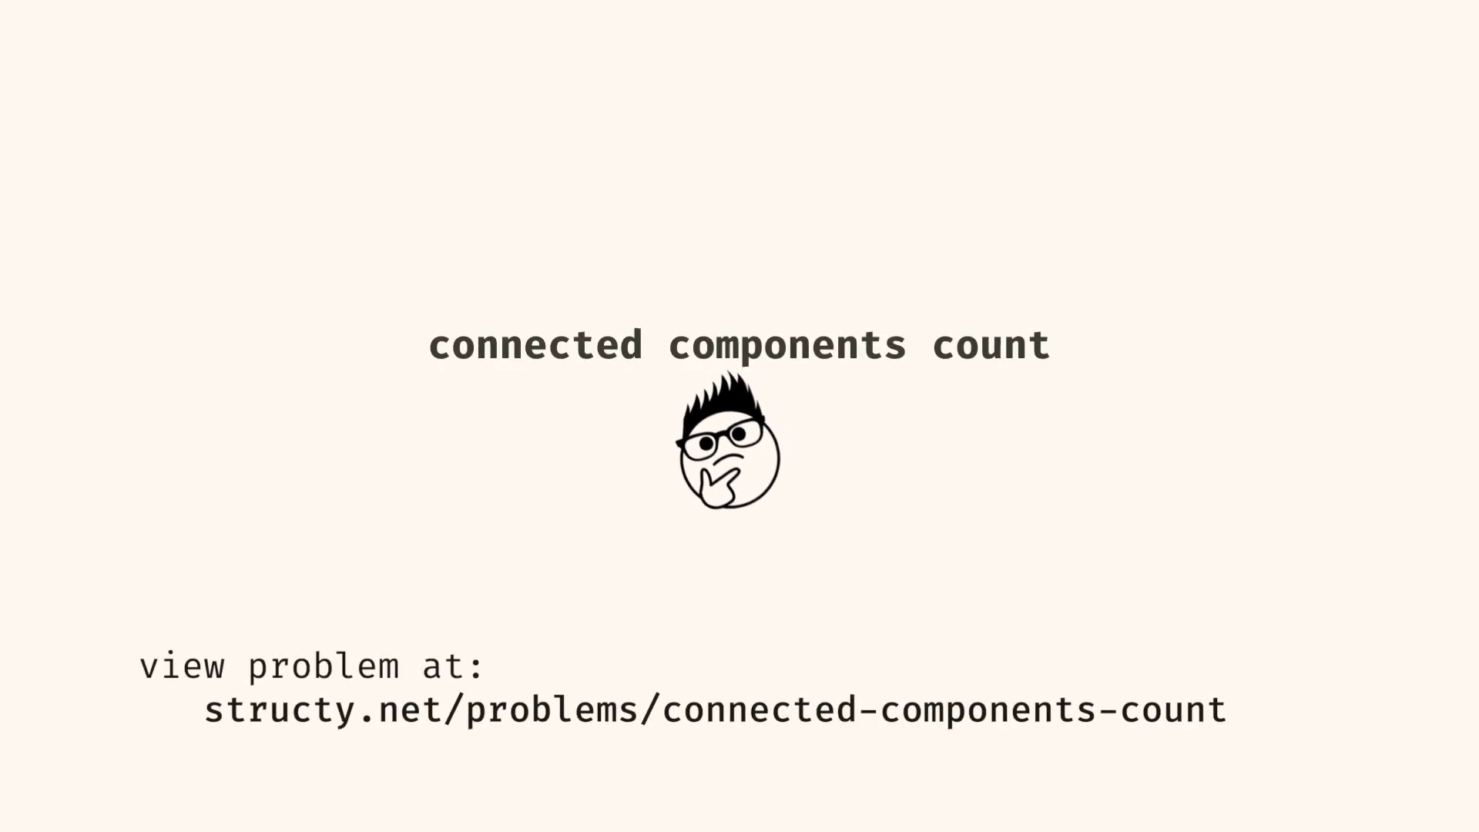

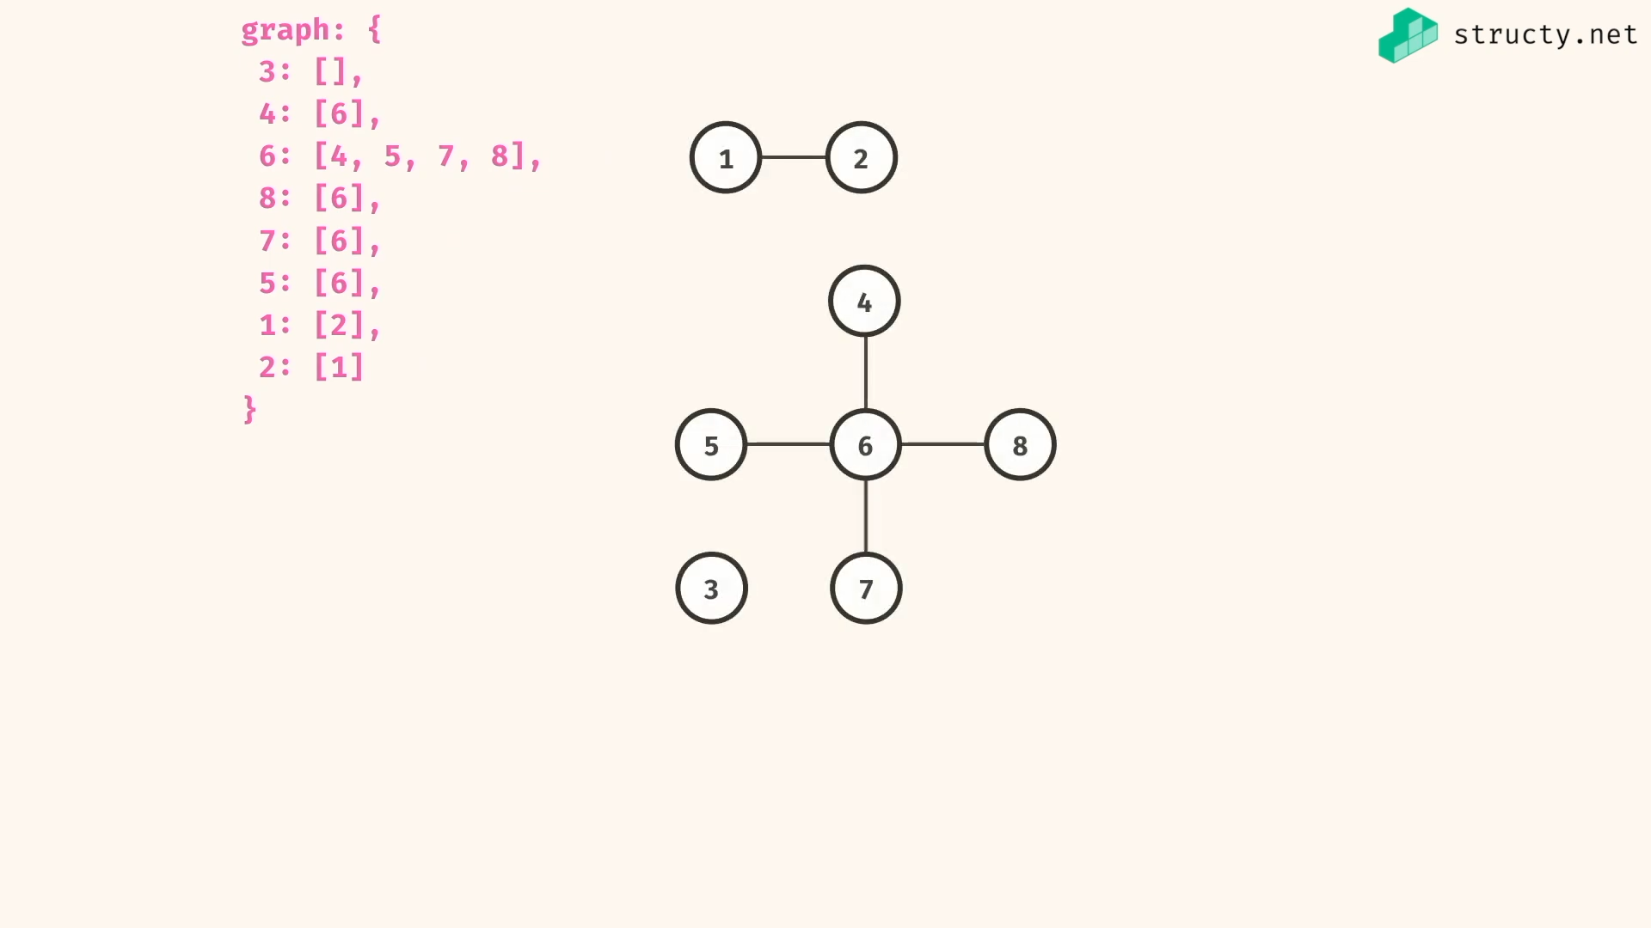

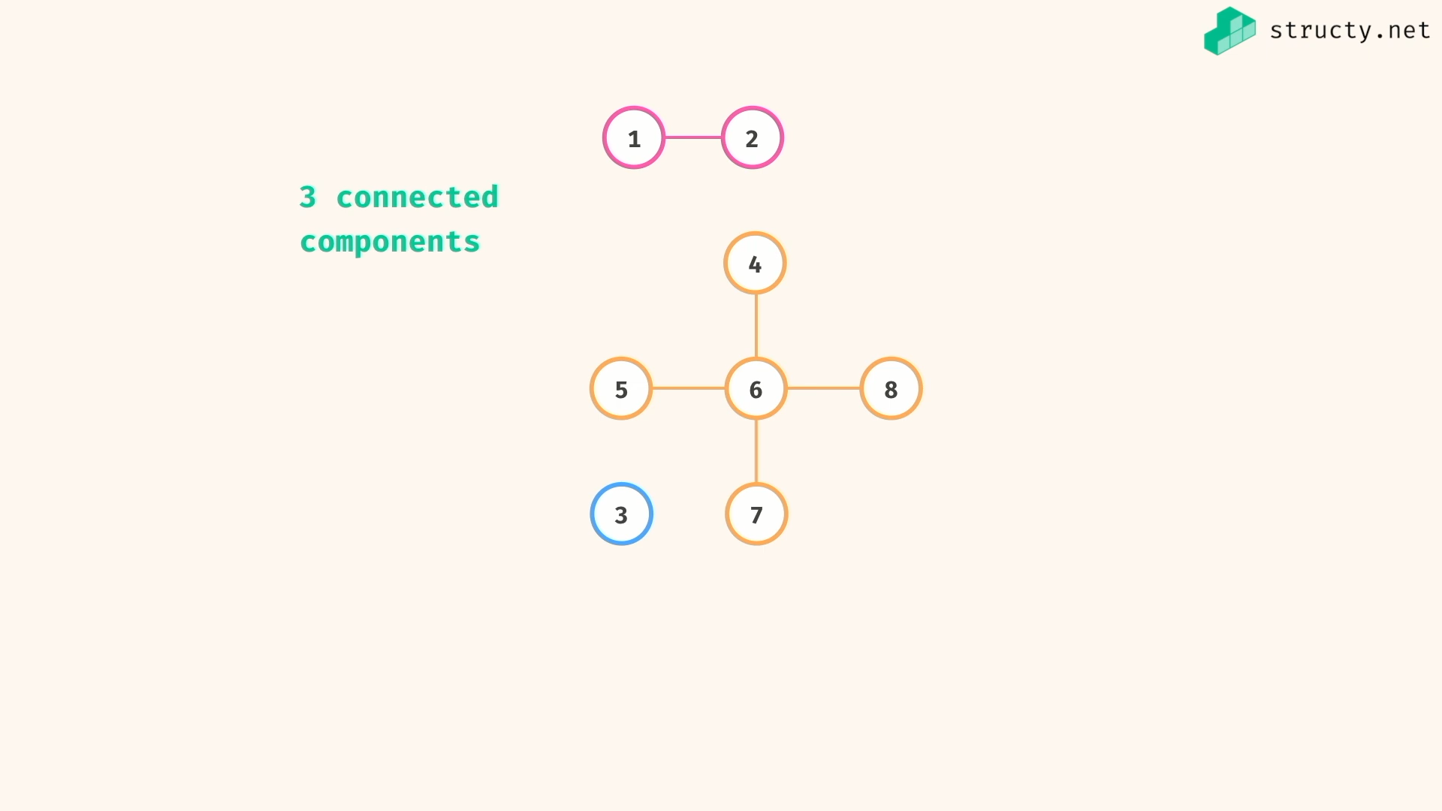

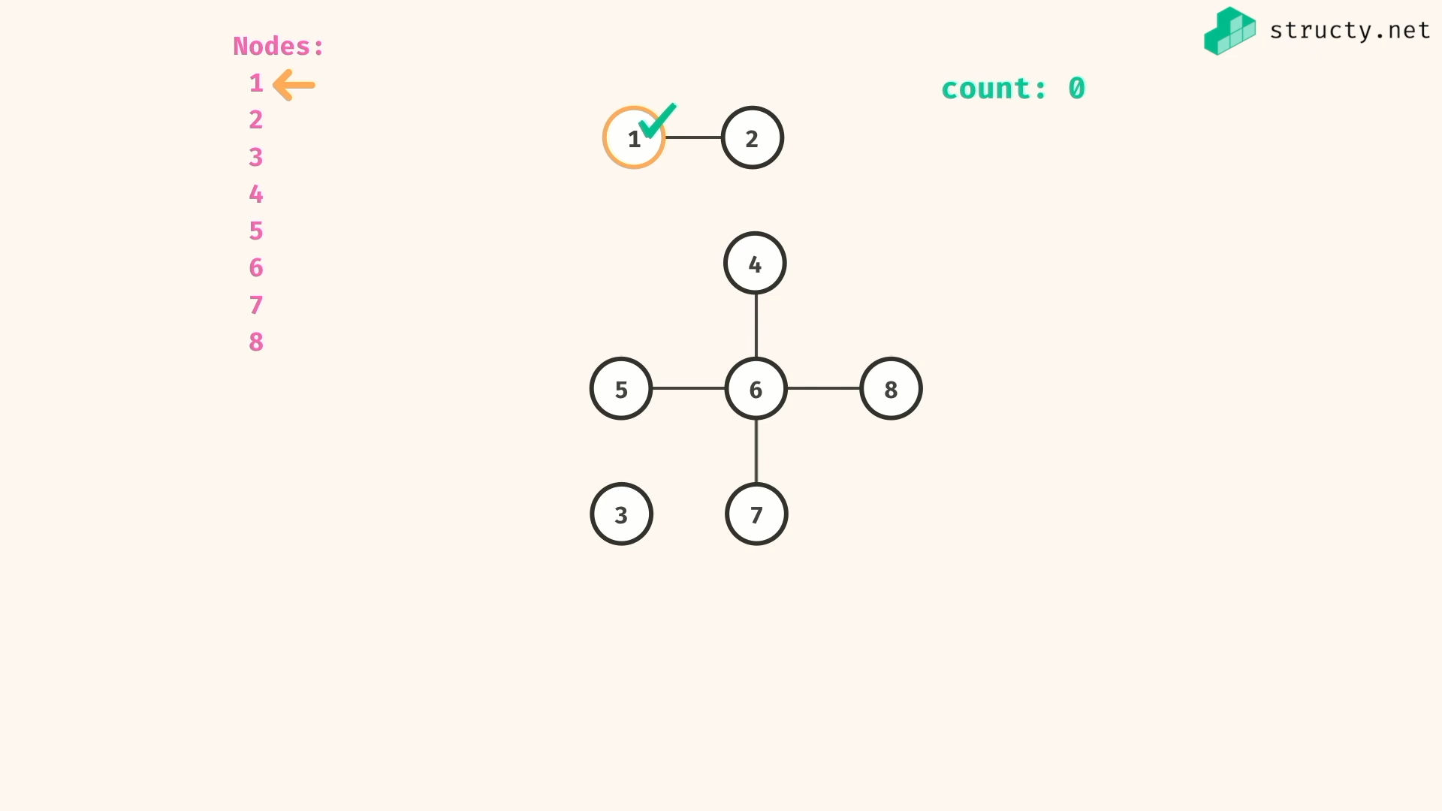

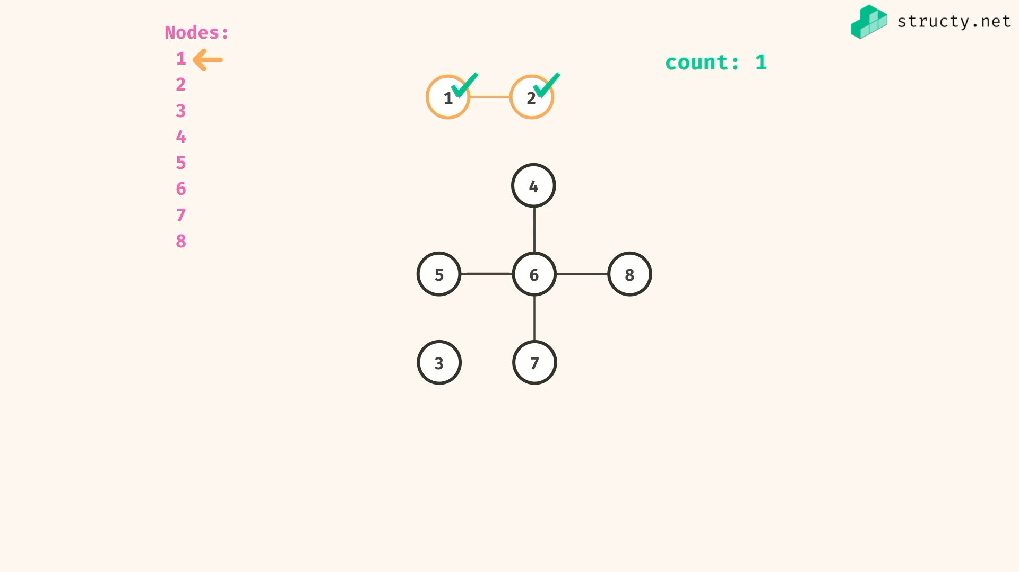

Visited markings helps for restricting cycles and double count of same components…

Visited set give O(1) lookup and add elements in set…

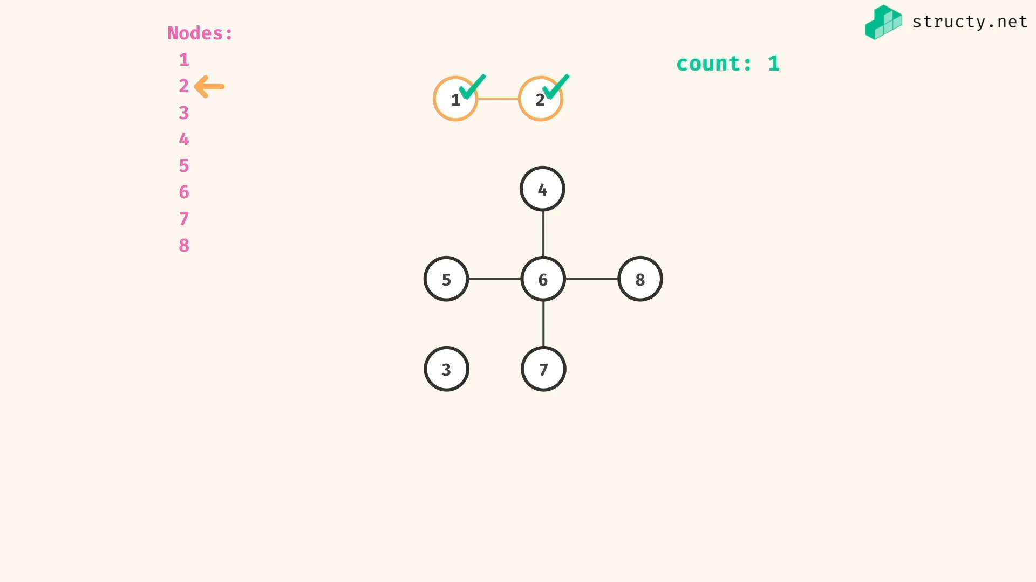

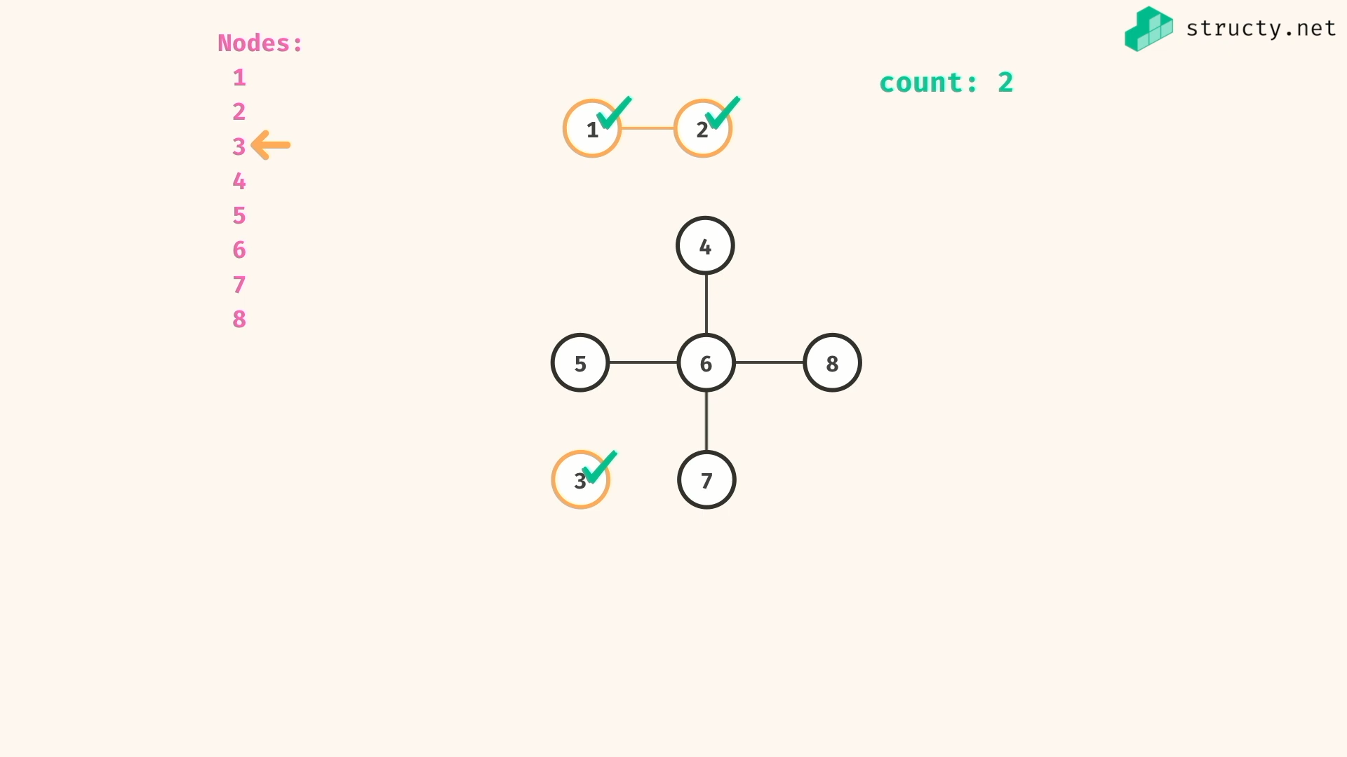

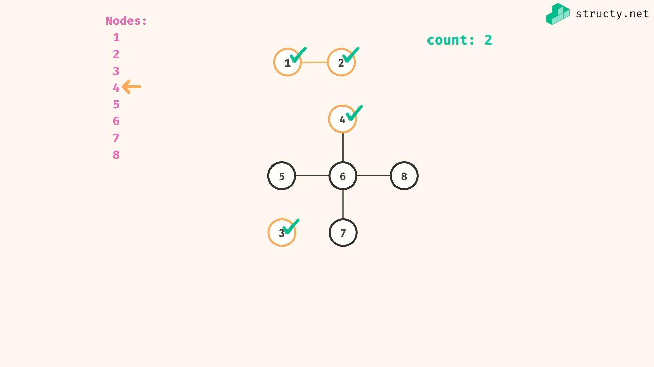

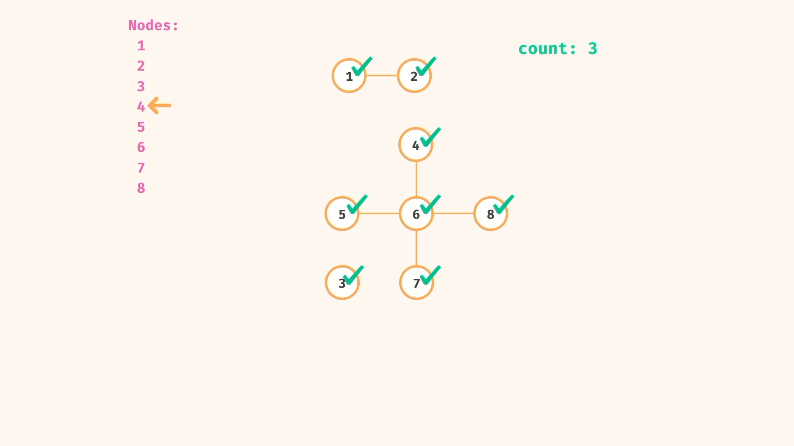

5,6 , 7, 8 -> already visited

Count will increase after finishing traversal of the whole component….

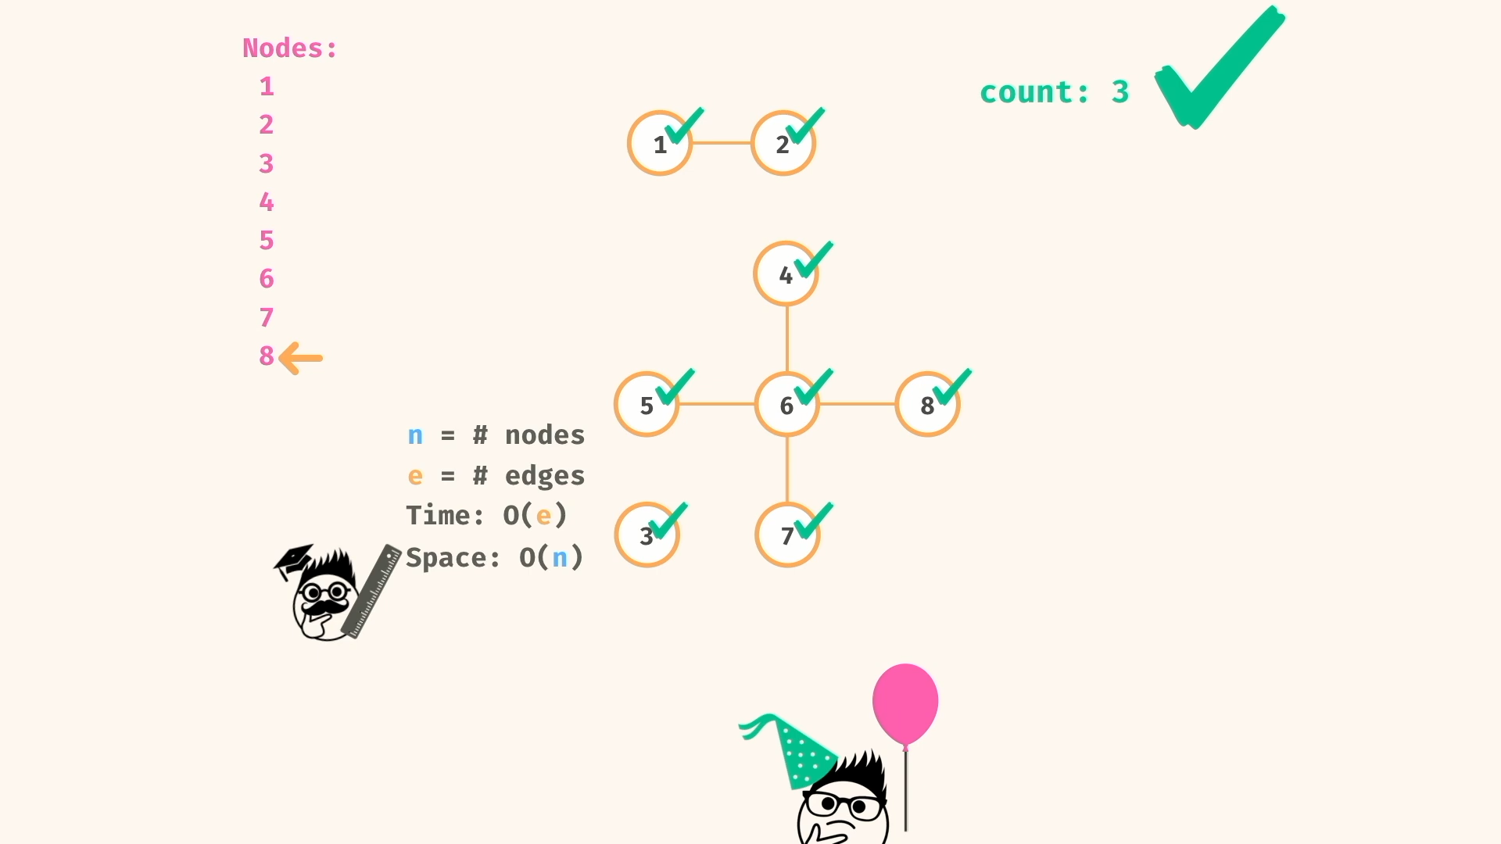

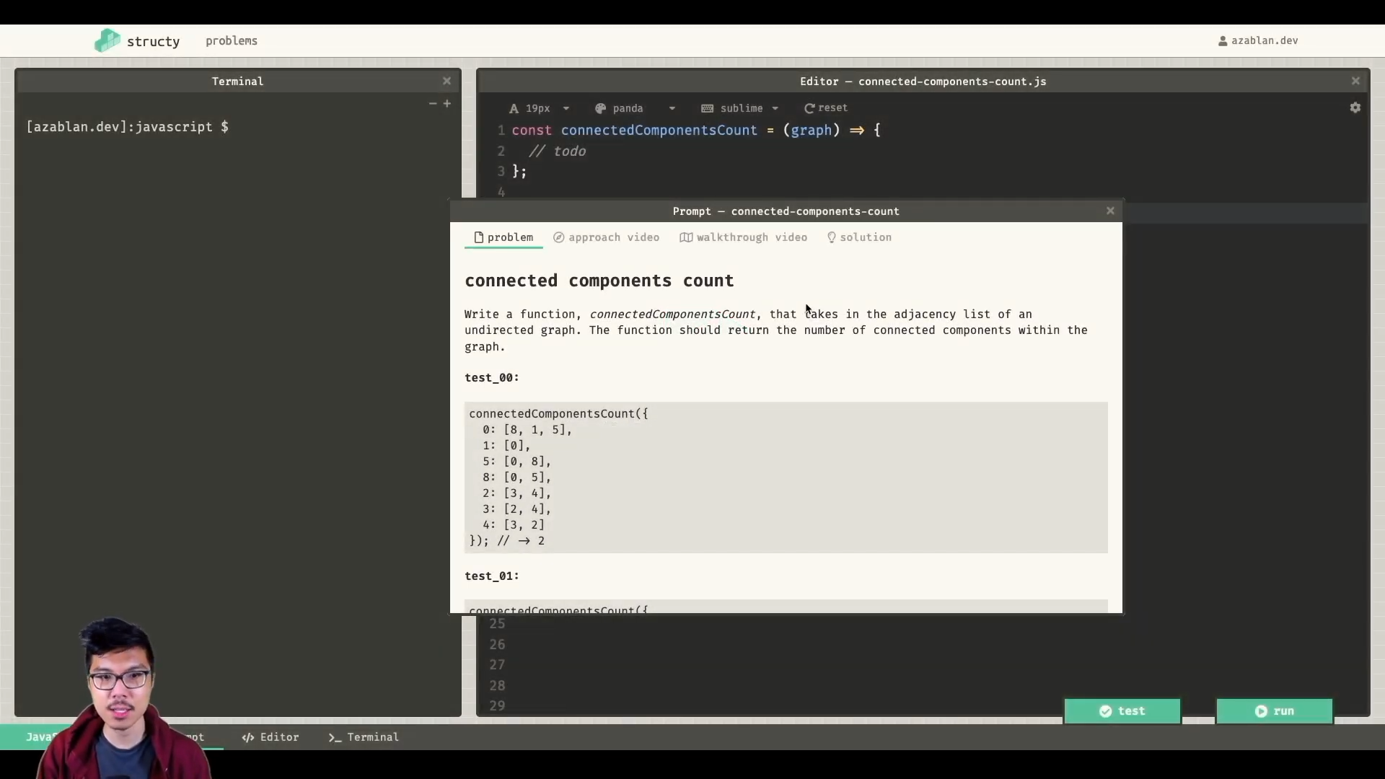

Note:

Here keys are number and values are also number…

But js coverts keys into string always..

So you have to manage visited set with single type without fail…

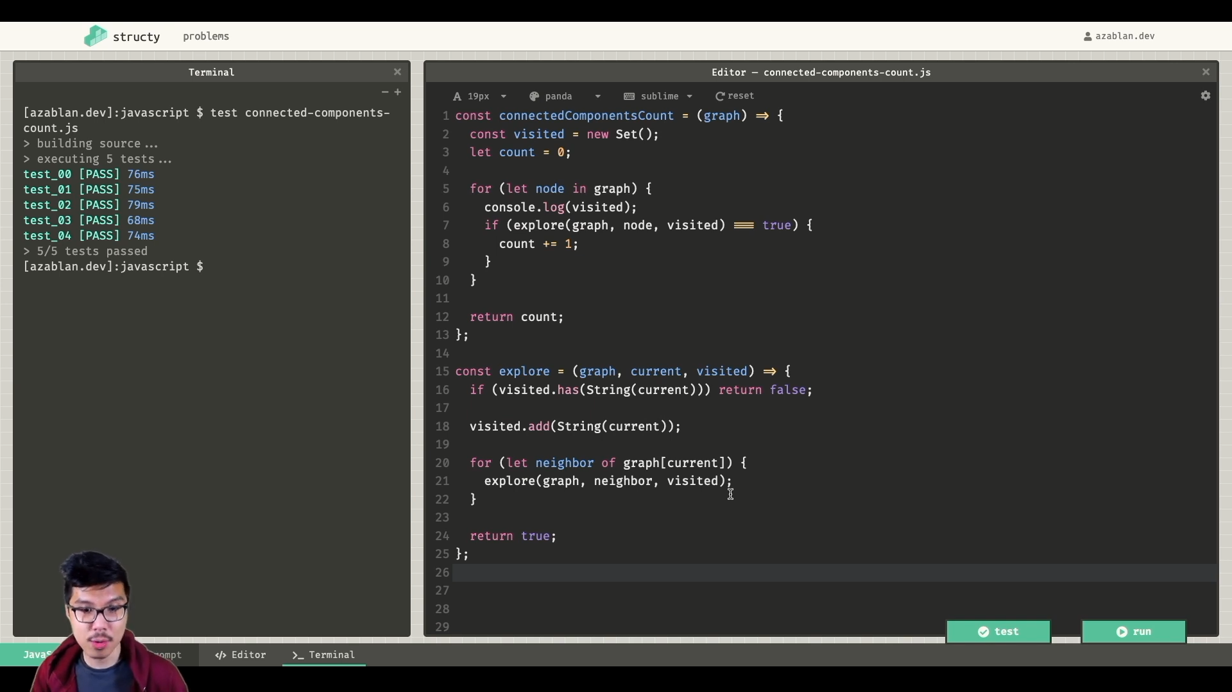

My soln:

*const* exploreComponent = (*graph*,*current*,*visited*) *=>* {

if(visited.has(current)) return false;

visited.add(current);

for(*let* neighbour of graph[current])

exploreComponent(graph,neighbour,visited);

return true;

}

*const* connectedComponentCount = (*graph*) *=>* {

*const* visited = new *Set*();

*let* count = 0;

for(*let* node in graph)

exploreComponent(graph,*Number*(node),visited) ?

count++ :

count;

return count;

}

graph = {

0:[8,1,5],

1:[0],

5:[0,8],

8:[0,5],

2:[3,4],

3:[2,4],

4:[3,2]

};

*console*.log(connectedComponentCount(graph)) //=> 2

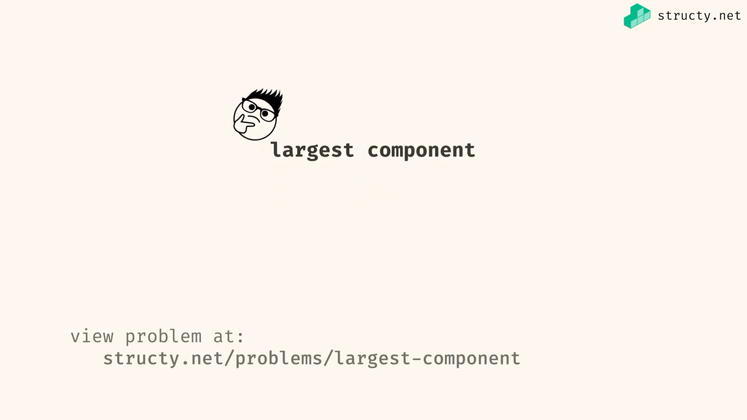

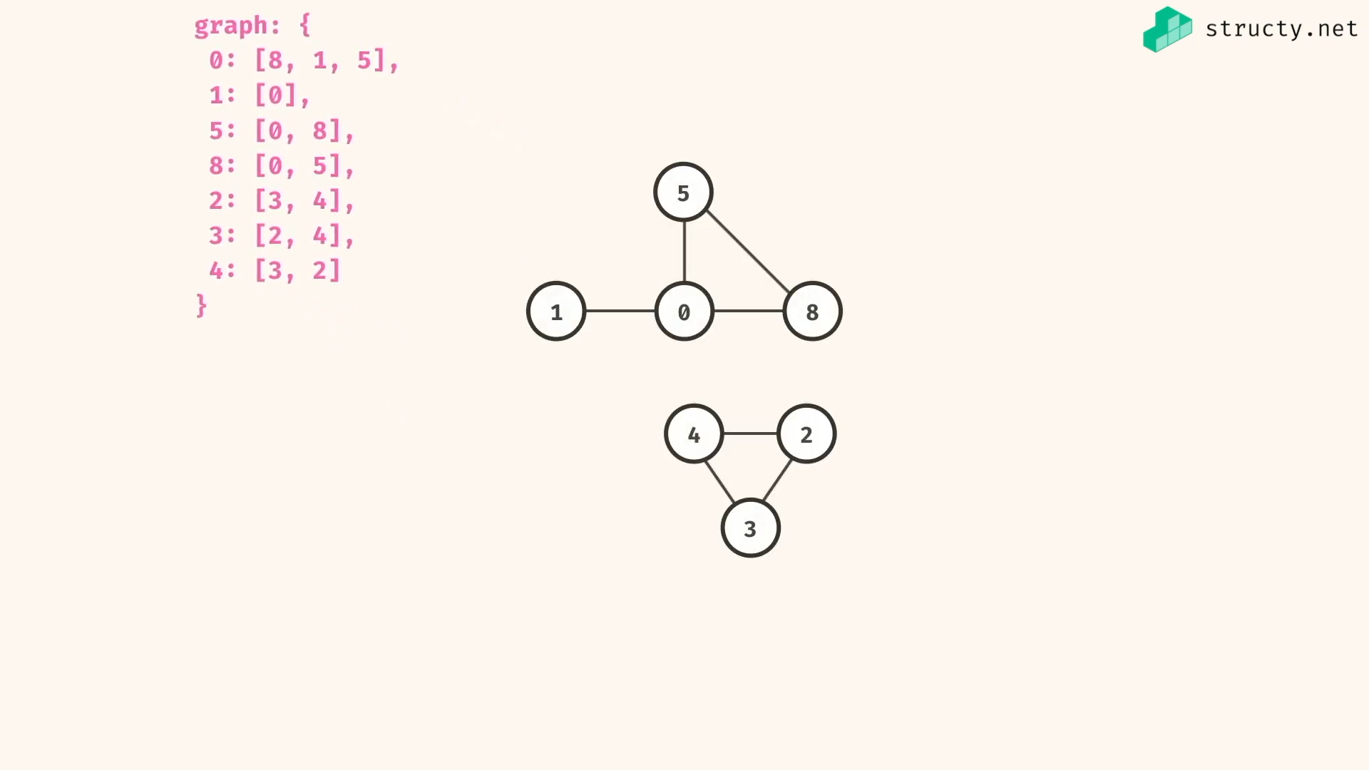

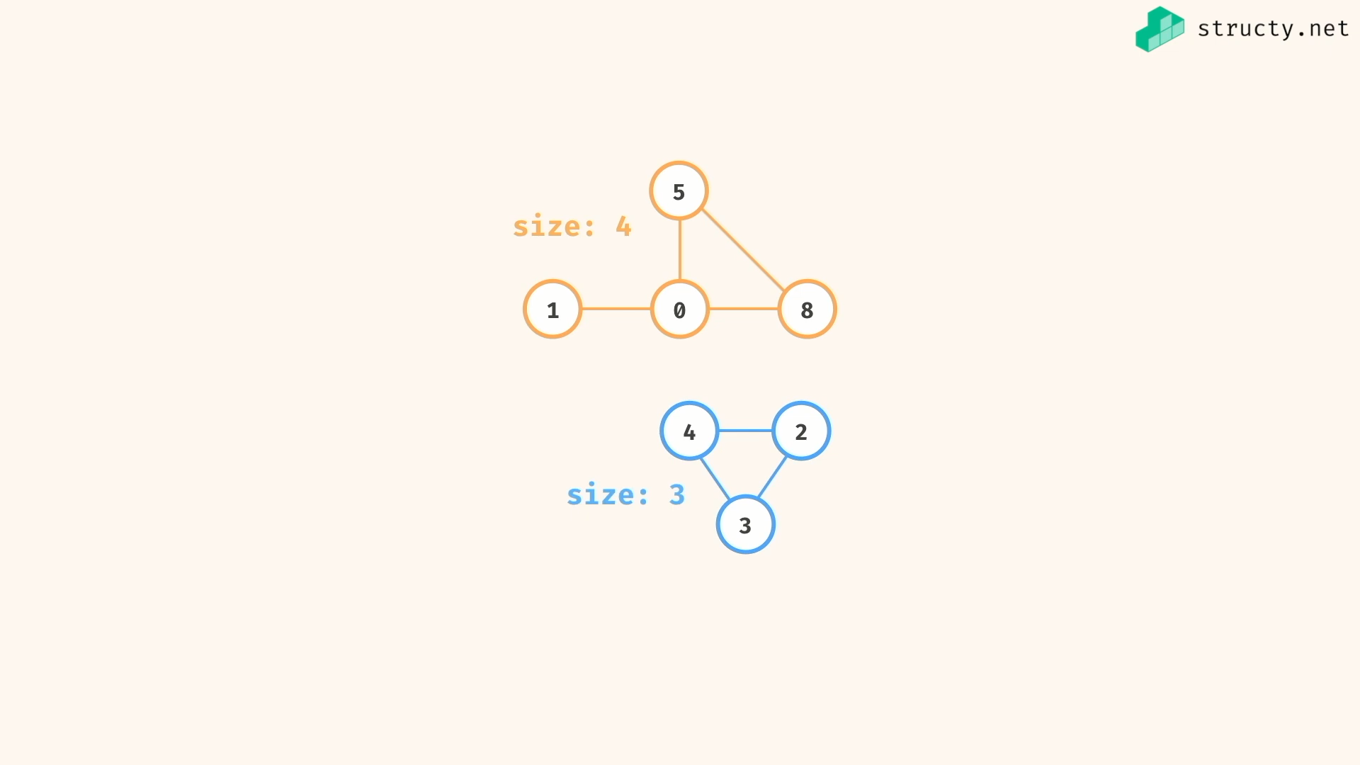

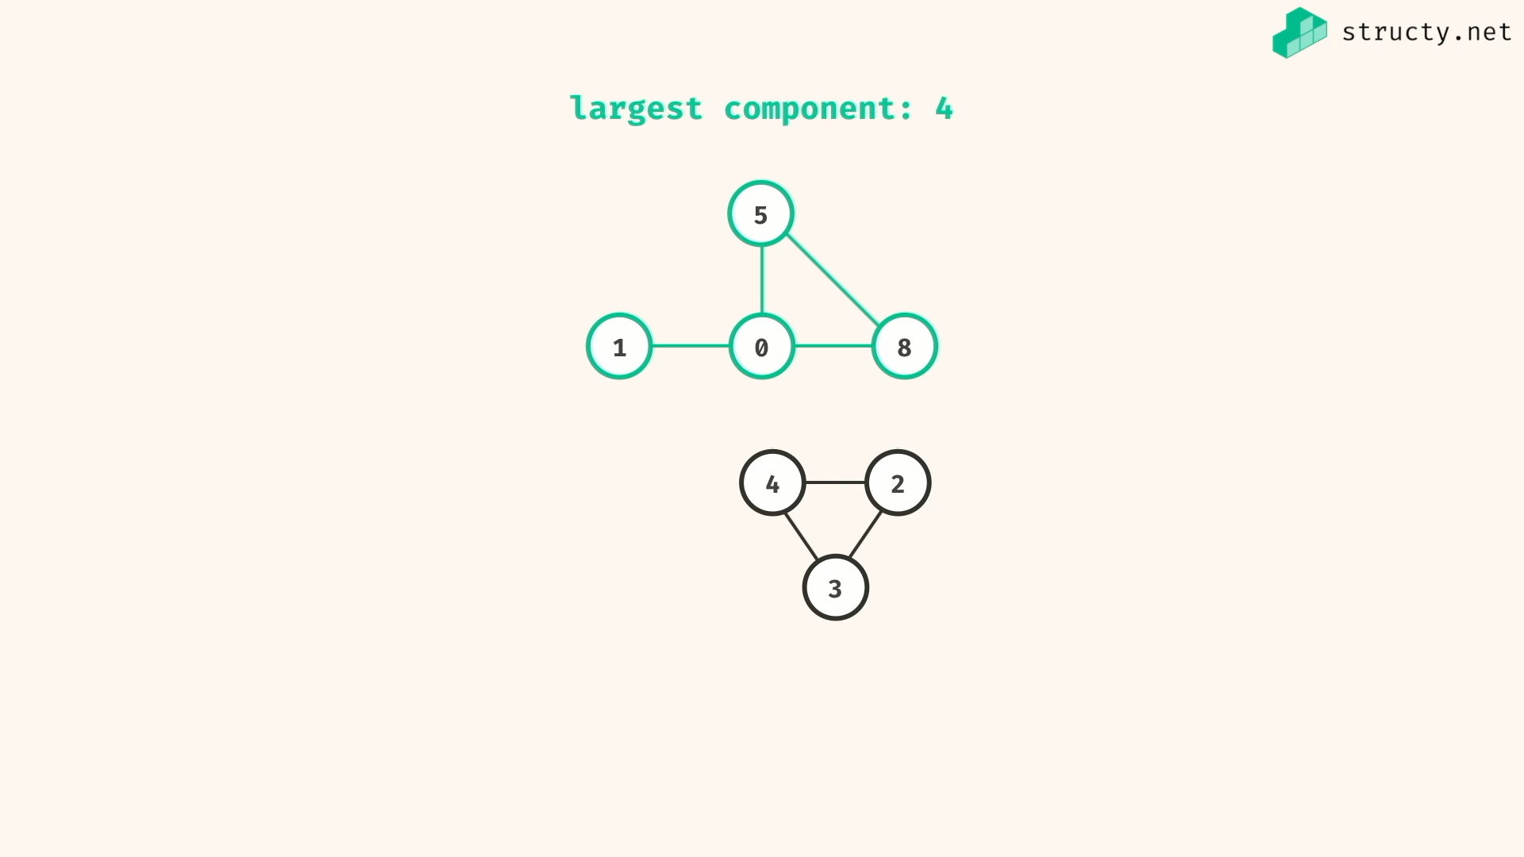

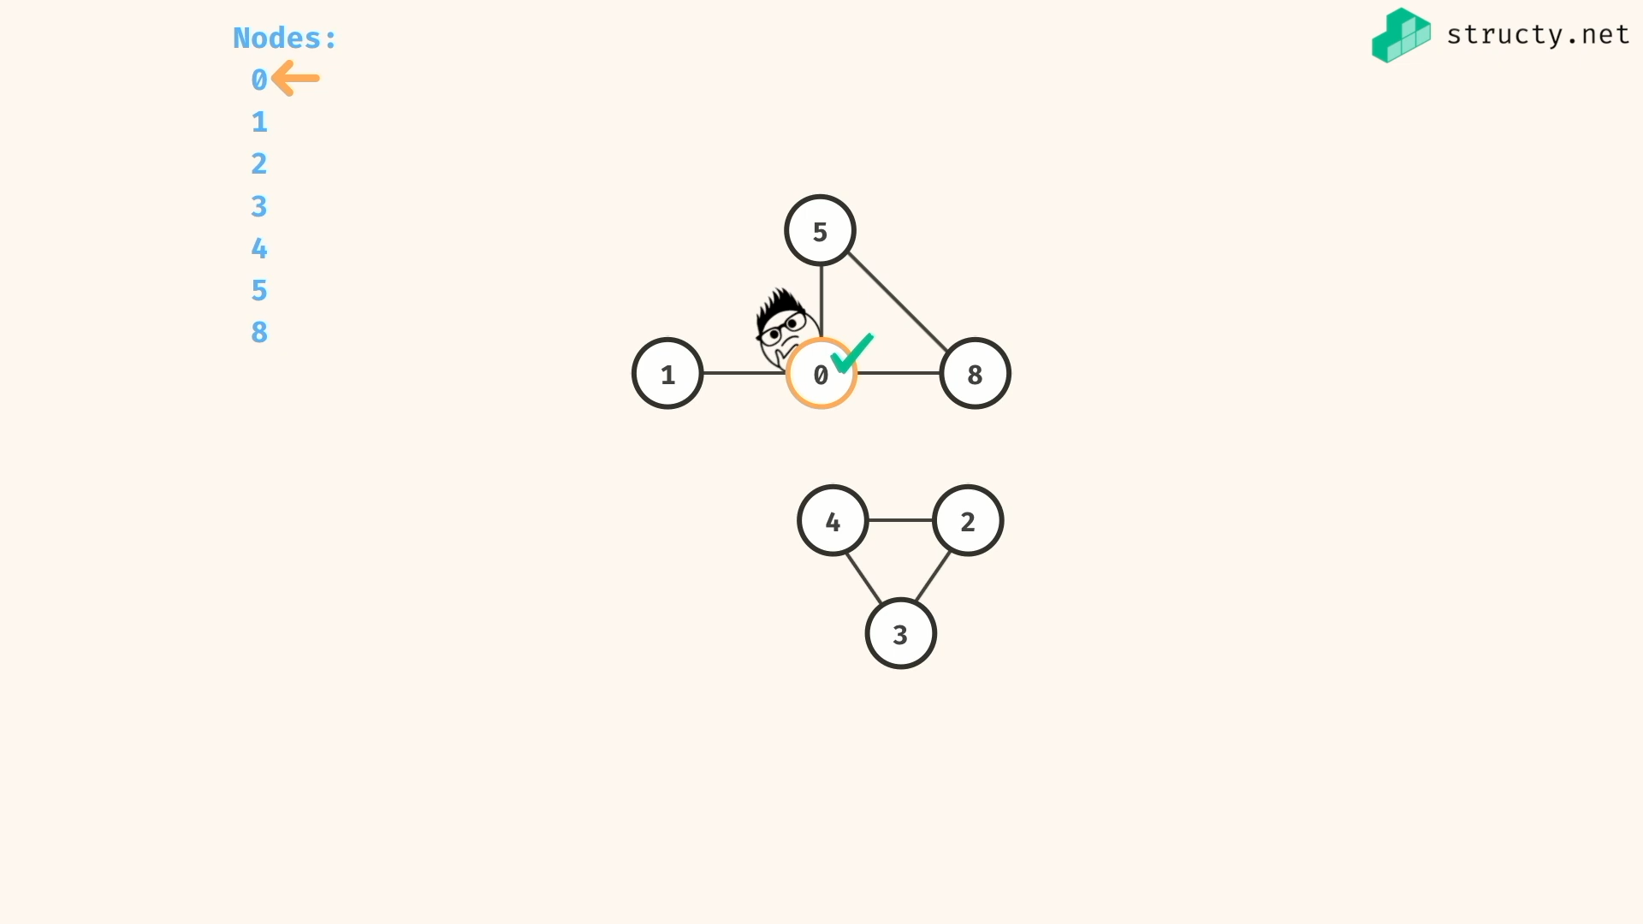

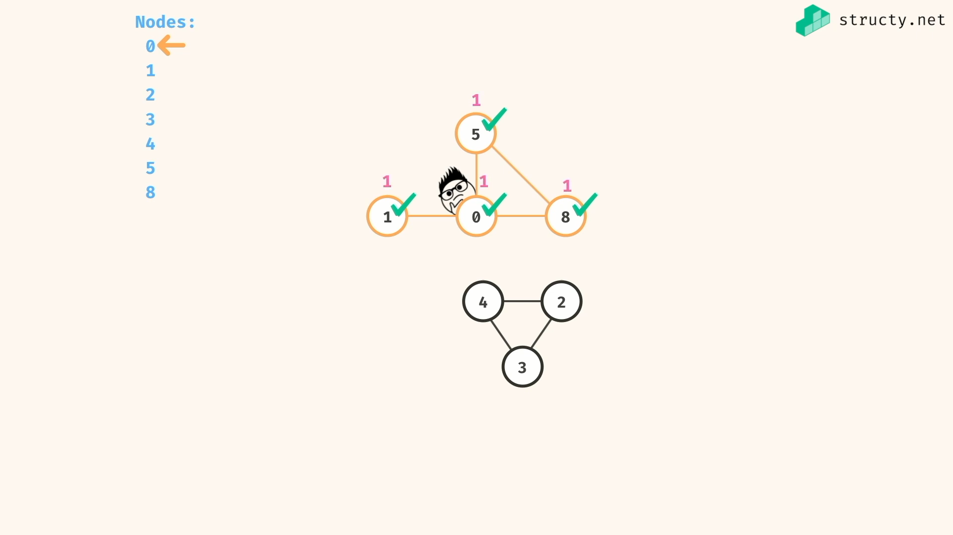

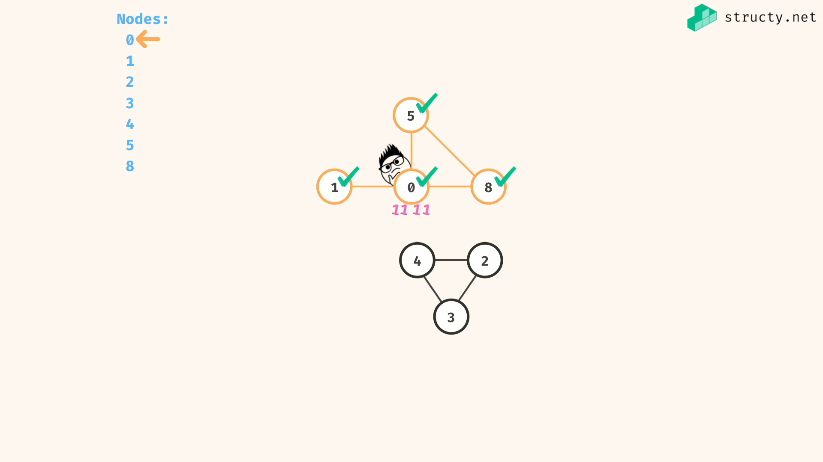

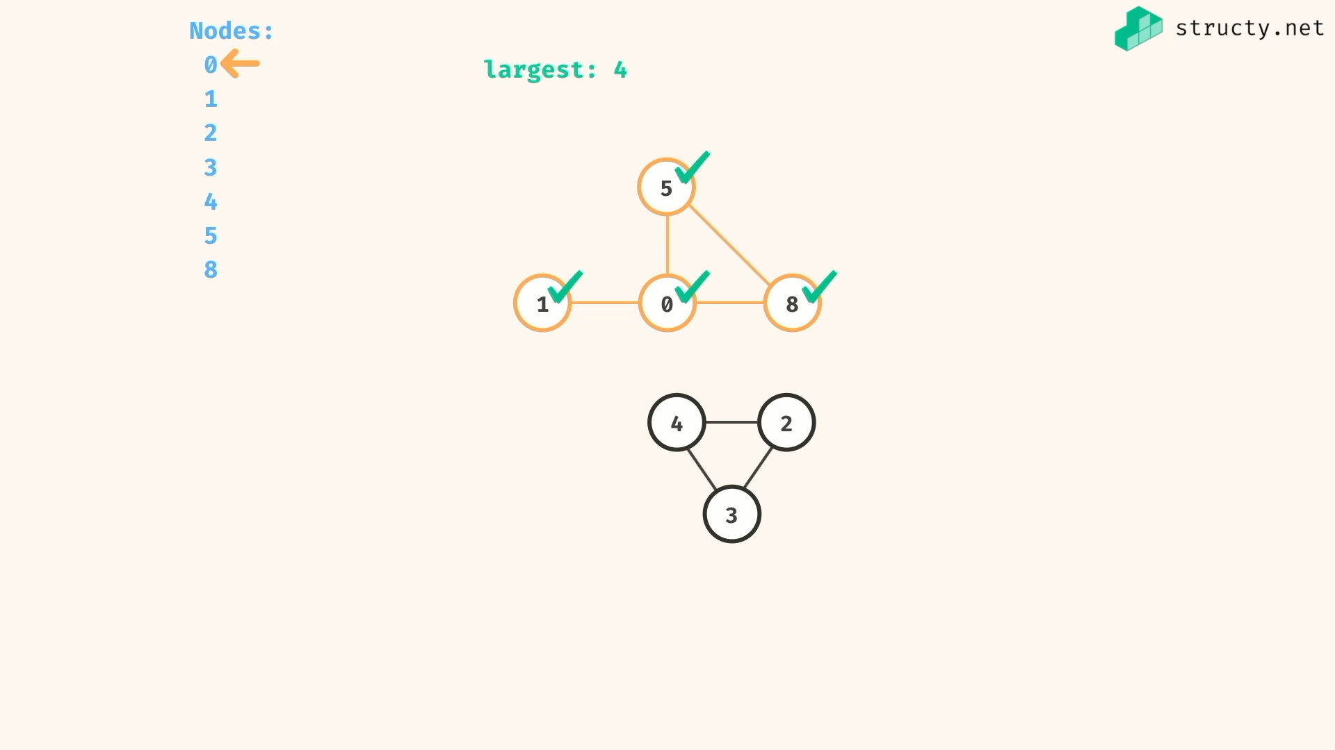

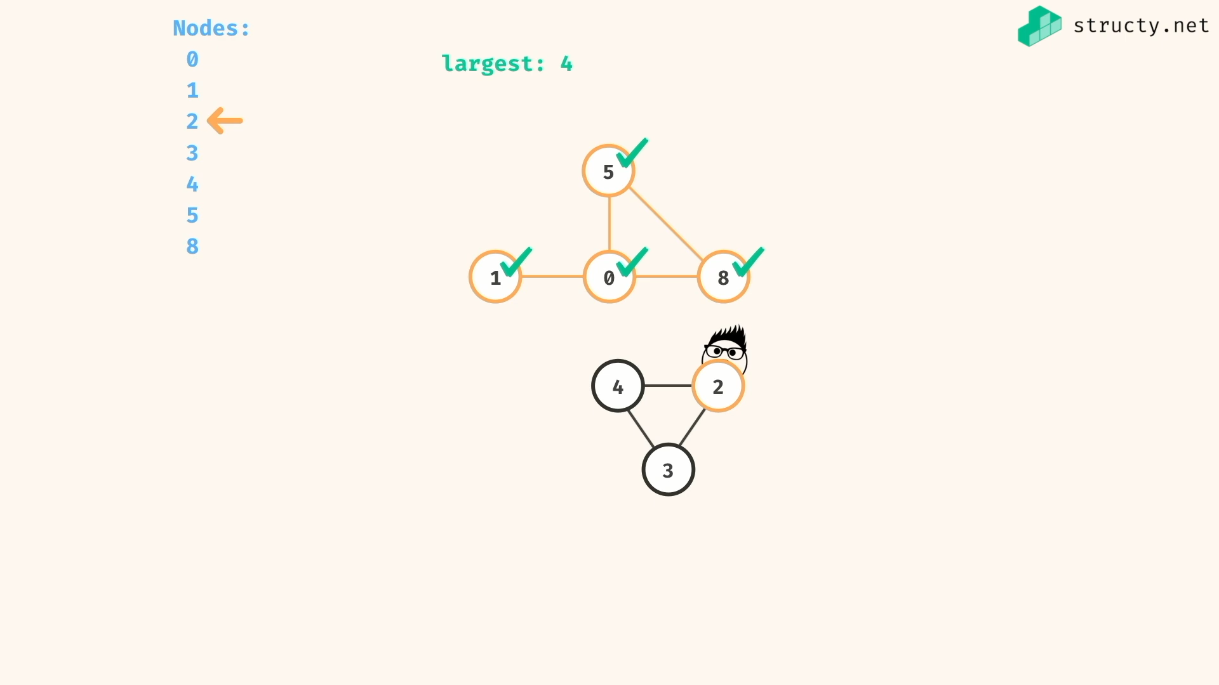

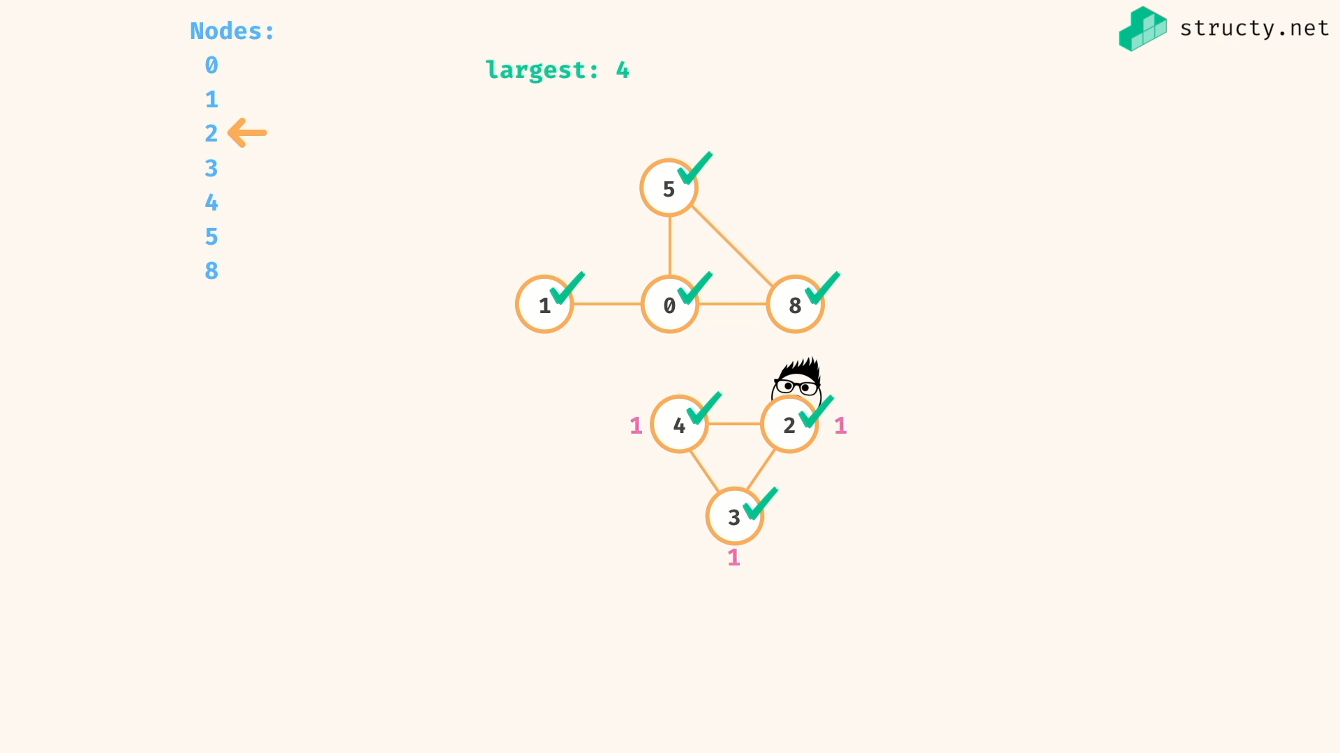

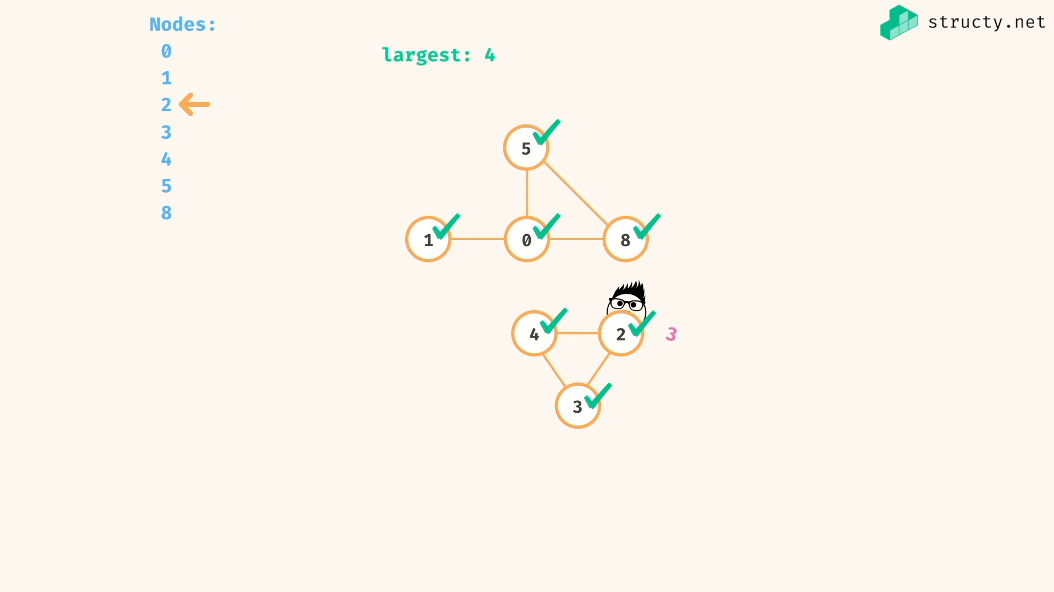

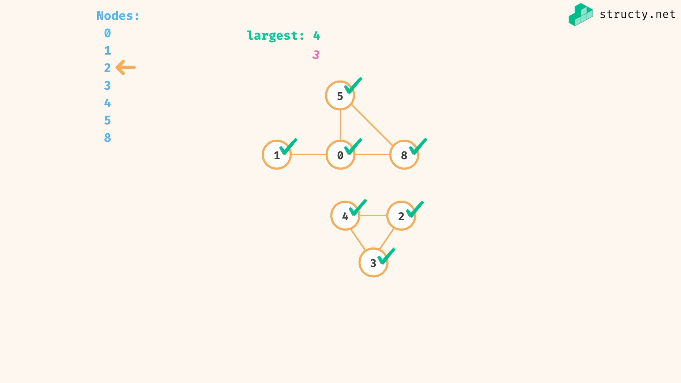

Other nodes are already visited…

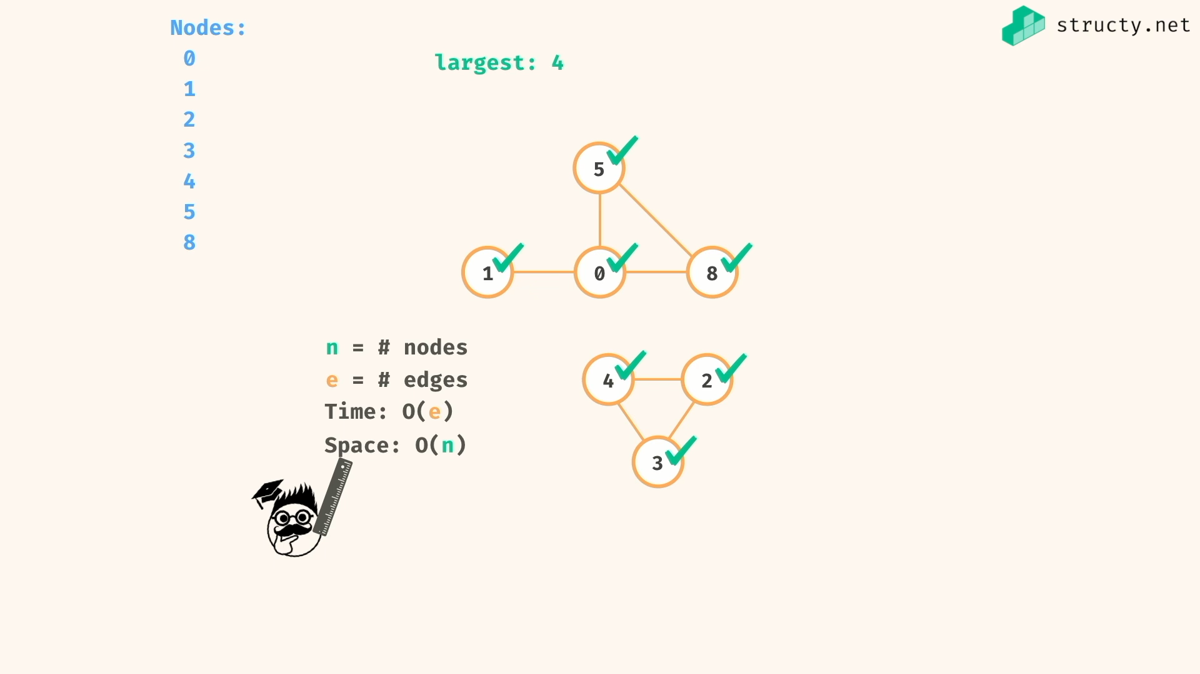

Remember : you have to avoid cycle for any undirected graph by visited set…

*const* getComponentSize = (*graph*,*current*,*visited*) *=>* {

if(visited.has(current)) return 0;

visited.add(current);

*let* nodesCount = 1;

for(*let* neighbour of graph[current])

nodesCount += getComponentSize(graph,neighbour,visited);

return nodesCount;

}

*const* getmaxSizeConnectedComponentSize = (*graph*) *=>* {

*const* visited = new *Set*();

*let* maxSize = 0;

for(*let* node in graph){

*const* currentSize = getComponentSize(graph,*Number*(node),visited);

if(currentSize > maxSize)

maxSize = currentSize;

}

return maxSize;

}

graph = {

0:[8,1,5],

1:[0],

5:[0,8],

8:[0,5],

2:[3,4],

3:[2,4],

4:[3,2]

};

*console*.log(getmaxSizeConnectedComponentSize(graph)) //=> 4

Things to note:

If the graph has disconnected components, then you must need an iterative code with recursive DFS to hop to different components..

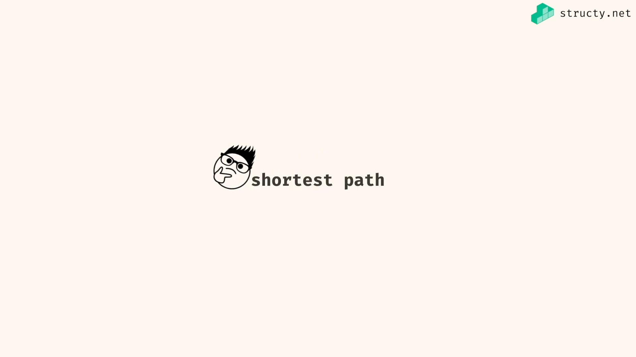

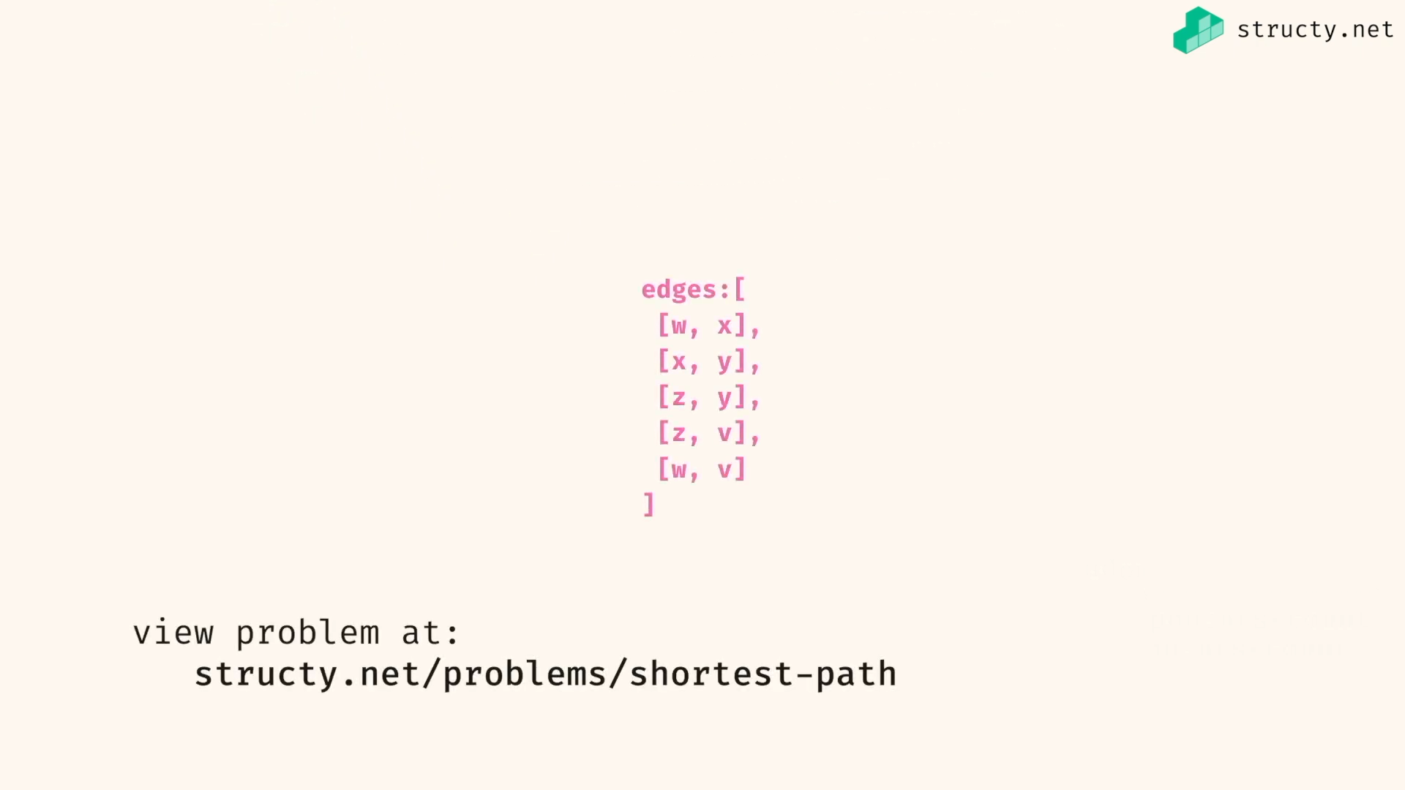

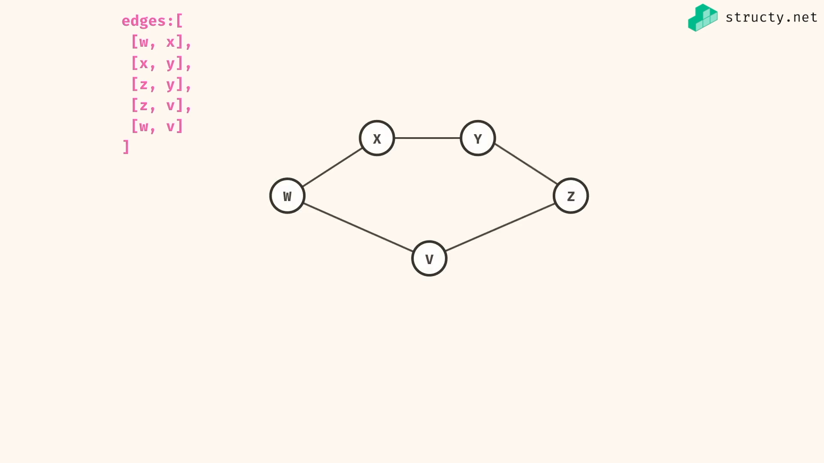

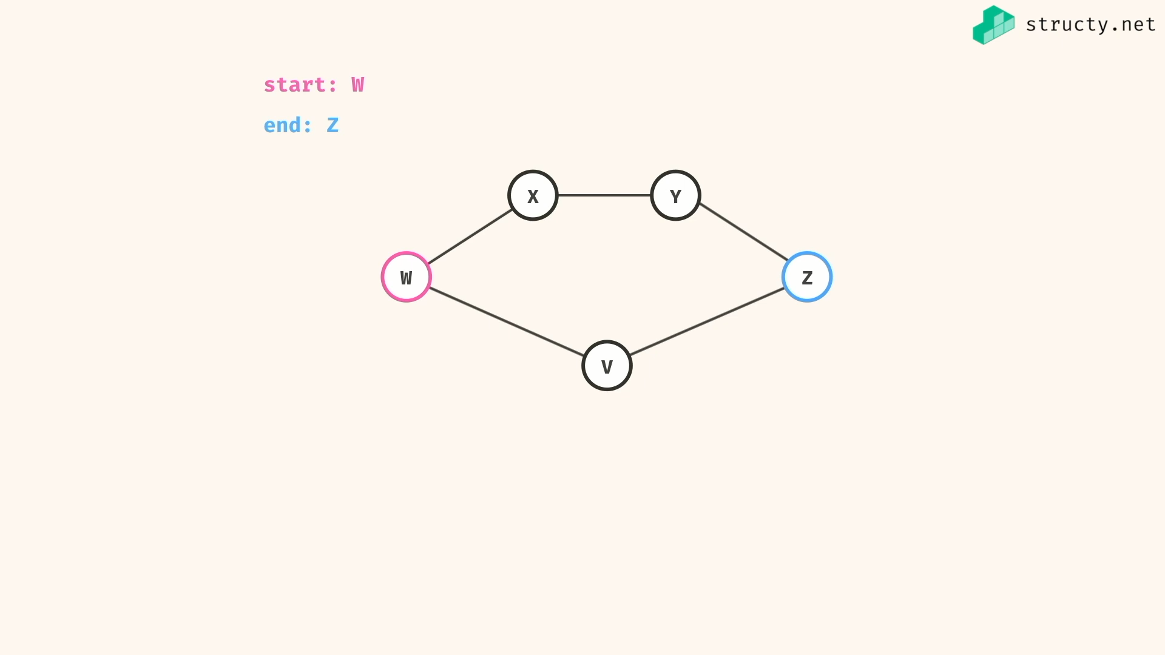

Path = no.of edges

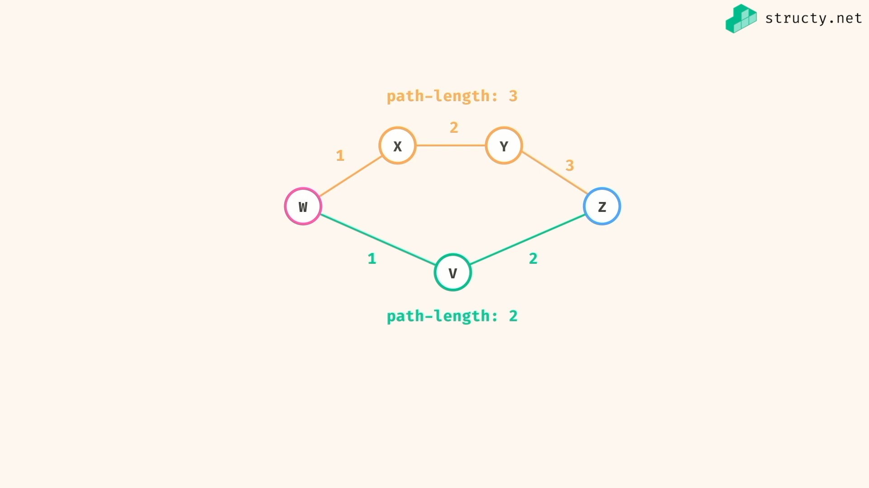

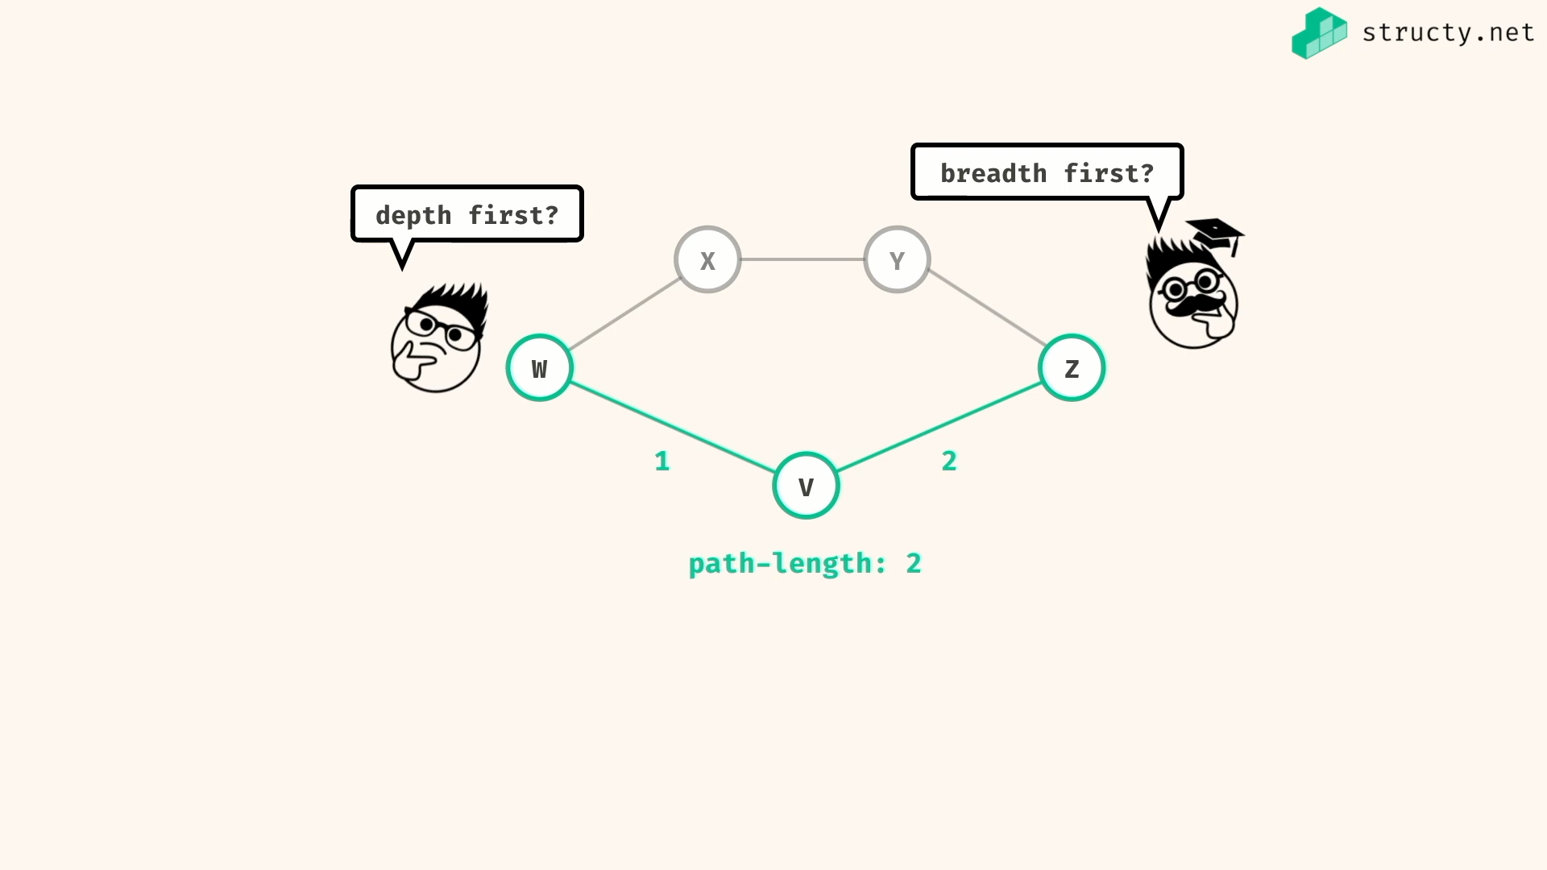

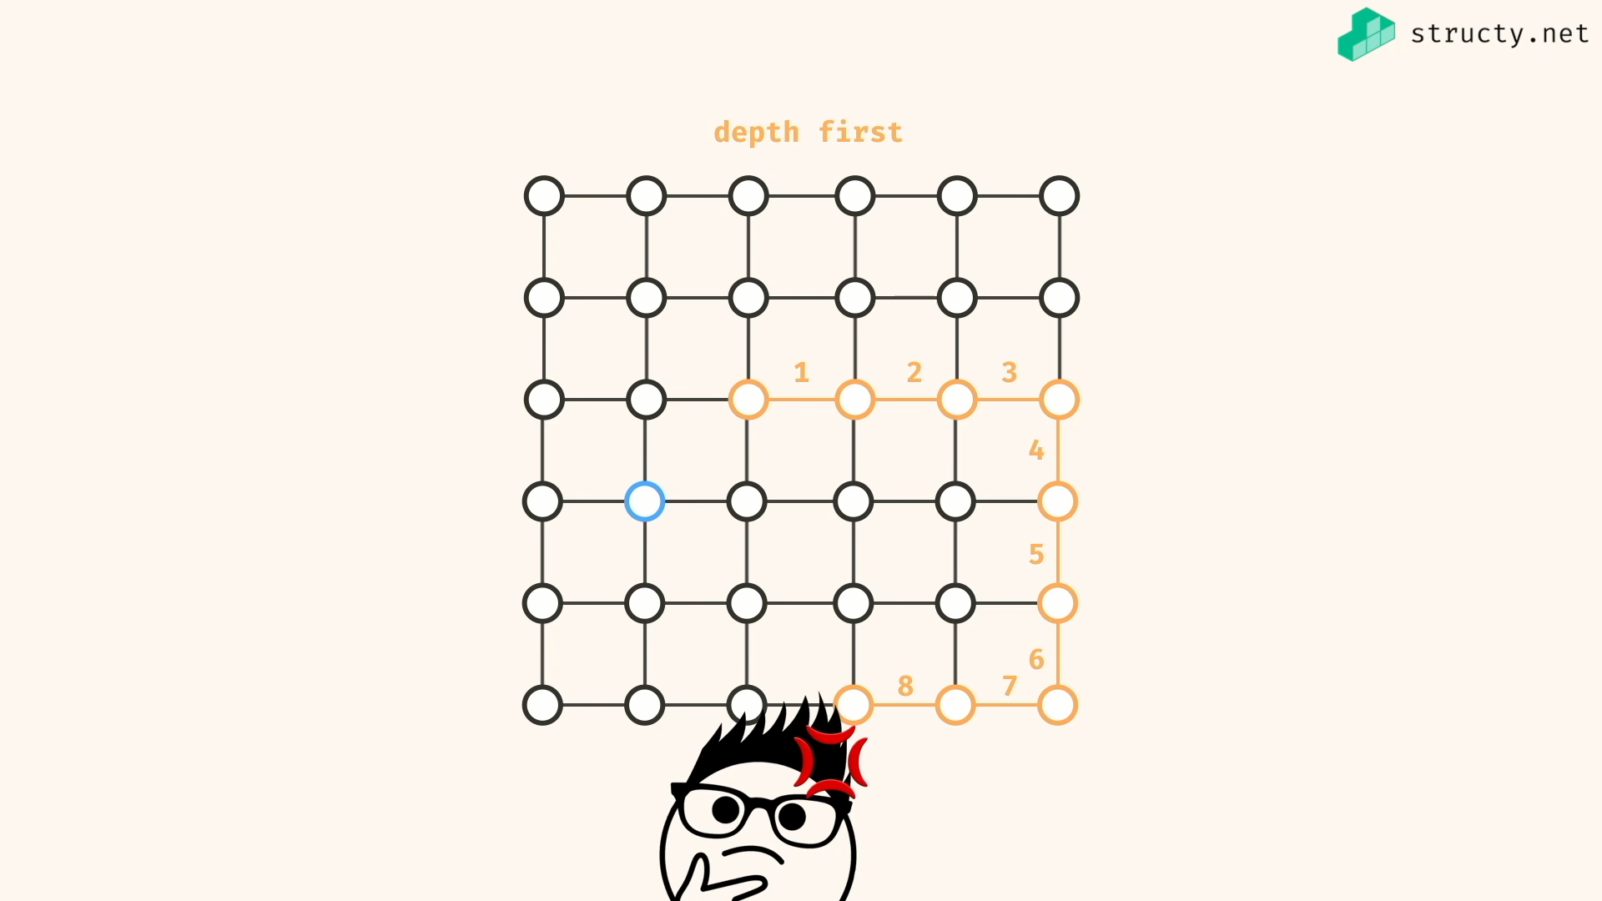

Depth first may take wrong path and dive deep into it unnecessarily…

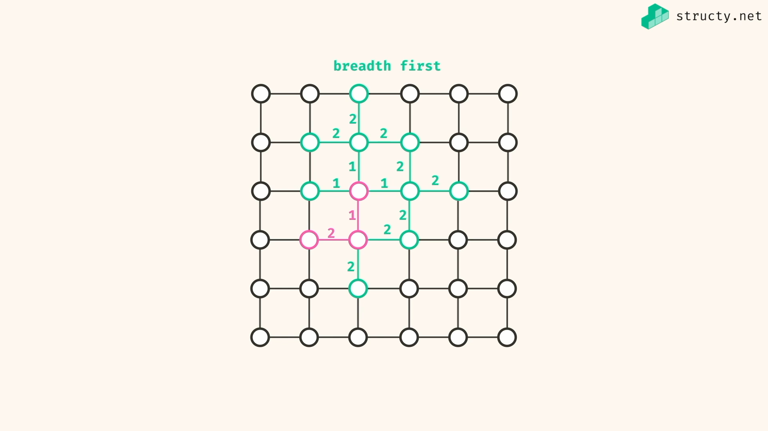

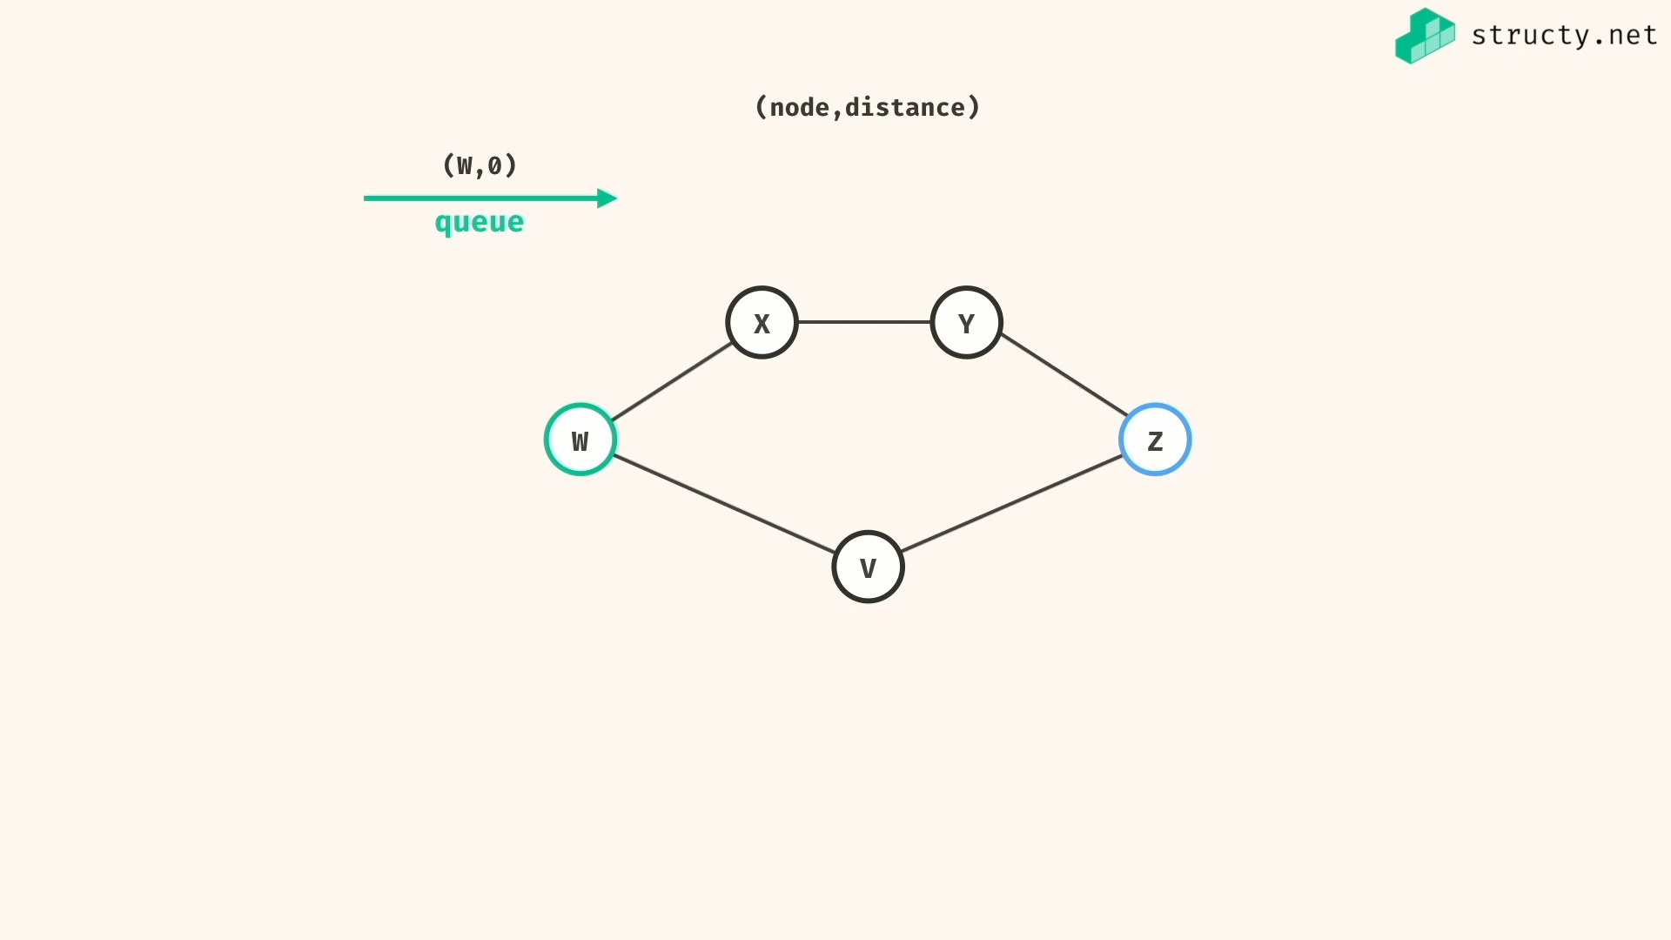

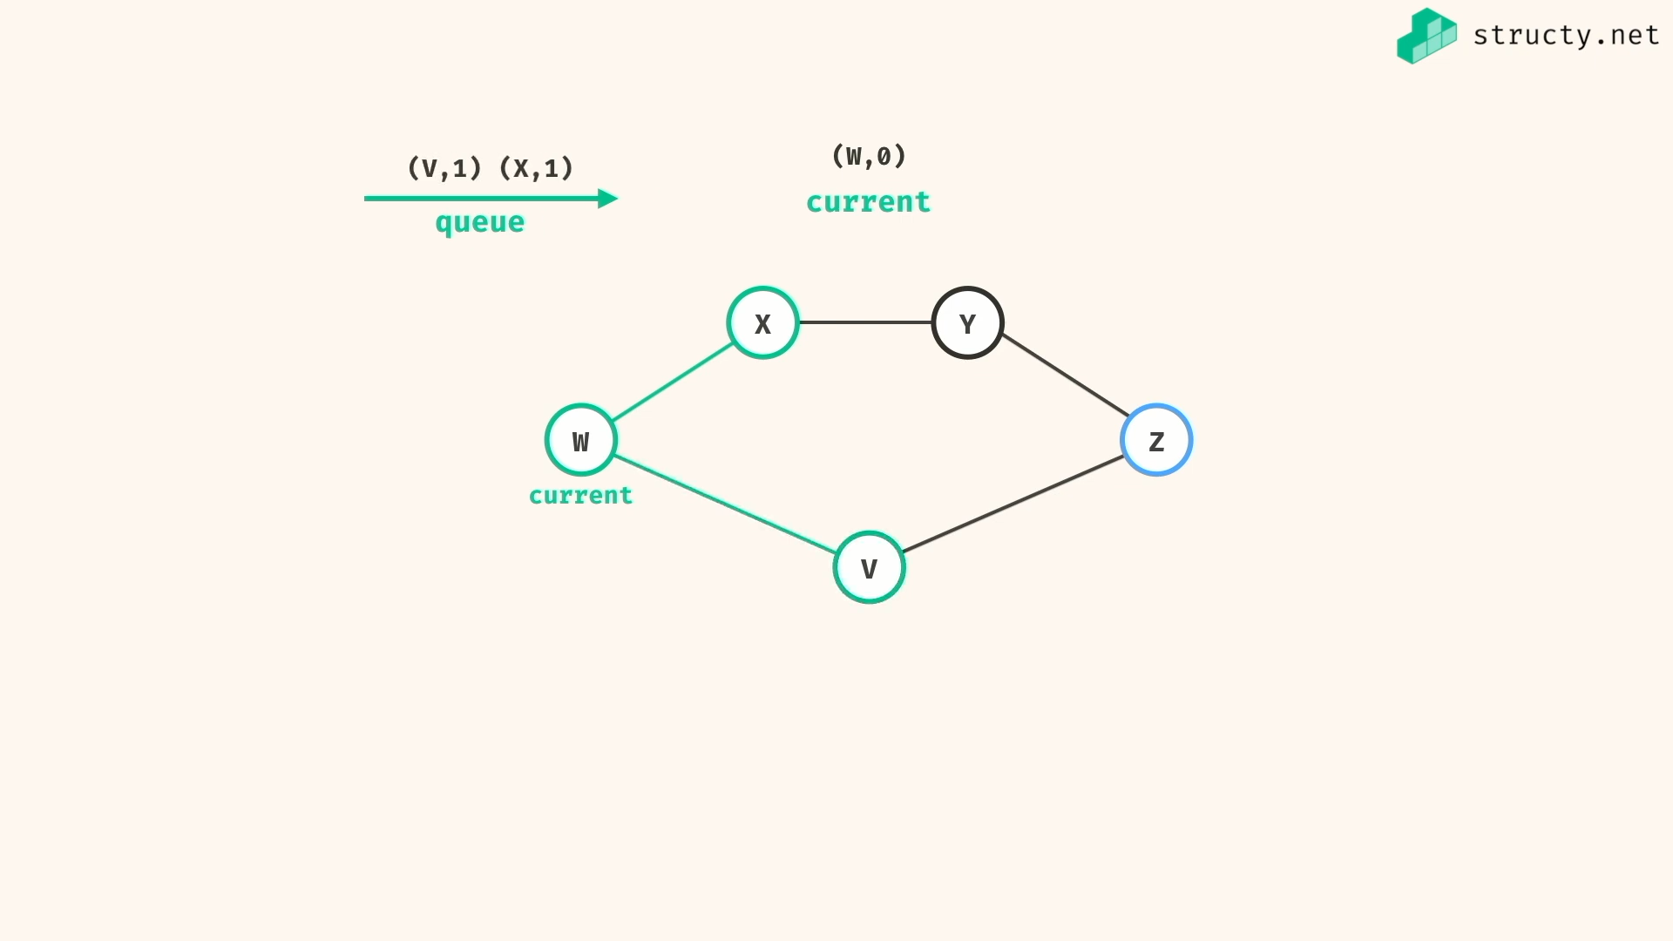

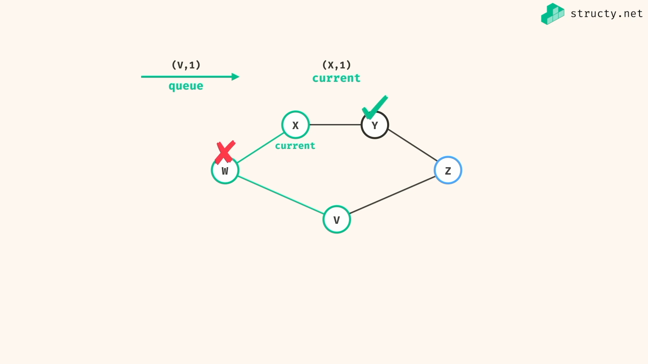

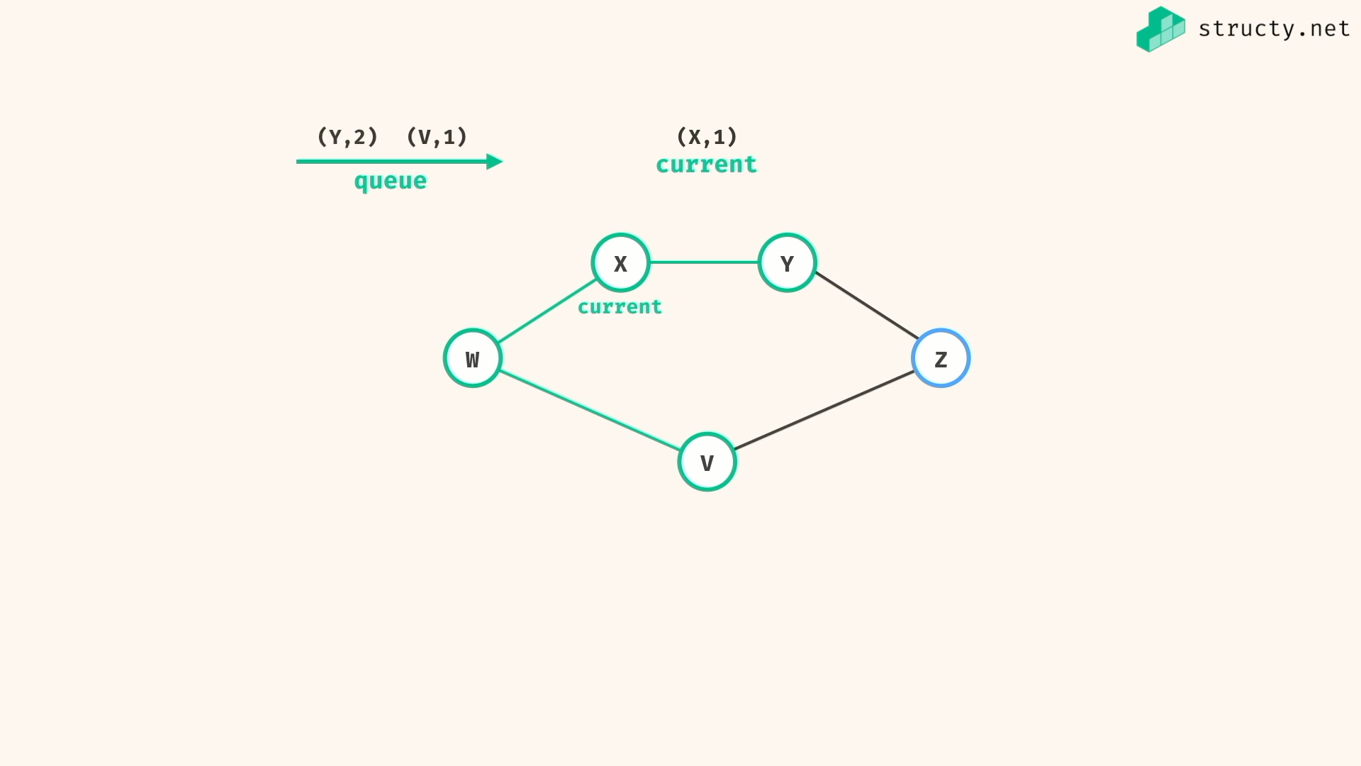

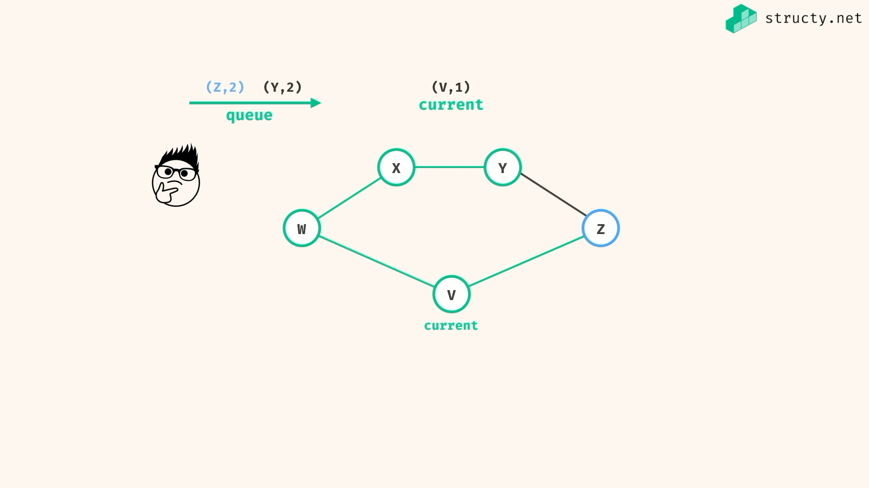

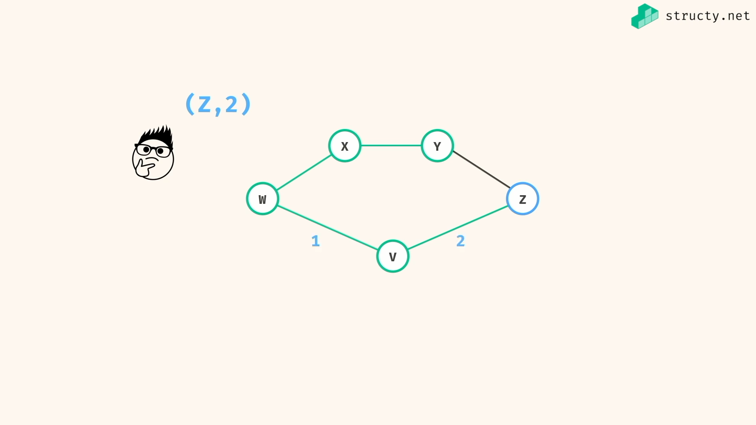

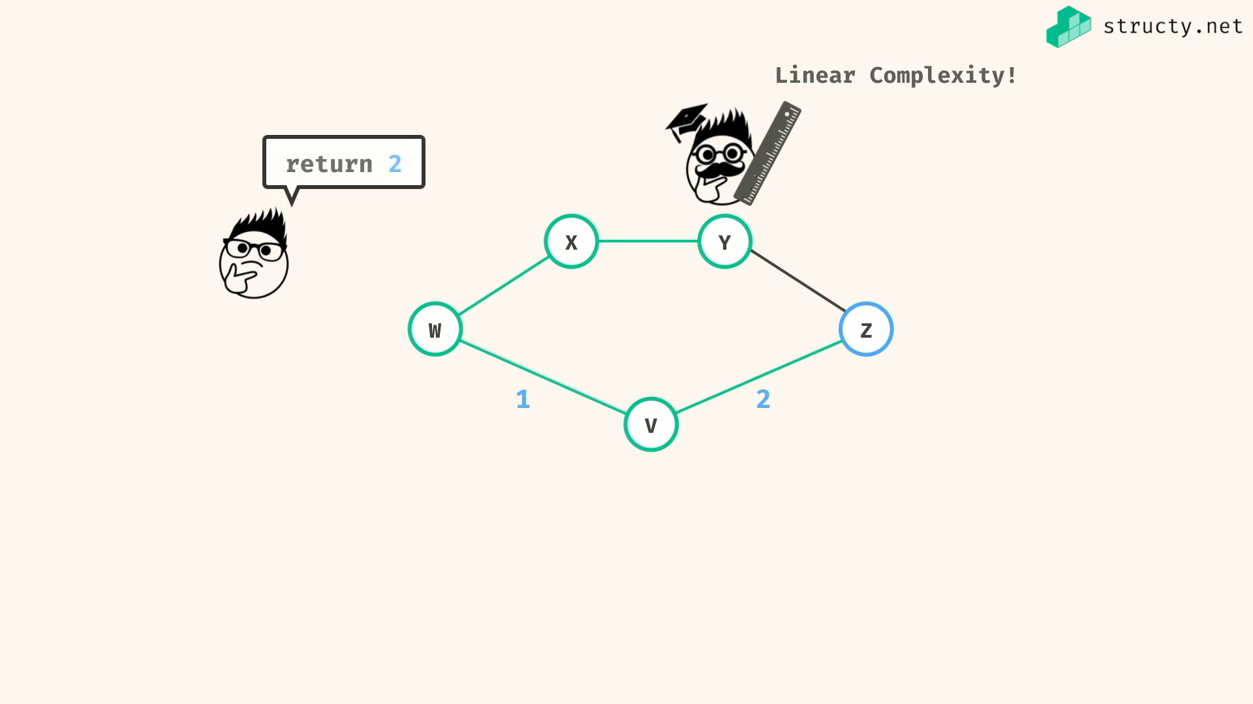

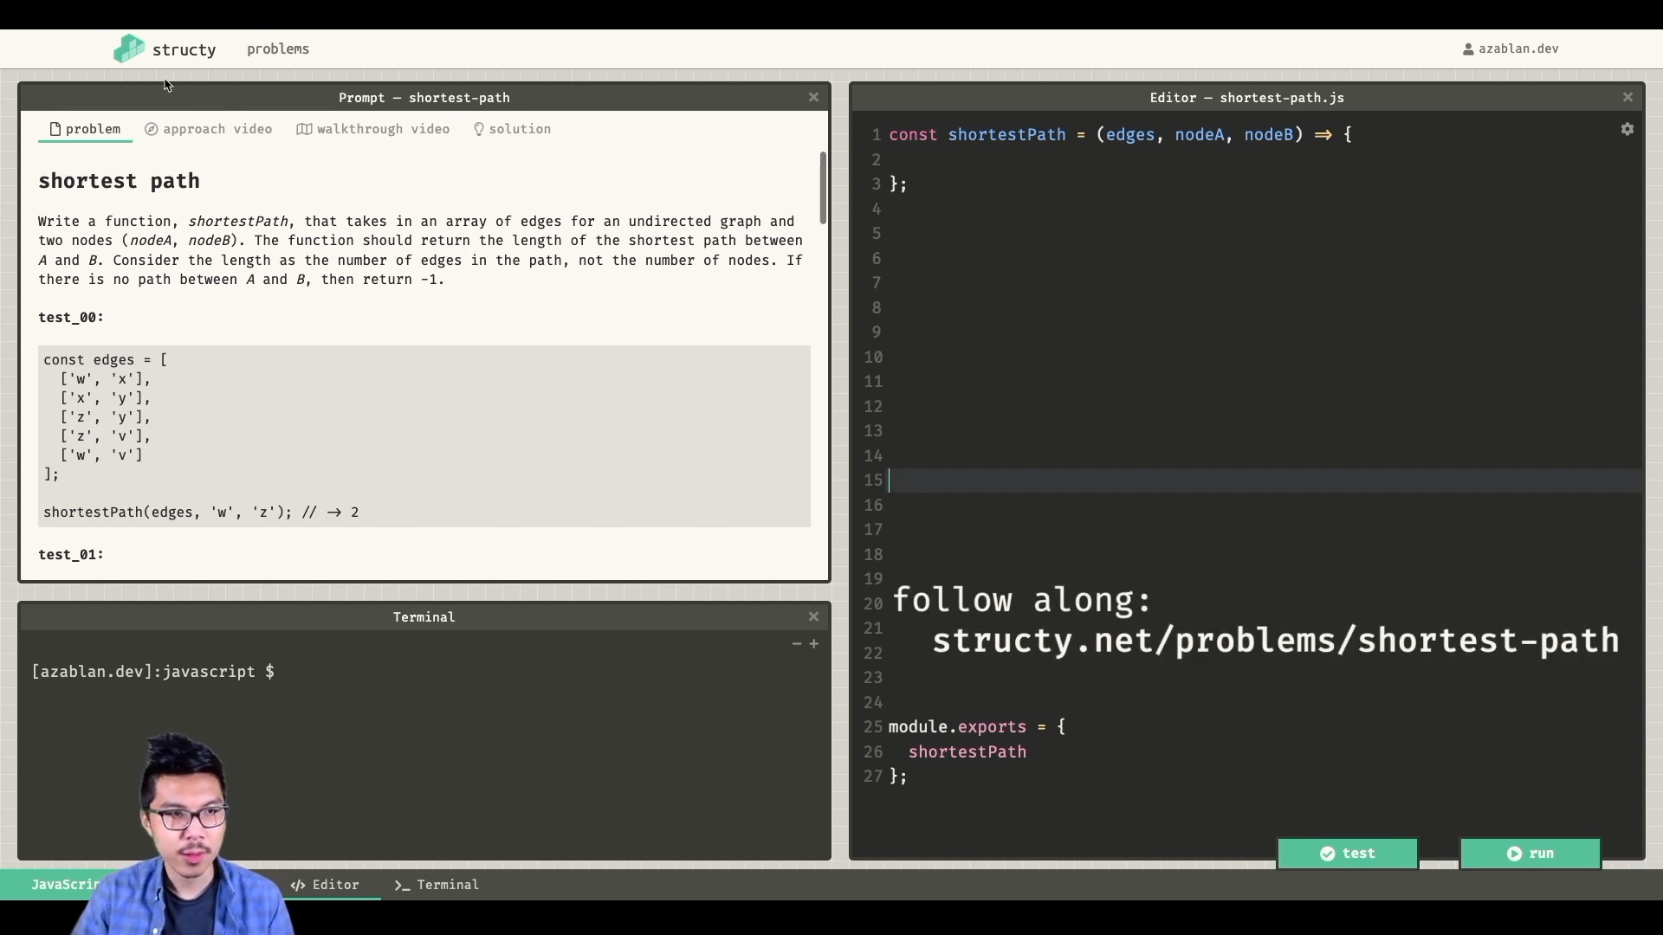

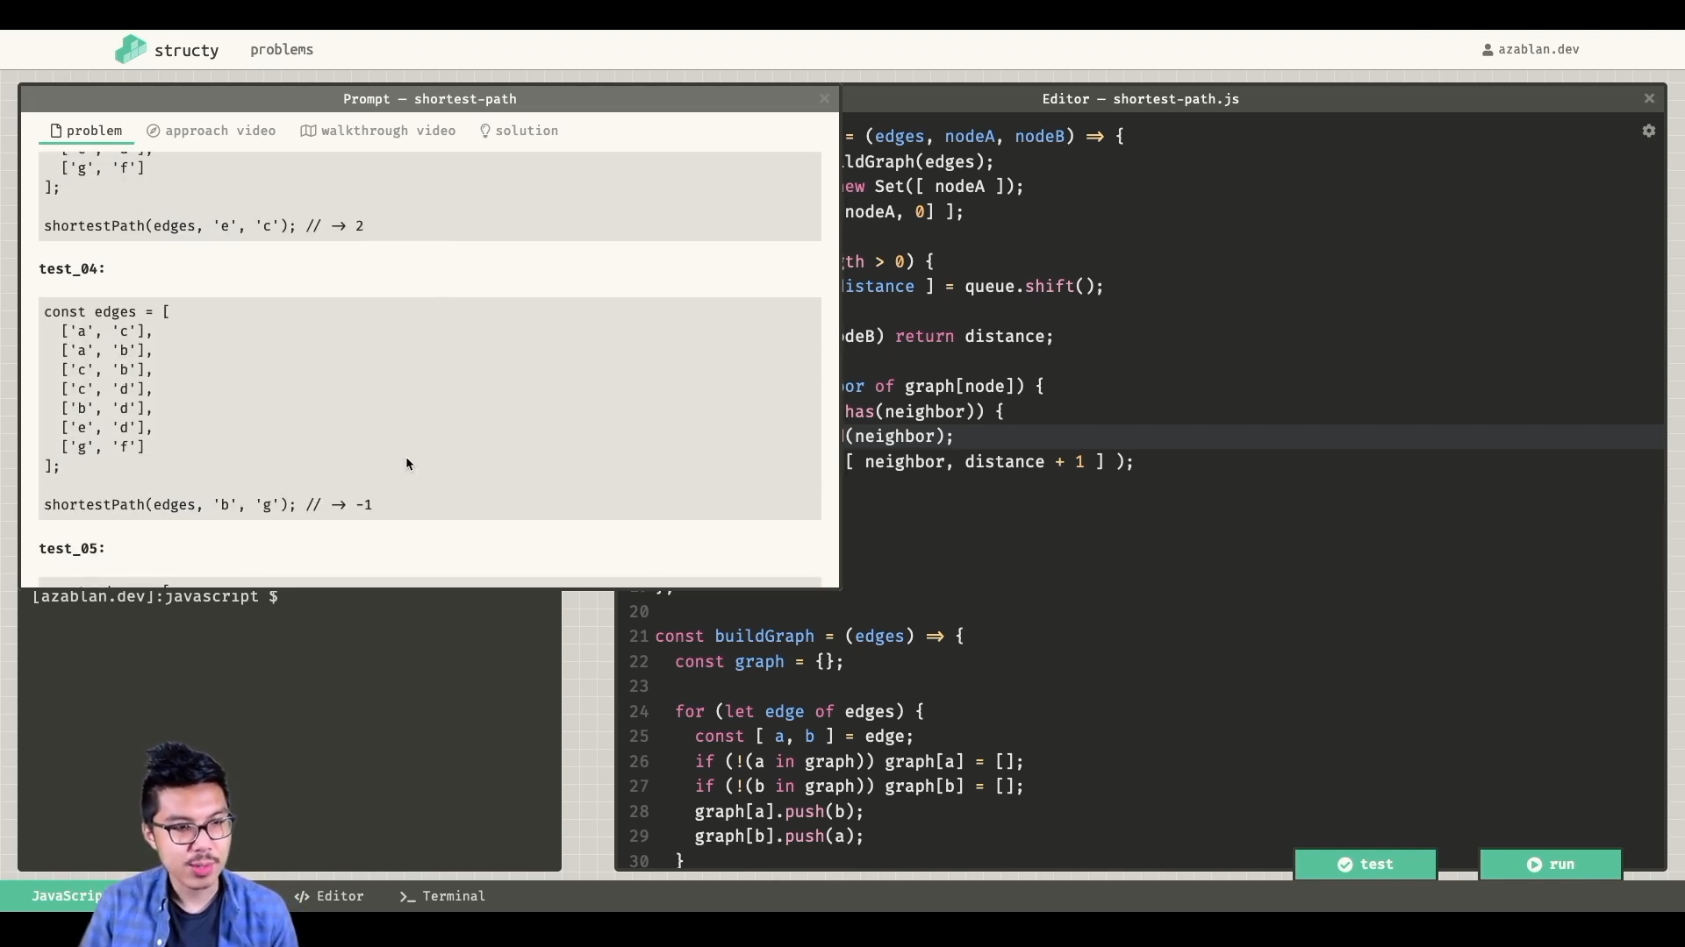

*const* buildGraph = (*edges*) *=>* {

*const* graph = {};

for(*let* edge of edges){

*const* [ a,b ] = edge;

if(!(a in graph)) graph[a] = [];

if(!(b in graph)) graph[b] = [];

graph[a].push(b);

graph[b].push(a);

}

return graph;

}

*const* shortestPath = (*edges*,*src*,*dst*) *=>* {

*const* graph = buildGraph(edges);

*const* visited = new *Set* ([ src ])

*const* queue = [ [ src, 0 ] ];

while(queue.length > 0){

*const* [ current, distance ] = queue.shift();

if( current === dst ) return distance;

for(*let* neighbor of graph[current]){

if(!visited.has(neighbor)){

visited.add(neighbor);

queue.push([ neighbor, distance+1 ]);

}

}

}

return -1;

}

*const* edges = [

['w','x'],

['x','y'],

['z','y'],

['z','v'],

['w','v']

];

*console*.log(shortestPath(edges,'w','z')); //=> 2

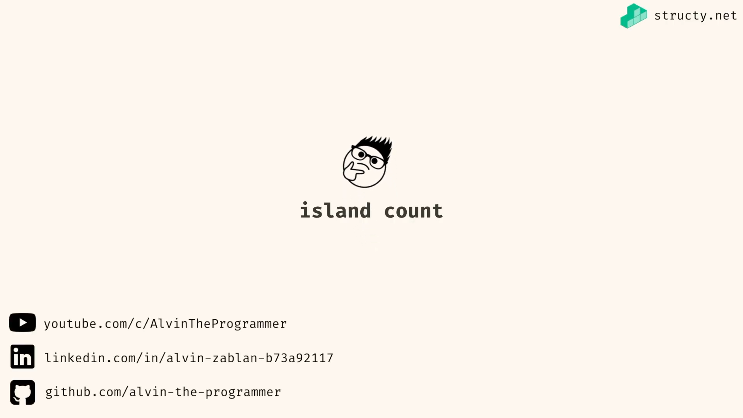

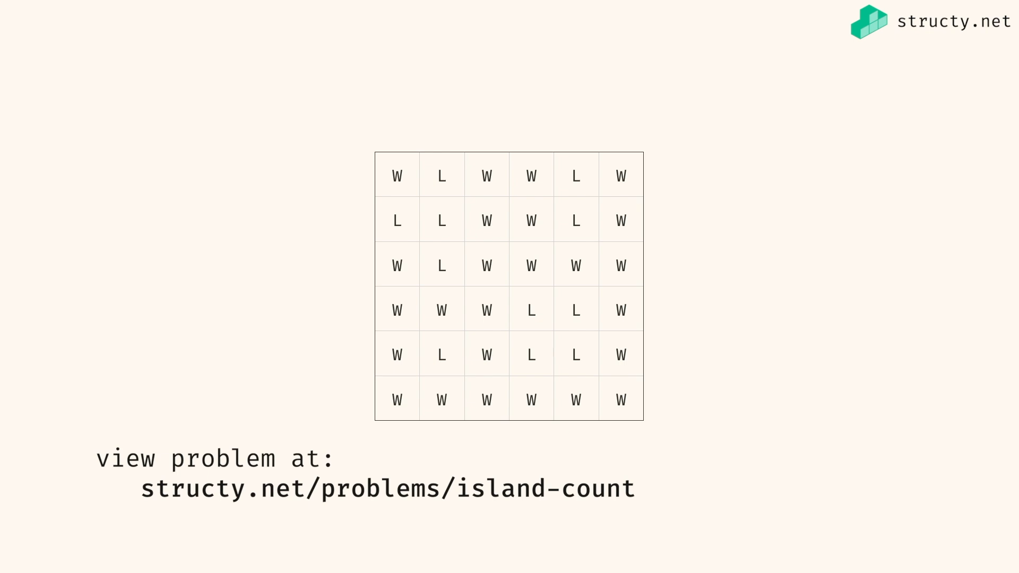

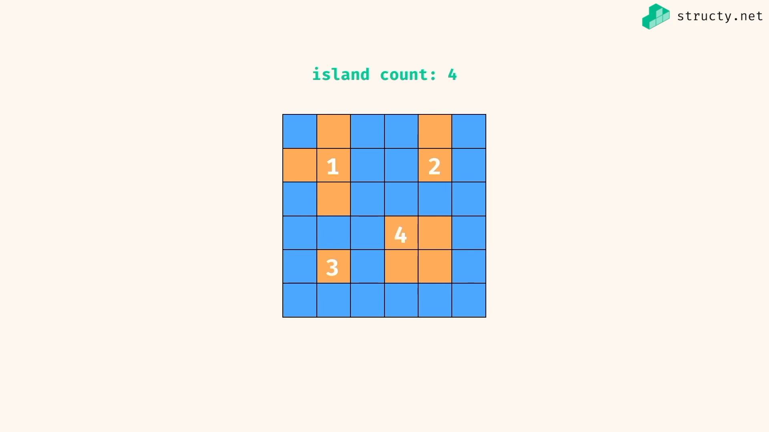

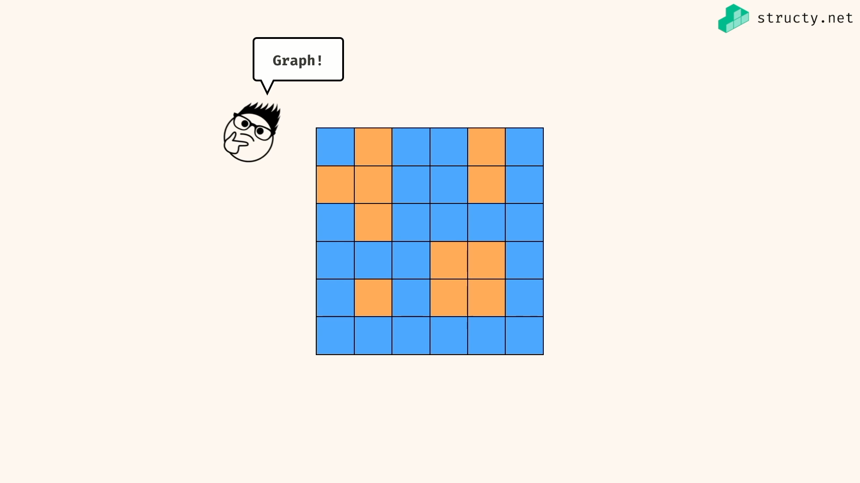

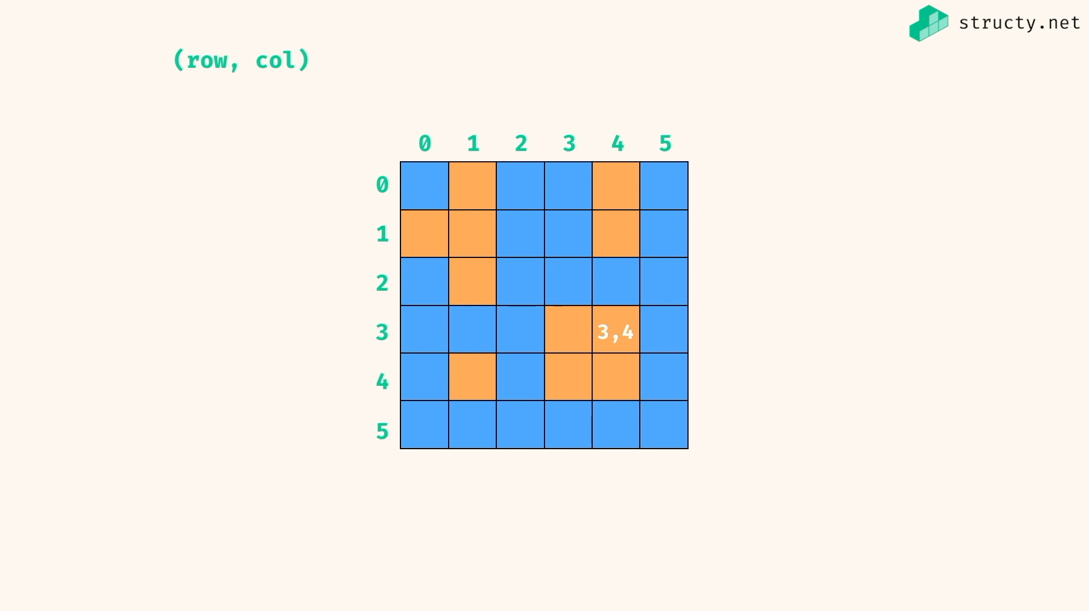

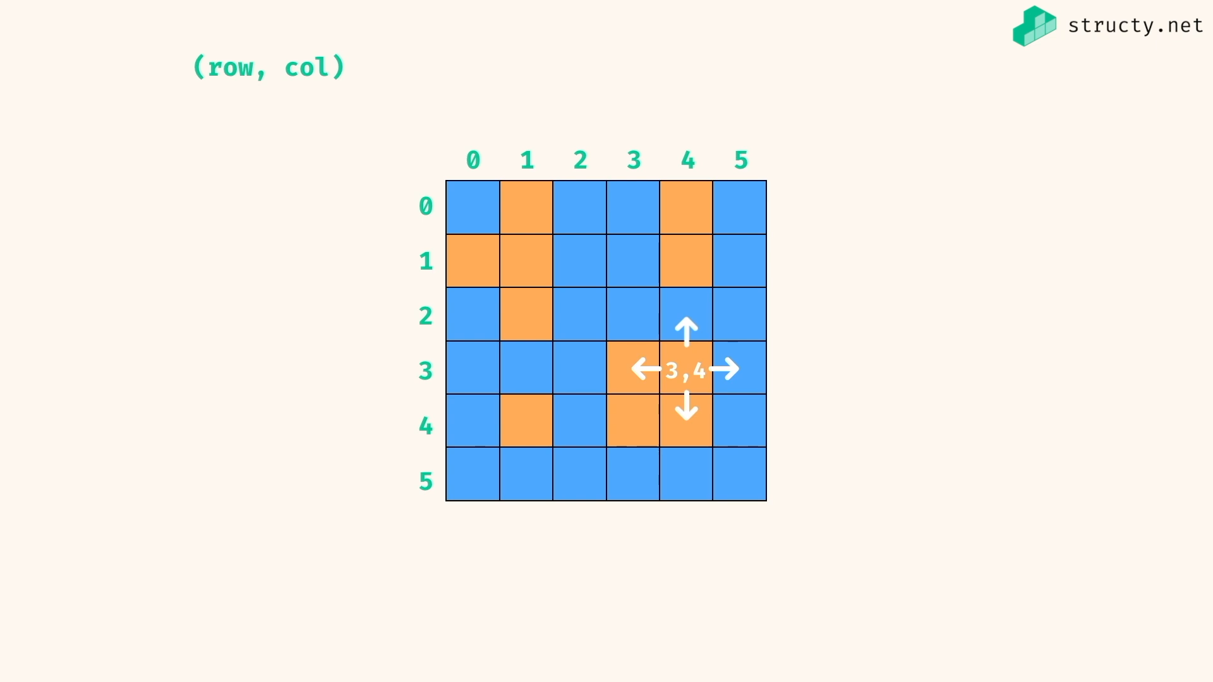

Any positions are nodes …

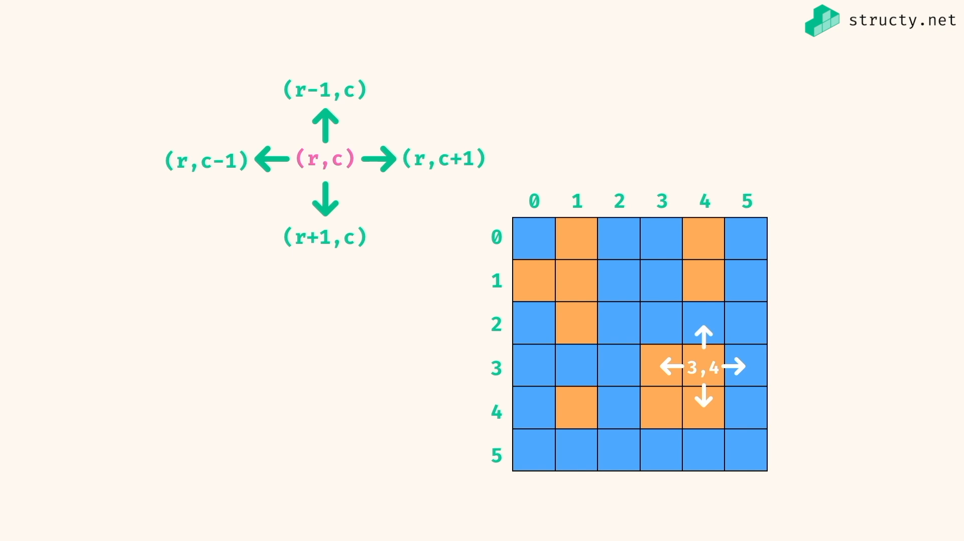

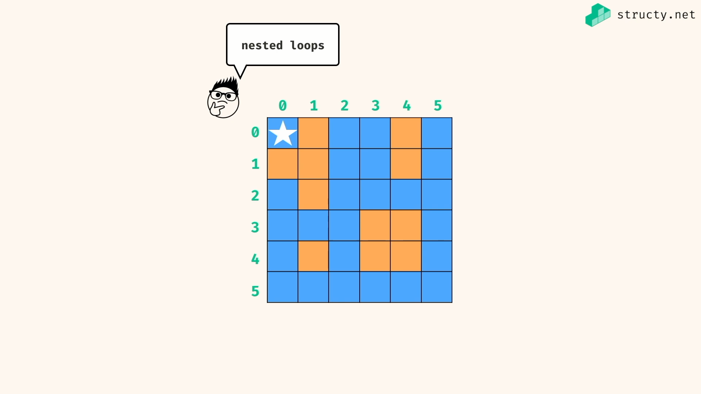

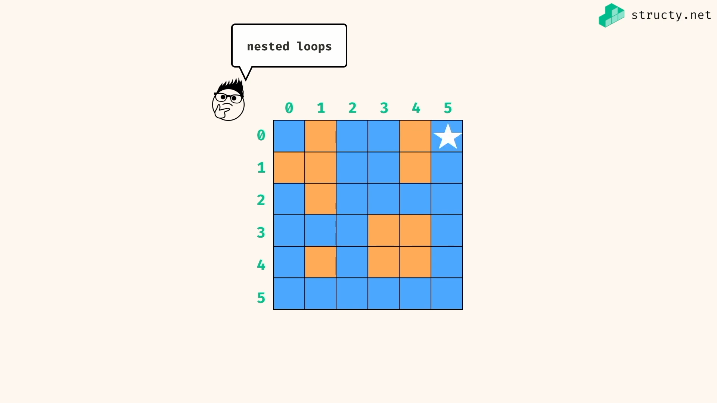

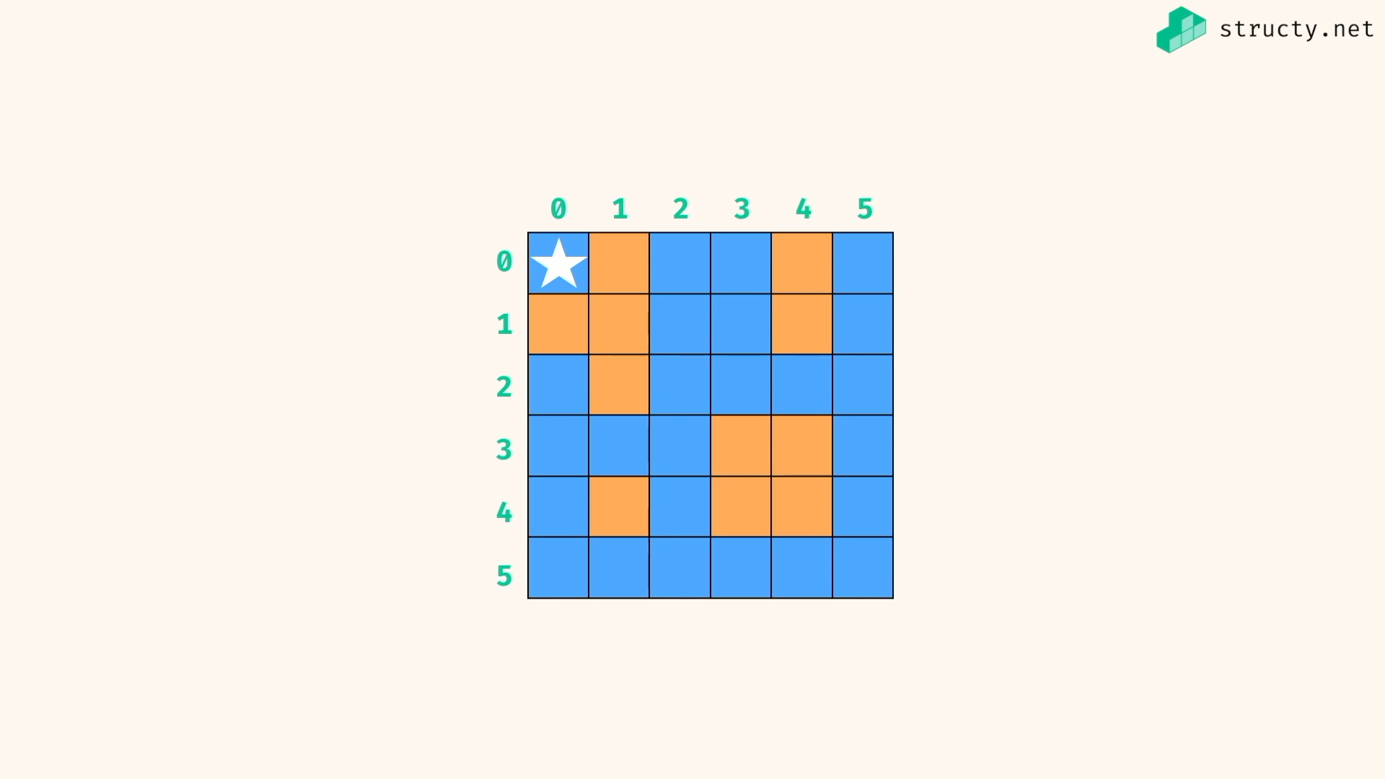

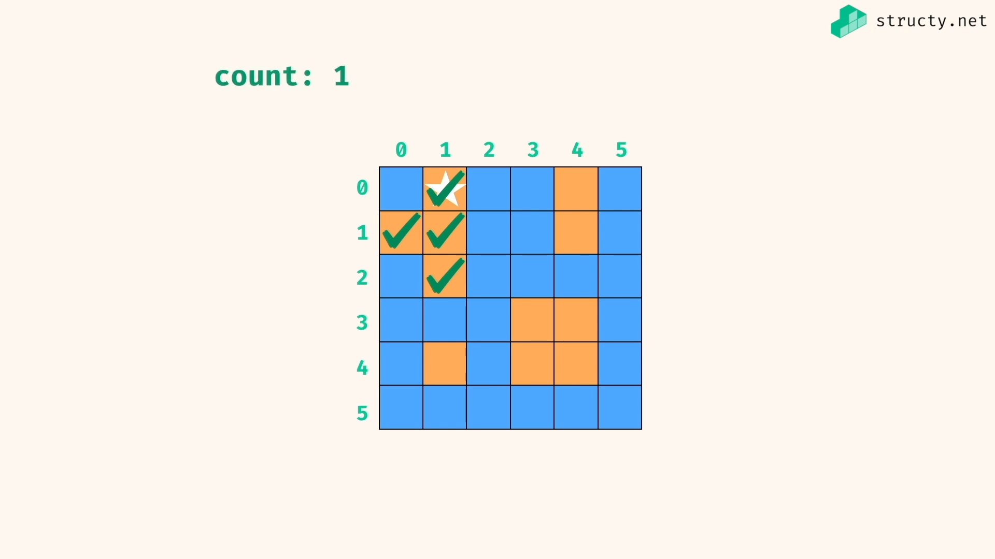

Using depth first search…

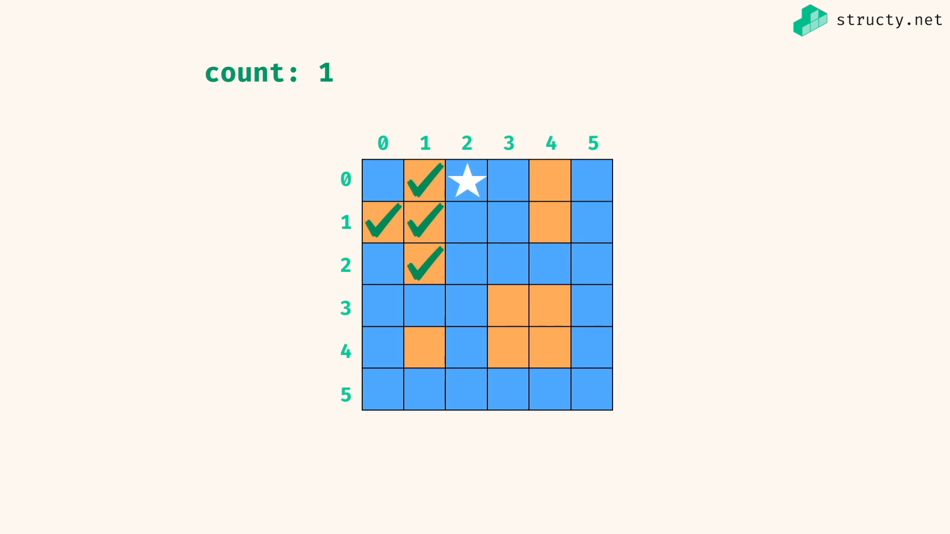

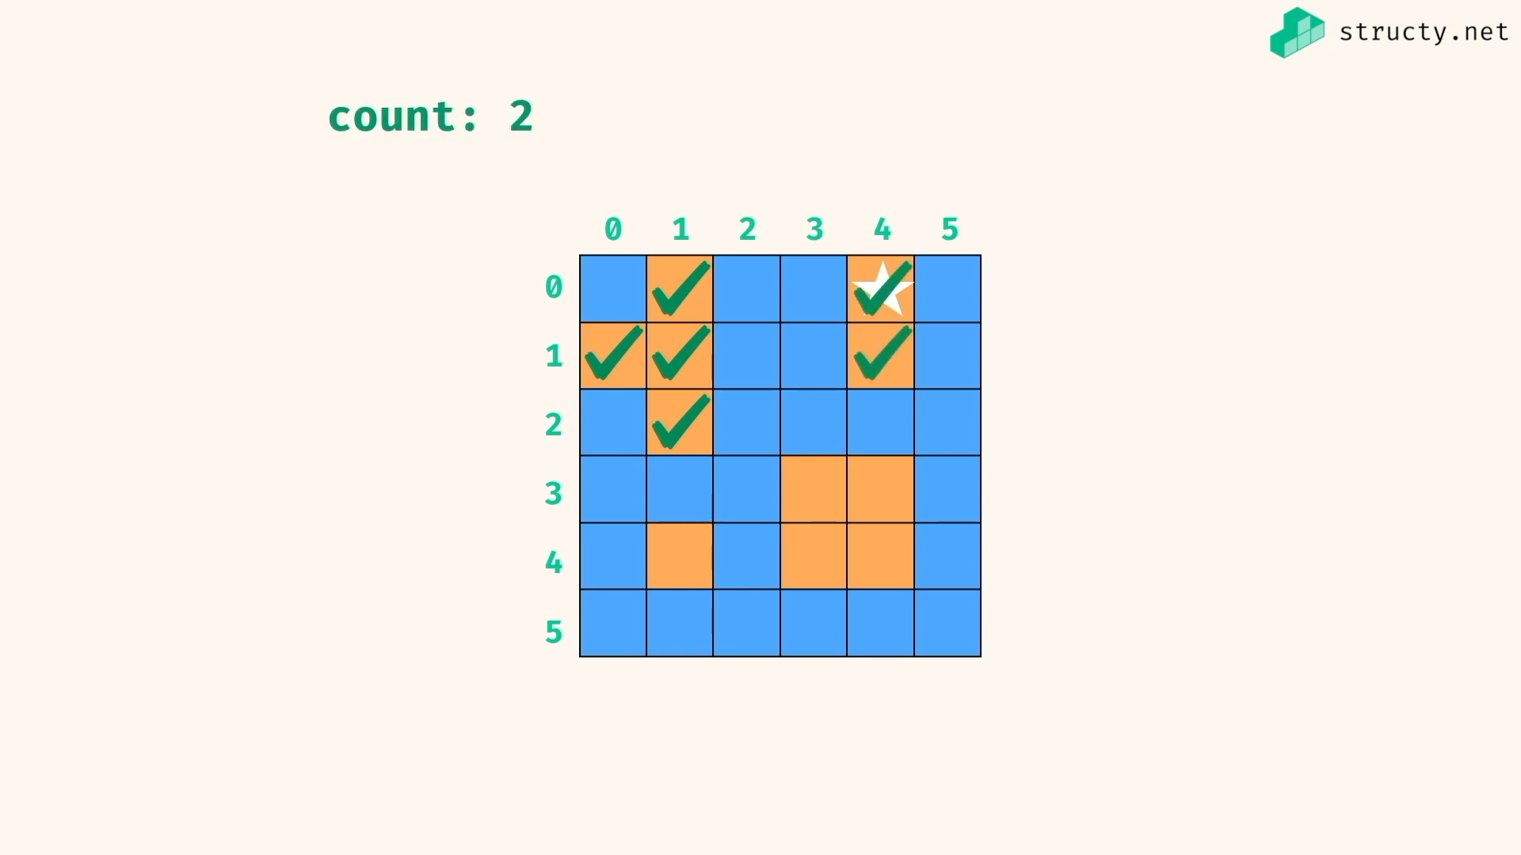

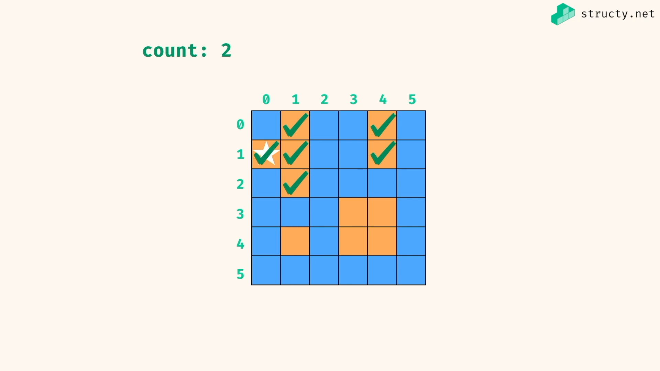

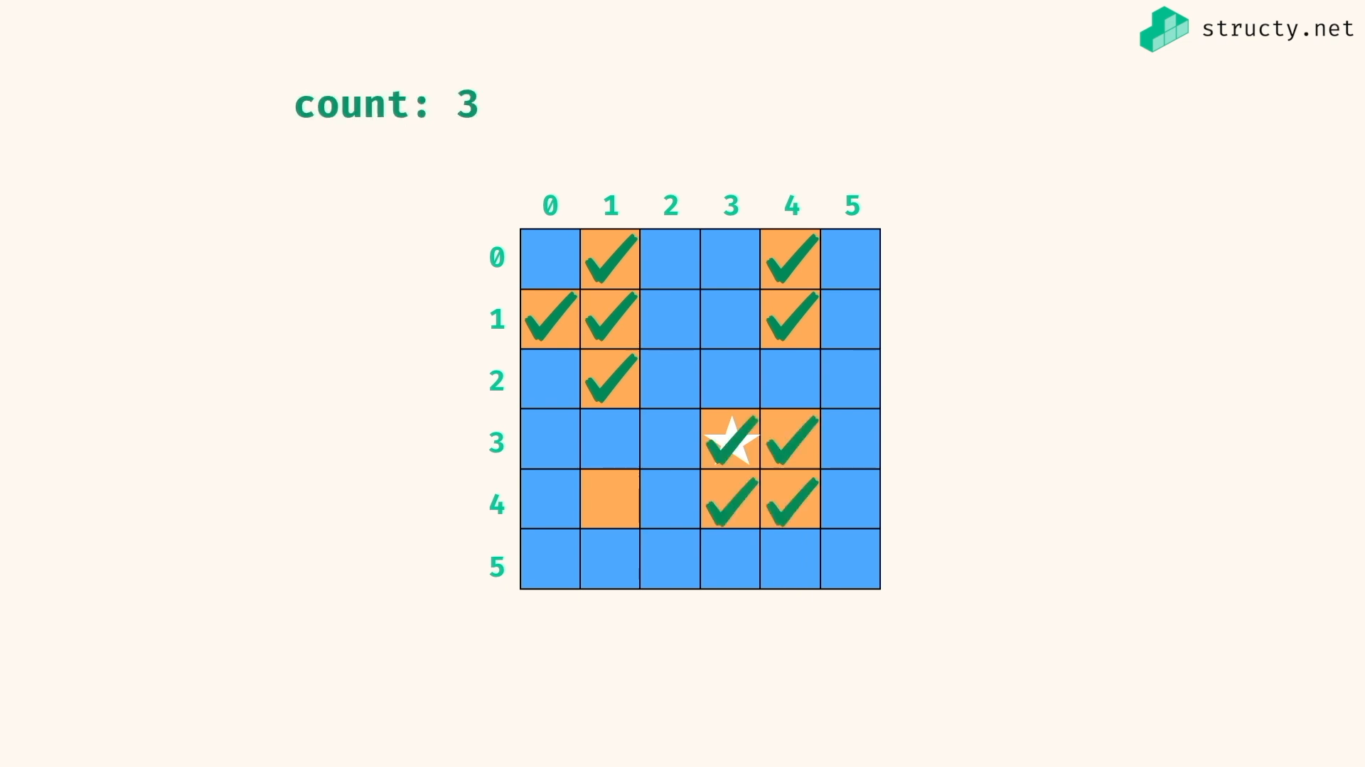

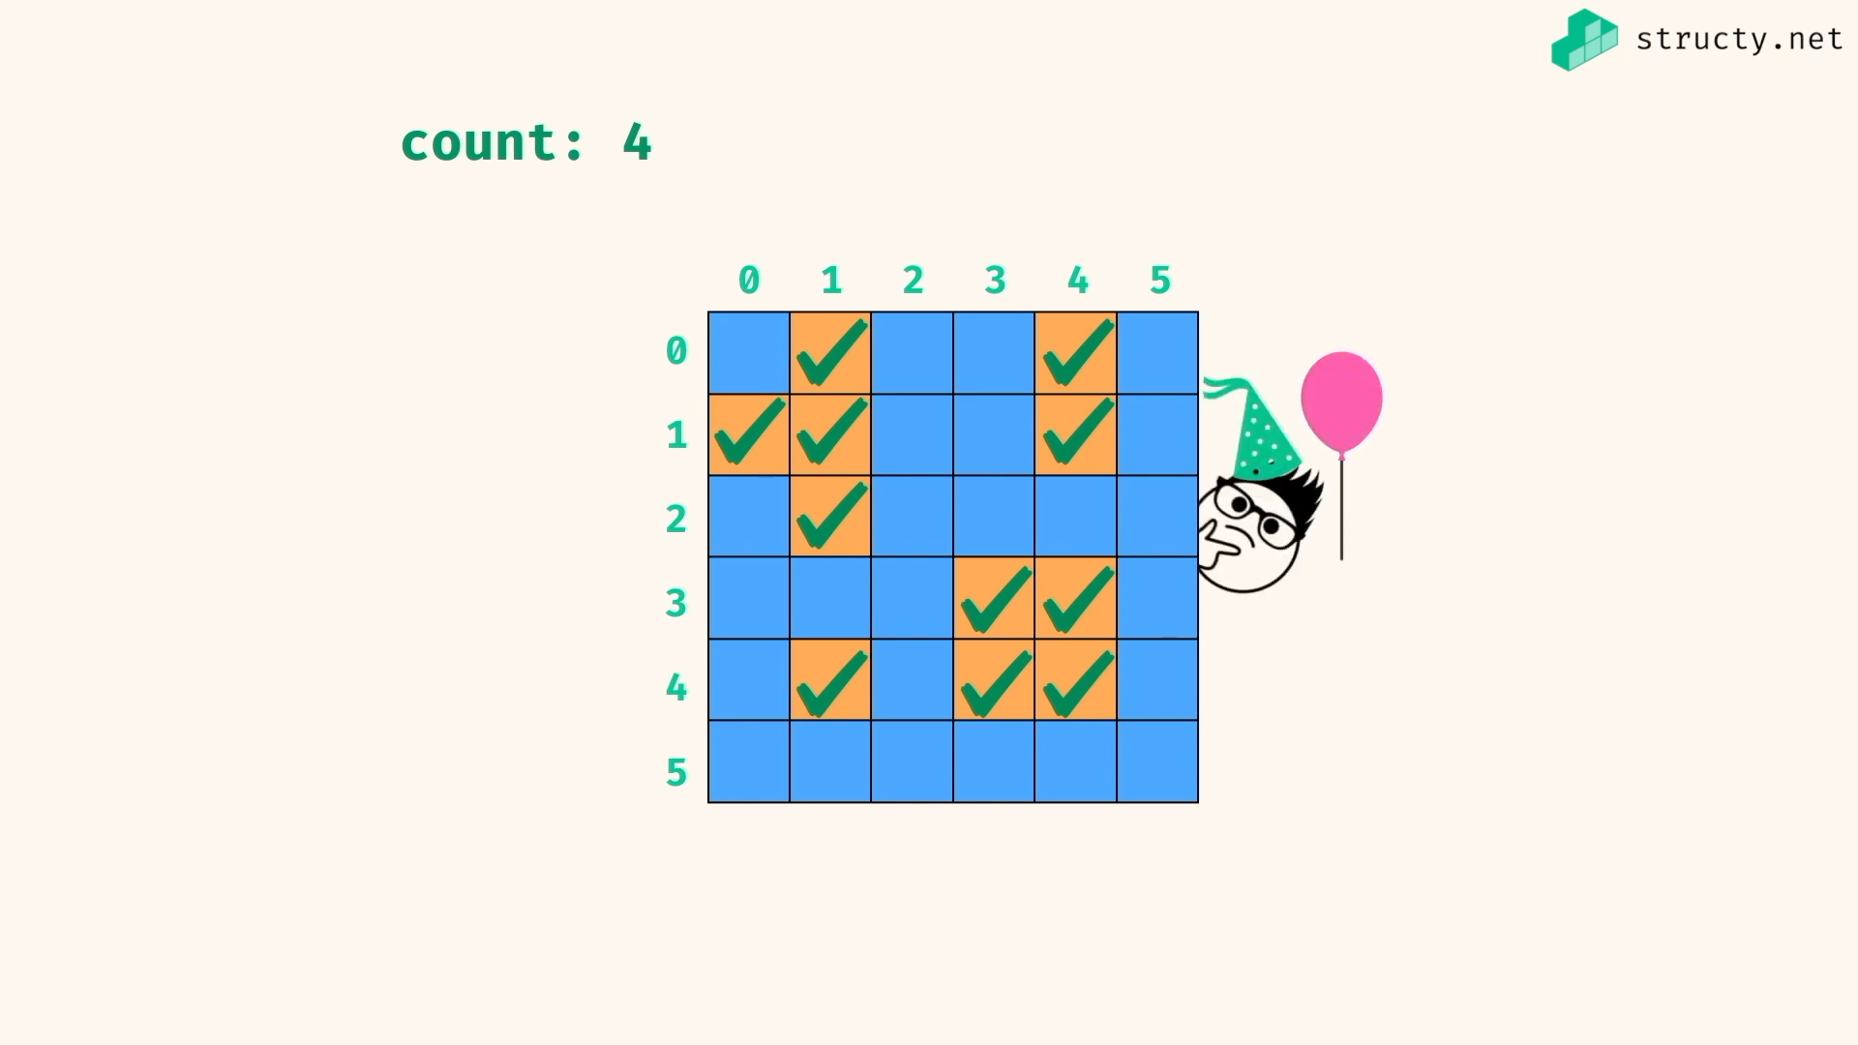

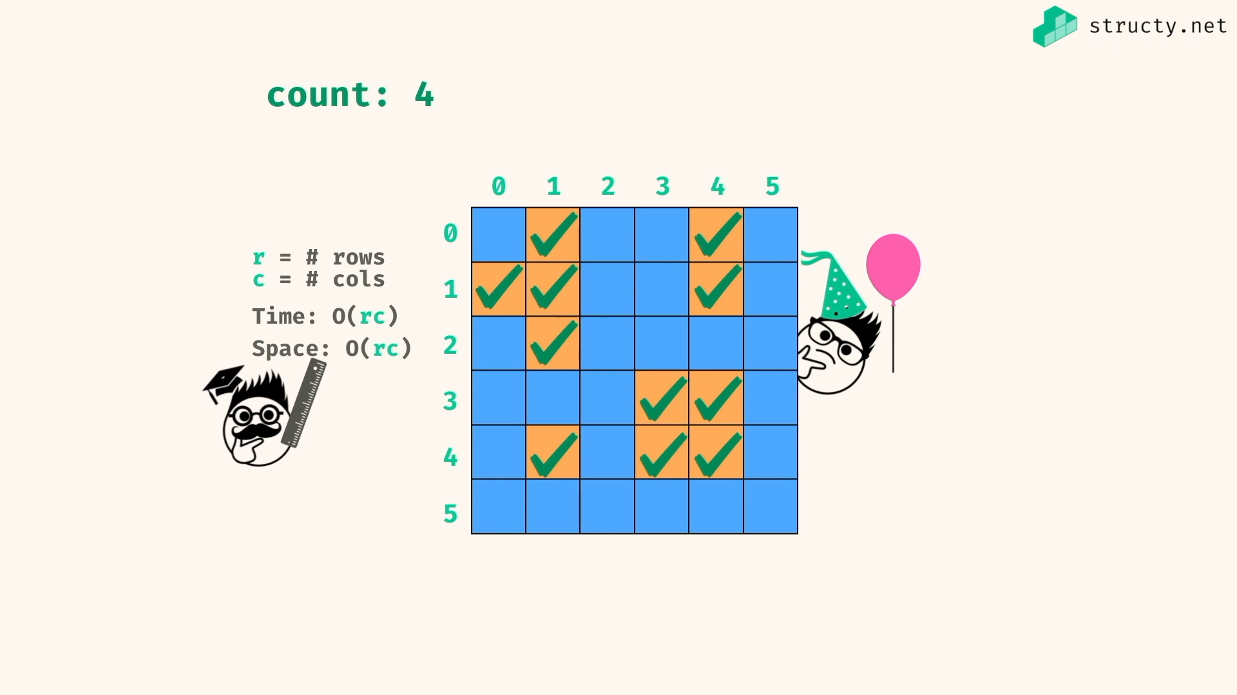

Time => getting all through the grid or dept first search of all grid .. both gives r\*c at worst case

Space => making all as visited, r\*c will be at worst case…

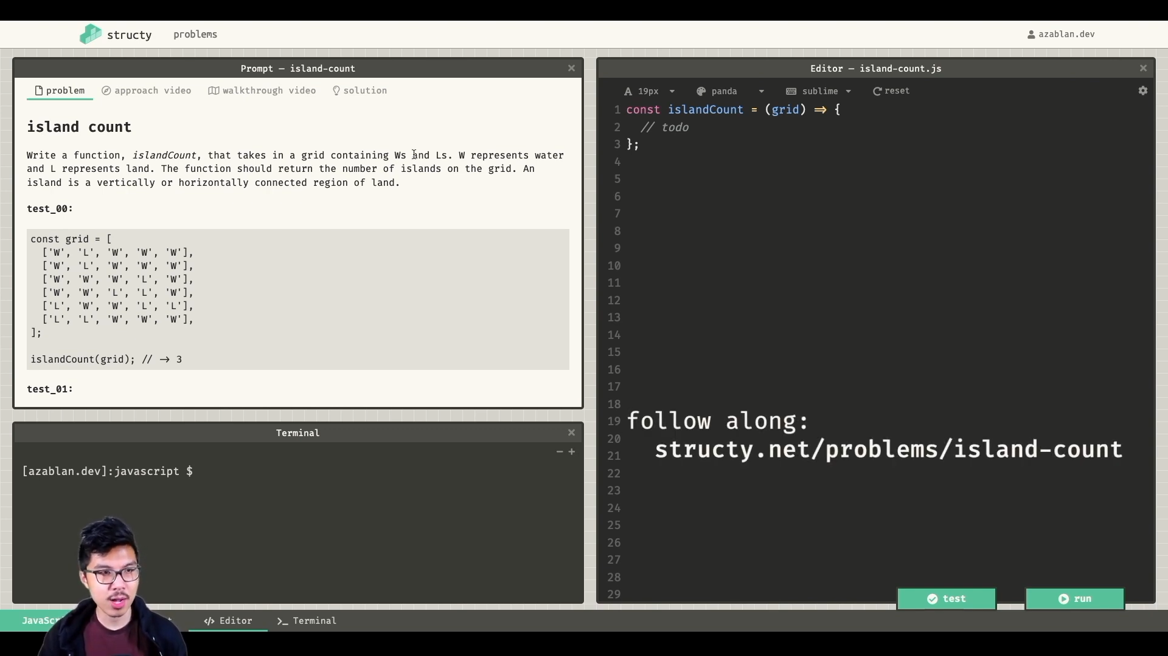

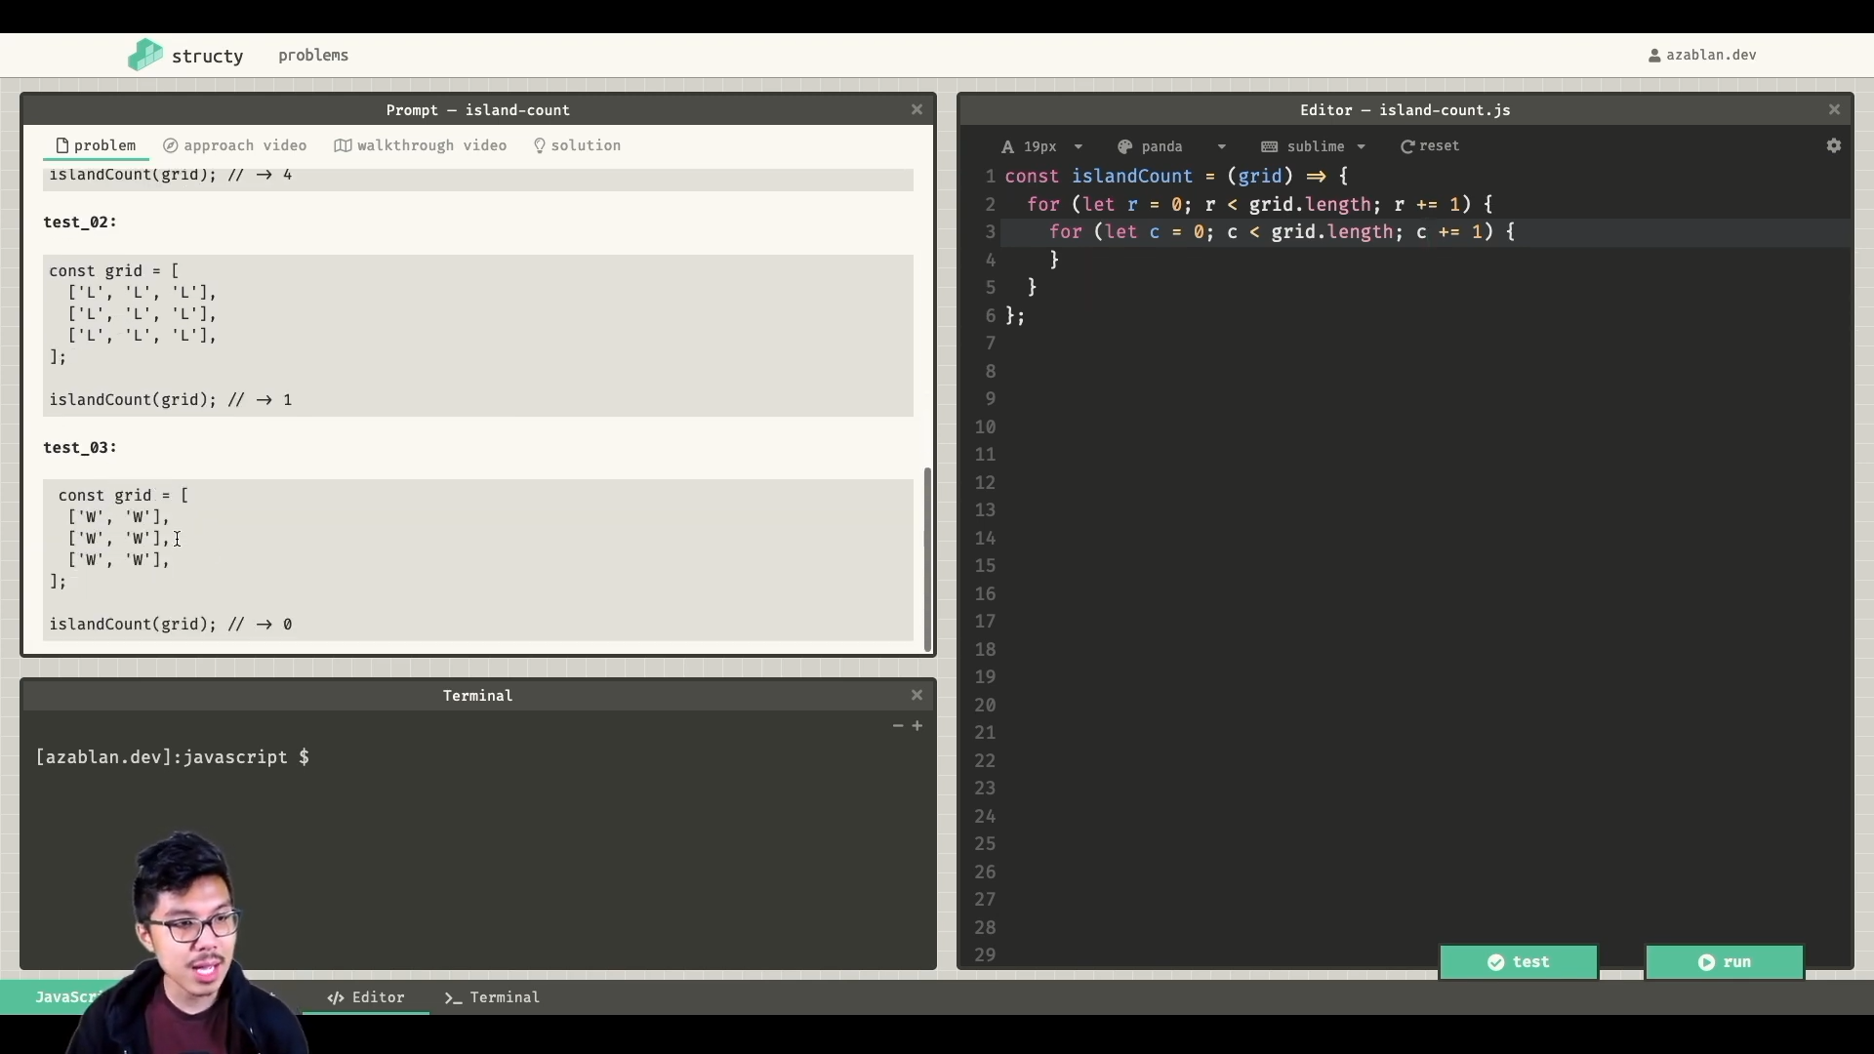

My soln:

*const* exploreIsland = (*grid*,*x*,*y*,*visited*,*row*,*column*) *=>* {

if(visited[x+" "+y]){

return;

}else{

visited[x+" "+y] = true;

}

if( x<0 || x>row-1 ) return;

if( y<0 || y>column-1 ) return;

if(grid[x][y] === 'W') return;

exploreIsland(grid,x+1,y,visited,row,column);

exploreIsland(grid,x-1,y,visited,row,column);

exploreIsland(grid,x,y+1,visited,row,column);

exploreIsland(grid,x,y-1,visited,row,column);

return;

}

*const* islandCount = (*grid*) *=>* {

if(!grid || !grid.length) return 0;

*const* [row,column] = [grid[0].length,grid.length];

*const* visited = {};

*let* count = 0;

for(*let* i=0;i<row;i++){

for(*let* j=0;j<column;j++){

if(grid[i][j] === 'L' && !visited[i+" "+j]){

count++;

exploreIsland(grid,i,j,visited,row,column);

}

}

}

return count;

}

*const* grid = [

['W','L','W','W','W'],

['W','L','W','W','W'],

['W','W','W','L','W'],

['W','W','L','L','W'],

['L','W','W','L','L'],

['L','L','W','W','W'],

];

*console*.log(islandCount(grid)) //=> 3

Thing to note :

sety = new *Set*( [[1,2]])

*console*.log(sety)

//=> Set { [ 1, 2 ] }

*console*.log(sety.has([1,2]))

//=> false { checks reference equality }

Alvin’s soln:

*const* explore = (*grid*,*r*,*c*,*visited*) *=>* {

*const* rowInBounds = 0 <= r && r < grid.length;

*const* colInBounds = 0 <= c && c < grid[0].length;

if( !rowInBounds || !colInBounds ) return false;

if(grid[r][c] === 'W') return false;

*const* pos = `${r},${c}`;

if(visited.has(pos)) return false;

visited.add(pos);

*const* neighbours = [ [r+1,c],[r-1,c],[r,c+1],[r,c-1]];

for(*let* [x,y] of neighbours){

explore(grid,x,y,visited)

}

return true;

}

*const* islandCount = (*grid*) *=>* {

*const* visited = new *Set*();

*let* count = 0;

for (*let* r=0; r<grid.length;r+=1){

for(*let* c=0; c<grid[0].length;c+=1){

if(explore(grid,r,c,visited)){

count += 1;

}

}

}

return count;

}

*const* grid = [

['W','L','W','W','W'],

['W','L','W','W','W'],

['W','W','W','L','W'],

['W','W','L','L','W'],

['L','W','W','L','L'],

['L','L','W','W','W'],

];

*console*.log(islandCount(grid)) //=> 3



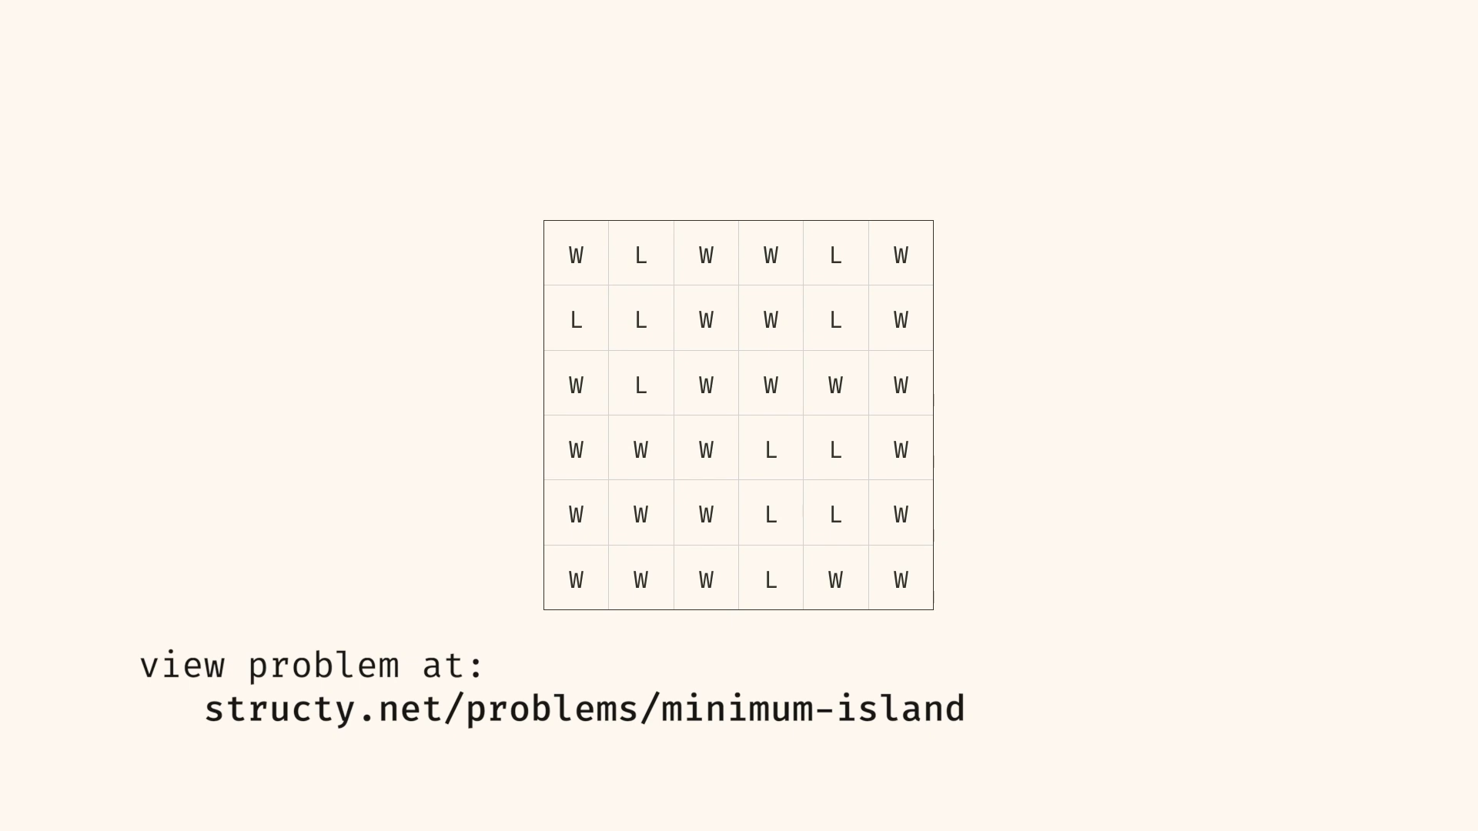

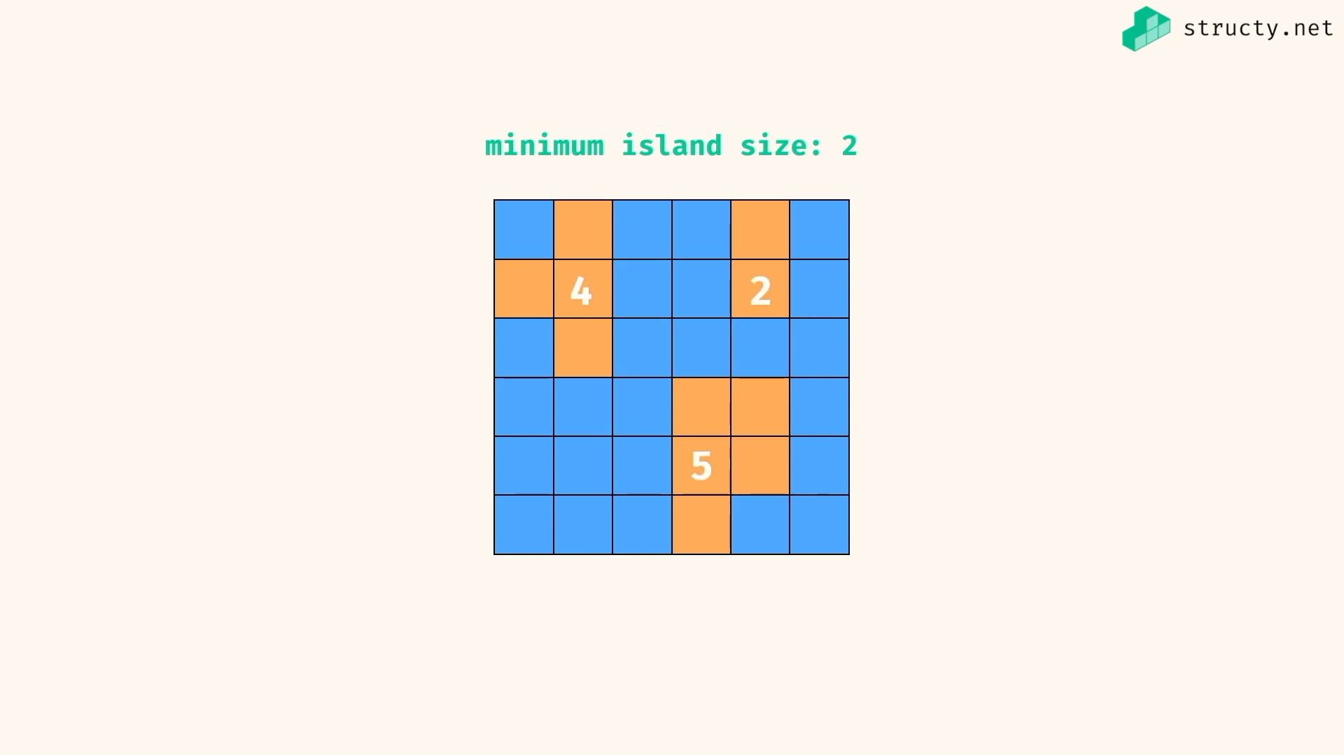

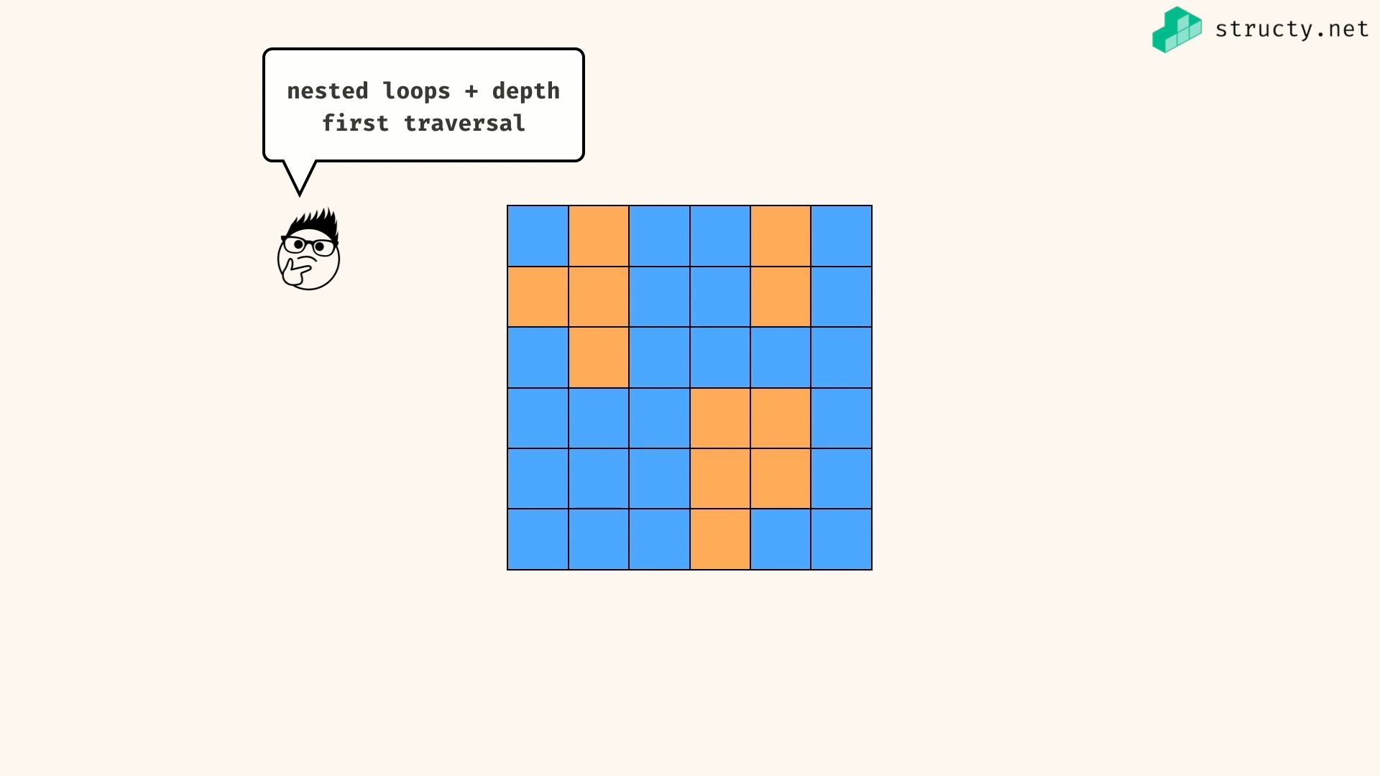

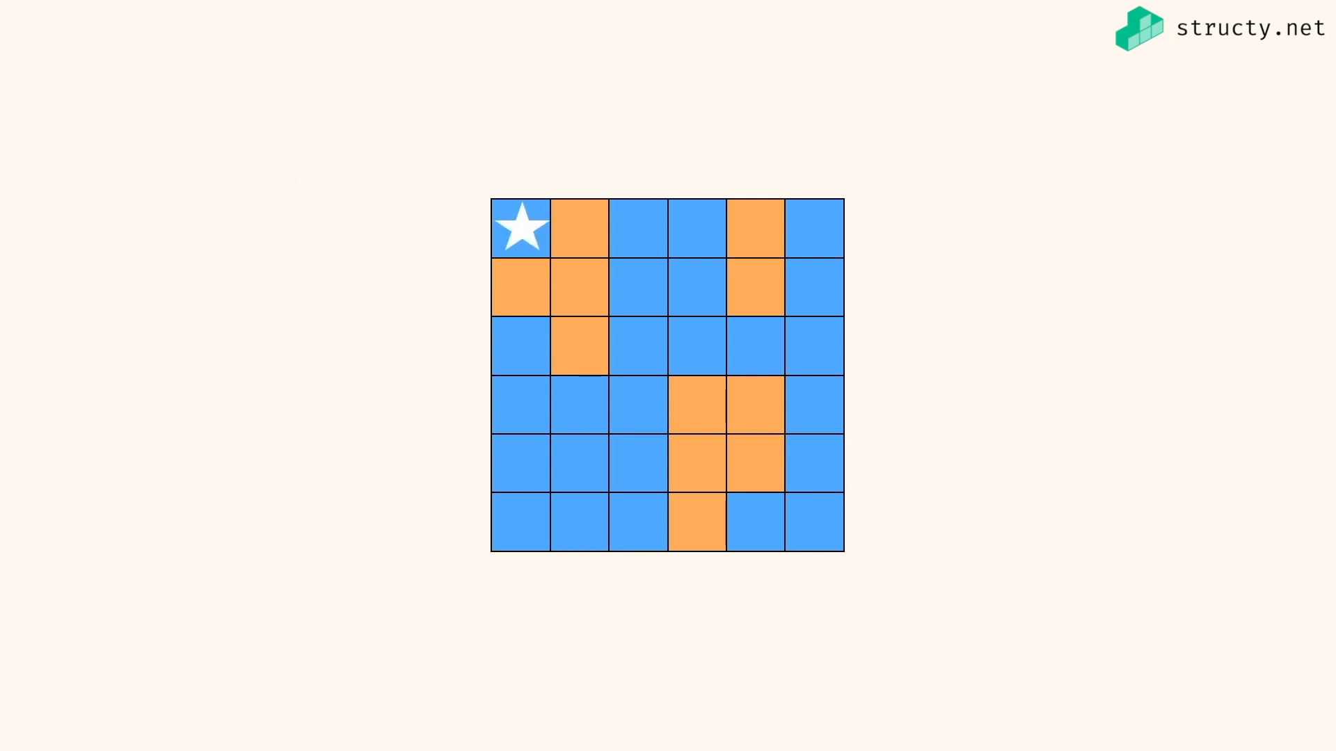

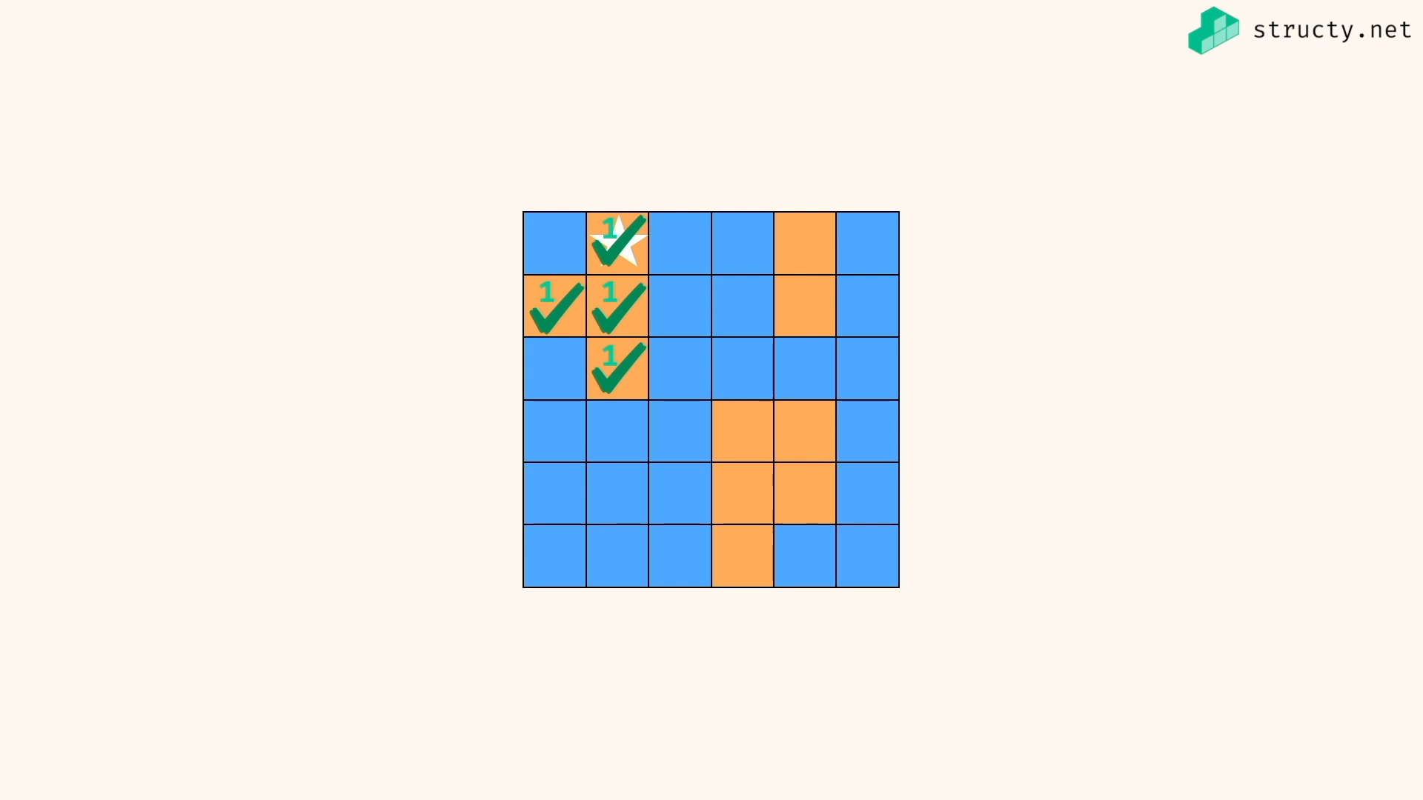

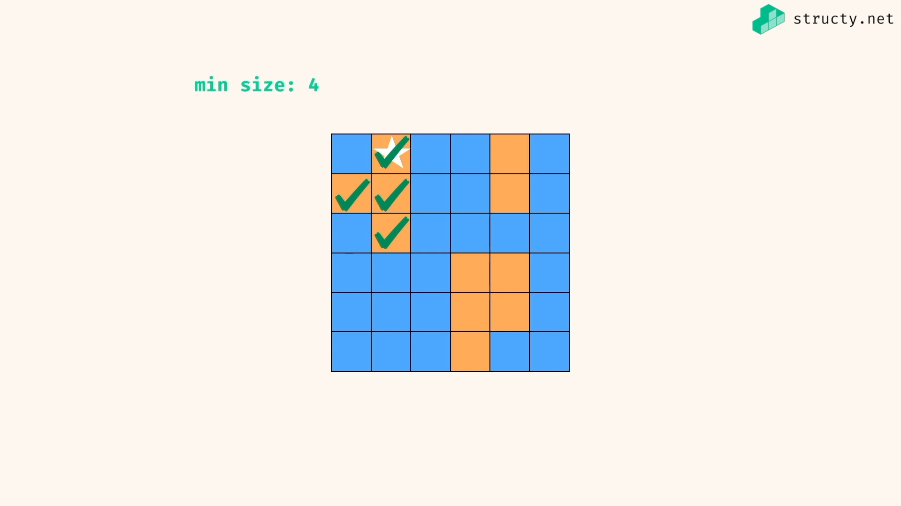

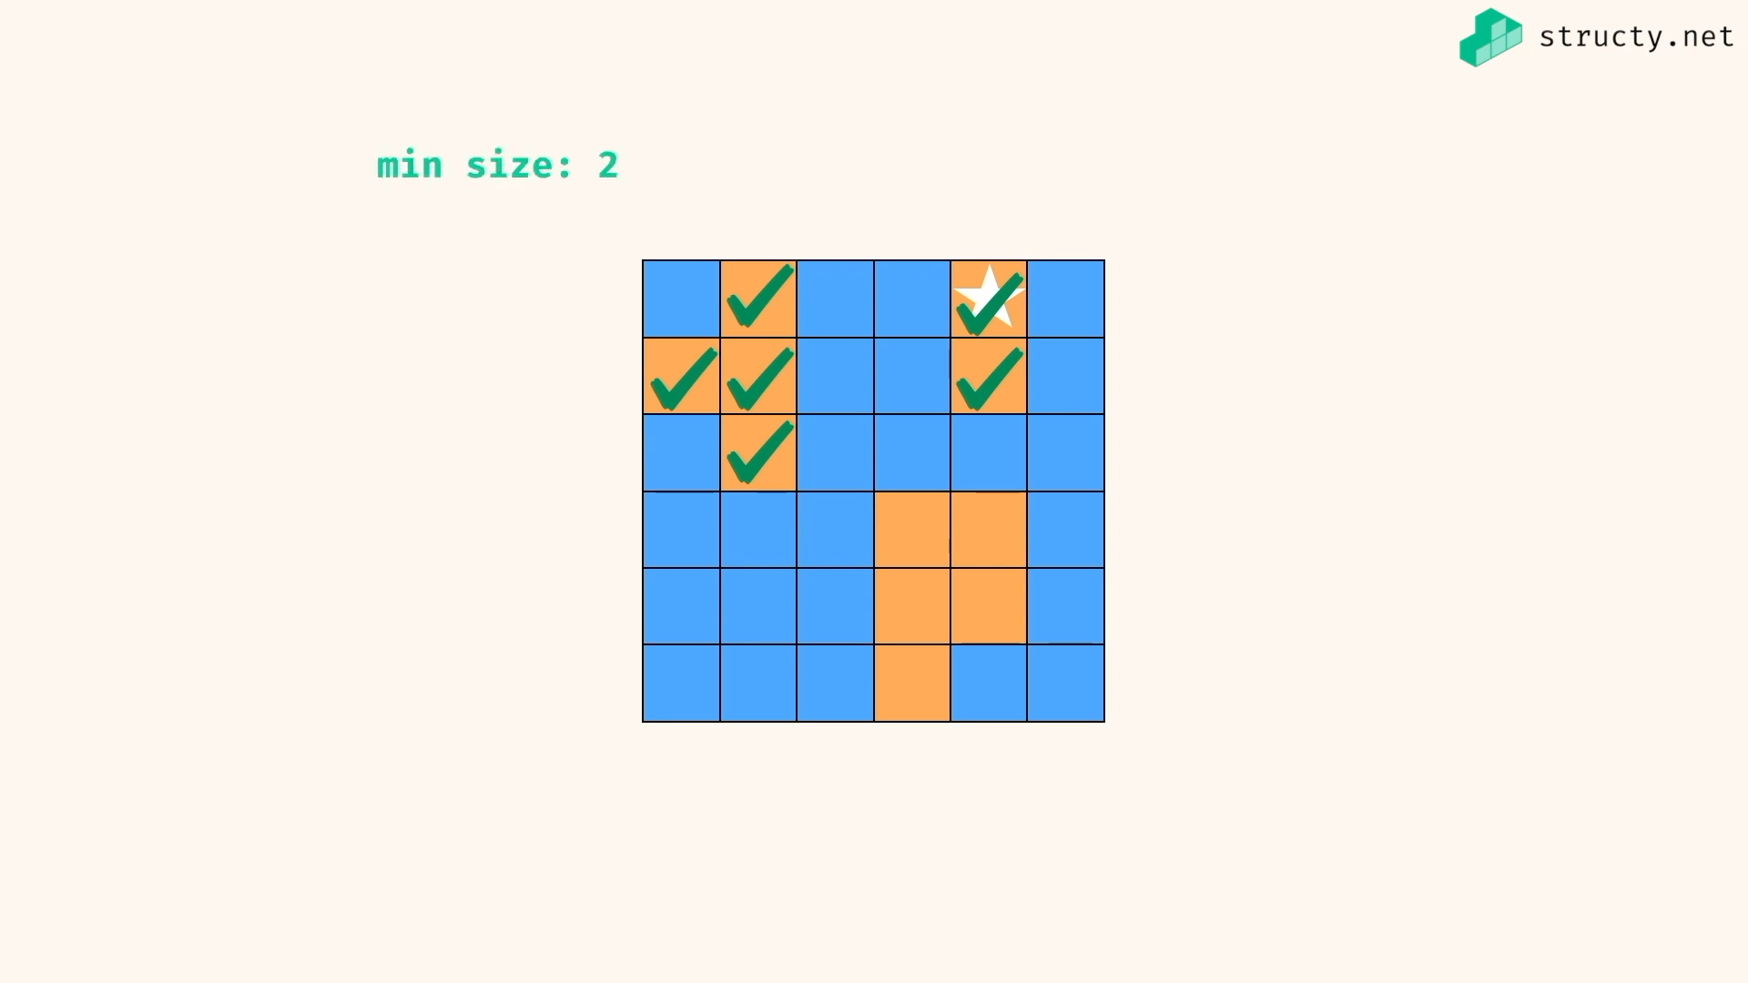

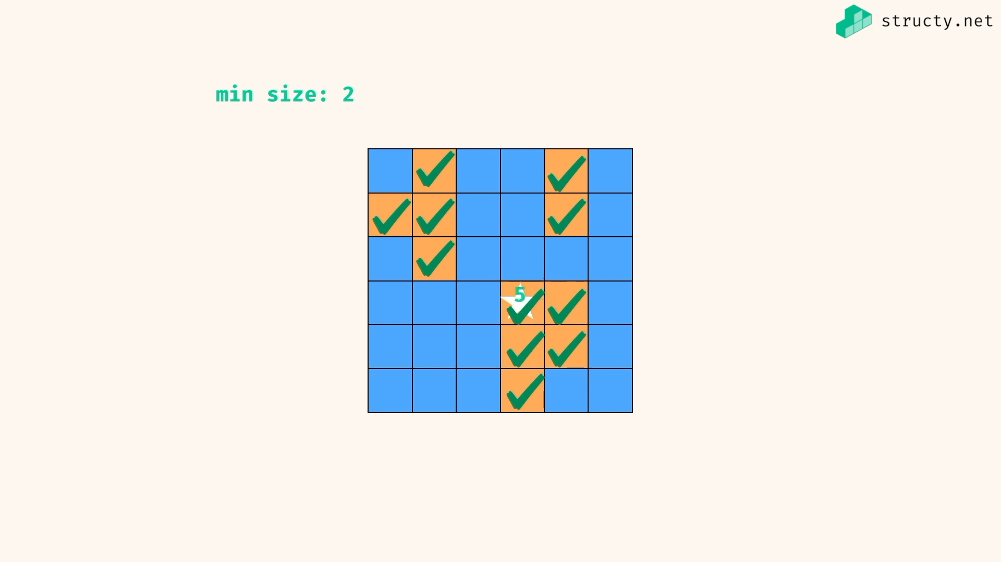

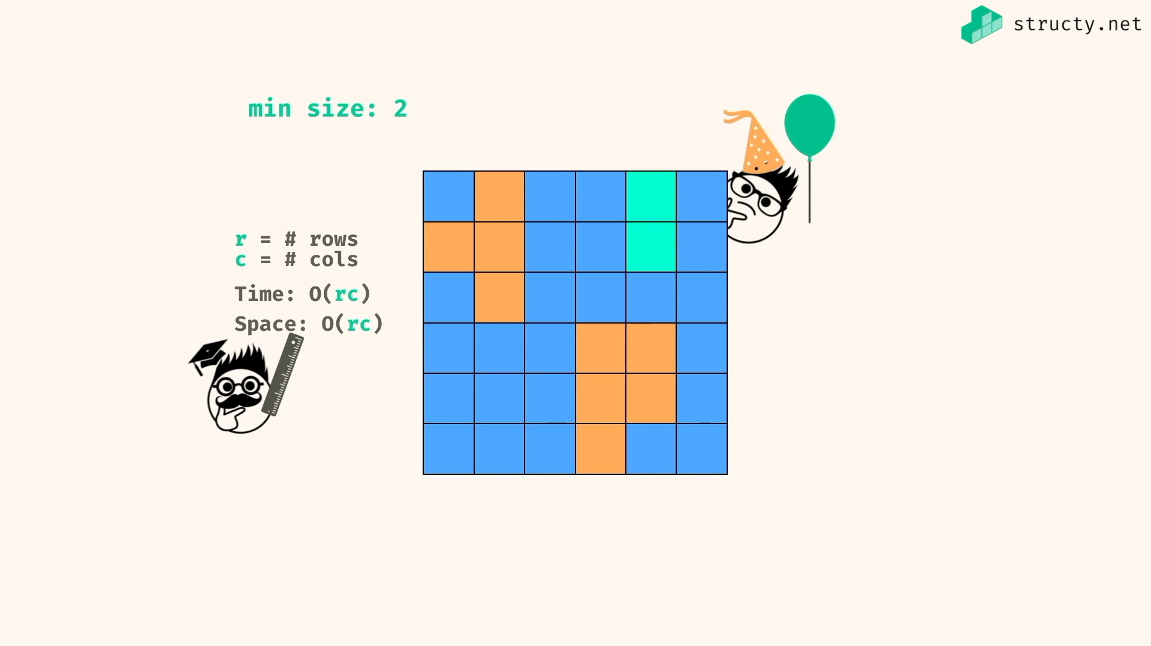

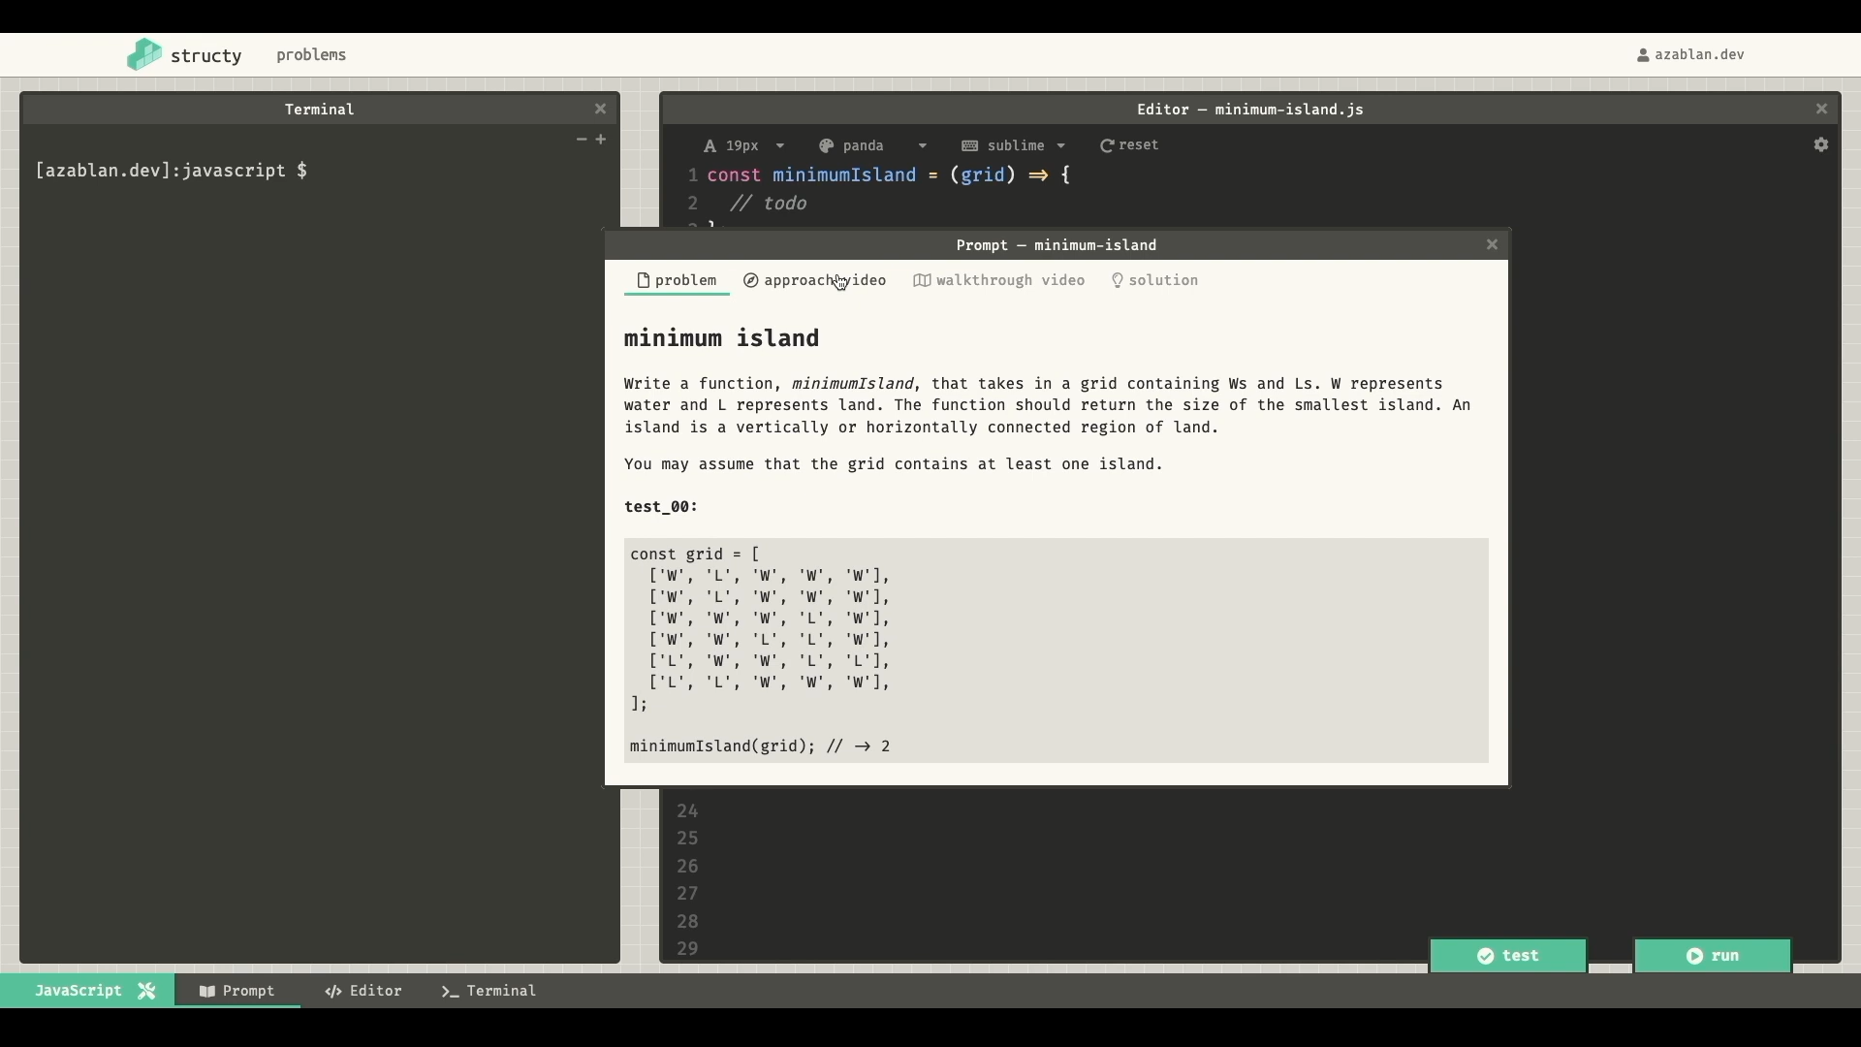

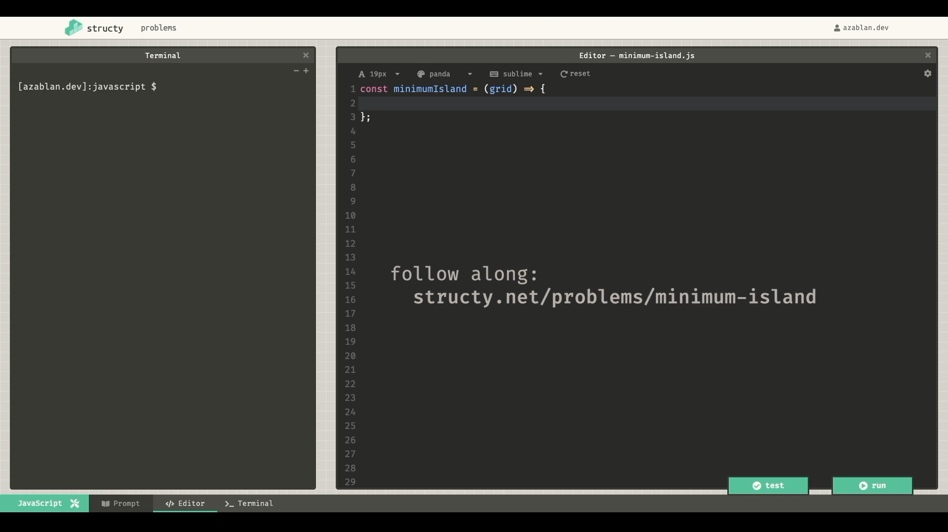

Just little alteration in problem:

*const* explore = (*grid*,*r*,*c*,*visited*) *=>* {

*const* rowInBounds = 0 <= r && r < grid.length;

*const* colInBounds = 0 <= c && c < grid[0].length;

if( !rowInBounds || !colInBounds ) return 0;

if(grid[r][c] === 'W') return 0;

*const* pos = `${r},${c}`;

if(visited.has(pos)) return 0;

visited.add(pos);

*const* neighbours = [ [r+1,c],[r-1,c],[r,c+1],[r,c-1]];

*let* count = 1;

for(*let* [x,y] of neighbours){

count += explore(grid,x,y,visited);

}

return count;

}

*const* islandCount = (*grid*) *=>* {

*const* visited = new *Set*();

*let* minSize = Infinity;

for (*let* r=0; r<grid.length;r+=1){

for(*let* c=0; c<grid[0].length;c+=1){

*const* size = explore(grid,r,c,visited)

if (size != 0 && size < minSize){

minSize = size;

}

}

}

return minSize === Infinity ? 0 : minSize;

}

*const* grid = [

['W','L','W','W','W'],

['W','L','W','W','W'],

['W','W','W','L','W'],

['W','W','L','L','W'],

['L','W','W','L','L'],

['L','L','W','W','W'],

];

*console*.log(islandCount(grid)) //=> 2